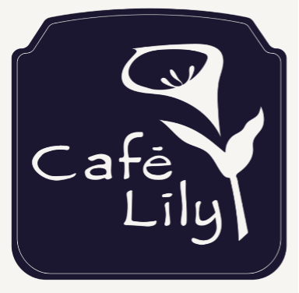
Anthony Pitillo, Executive Chef/Owner
Angelo Pitillo, Co-Founder
Katie McLellan, Manager/Co-Owner
Sowmya Burugu, Bar Director/Co-Owner

Choice of Salad

Caesar Salad – garnished with shredded Grana Padano cheese

Insalata Mista – field greens tossed in balsamic vinaigrette, garnished with Roma tomatoes

Choice of Entrée

Petto di Pollo alla Parmigiano – breaded breast of chicken and capellini pasta baked in a savory tomato sauce, topped with imported Fontal, Asiago, and Pecorino Romano cheeses

Charbroiled Salmon Steak – garnished with mango-dried sour cherry salsa, served with lemon-garlic mashed potatoes

Pinchitos – lamb tenderloin rubbed with a special blend of Spanish spices, chargrilled, with sautéed white sweet potatoes (when available) and fresh green beans, topped with a picante salsa verde and Manchego cheese

Ravioli di Zucca con Burro Marrone e Salvia – pasta filled with a roasted butternut-squash stuffing and tossed in a sage brown-butter sauce, garnished with pecorino Romano cheese

(no substitutions, please)

Choice of Dessert

Lemon-Sponge Custard – Fresh Lemon Custard and Light Lemon-Sponge Cake served Warm and topped with Fresh Chantilly Cream and Raspberry Sauce

Vanilla Bean Ice Cream

$45 Per Person Plus Tax And Gratuity

Café Lily
308-B W. Ponce de Leon Ave., Decatur GA 30030
(404) 371-9119
www.cafelily.com

