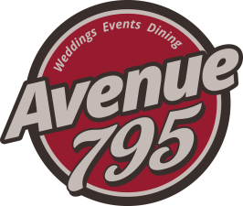
The Fond du Lac Columbian Club, Inc.
795 Fond du Lac Avenue
Fond du Lac, Wisconsin 54935
Sean M. Maroney - Manager
Banquet Facility
Hors d’oevres &Platters
All prices based on 50 pieces
Hot Hors d’oeuvres
Cocktail Meatballs (Choice of BBQ, or Swedish) ………………………… $85
Bacon Wrapped Water Chestnuts ……………………………………………… $100
Chicken Wings (Choice of Buffalo, BBQ, or Asian Sauce) ……………. $85
Stuffed Mushrooms (Choice of Sausage or Seafood) …………………. $95
Stuffed Potato Skins with bacon and cheese ……………………………… $90
Breaded Jumbo Shrimp with house made cocktail sauce …………… $125
Mini Crab Cakes served with spicy orange sauce ………………………. $115

Cold Hors d’oeuvres
Deviled Eggs ……………………………………………………………………………… $75
Assorted Mini Sliders (with ham, turkey and beef) ……………………. $100
Jumbo Shrimp Cocktail (100 pieces .………………………………………….. $205
Grilled Asparagus wrapped in Prosciutto …………………………………… $120
Traditional Tomato Basil Bruschetta …………………………………………. $100

Platters
Fresh Fruit Display …………………………………………………………………. $120
Fresh Vegetable Display with Dip …………………………………………… $90
Cheese and Sausage Display ………………………………………………….. $150
Taco Dip served with tortilla chips …………………………………………. $75
Spinach and Artichoke Dip served with rye crisps ………………….. $85
Smoked Salmon Display …………………………………………………………. Market

We require a minimum attendance guarantee 72 hours in advance.
All prices are subject to tax of 5.5% and service charge (gratuity) of 18%

We would love to work with you on custom menus for your event.
Subject to availability of products and necessary pricing adjustment

