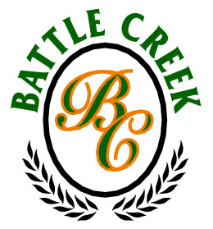

Wedding & Receptions
At the award winning
Battle Creek Golf Club
Broken Arrow, Oklahoma

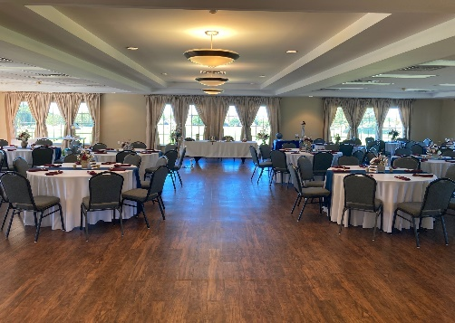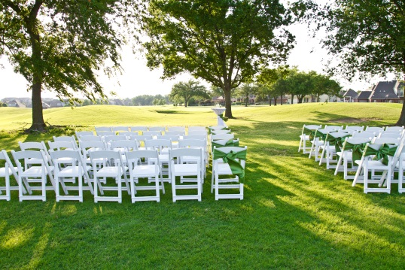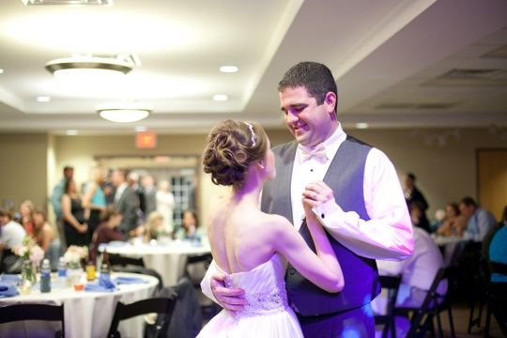

Weddings & Receptions at Battle Creek Golf Club
- Newly updated and remodeled
- Indoor & outdoor ceremony options
- No vendor restrictions and adult beverage friendly
*Hard alcohol requires a licensed and insured bartender
- Use of our catering kitchen & satellite bar
- Panoramic windows in ballroom, overlooking beautiful scenery & sunsets
- Use of indoor tables & chairs up to 175 guests max
- Basic set-up & clean-up included
- A separate room for the bridal party to get ready
- Indoor use of our sound system including a microphone and auxiliary cord
- Outdoor patio area perfect for bistro tables or outdoor entertainment
- Rental time of 8am-12am
- Ample parking & handicap accessibility
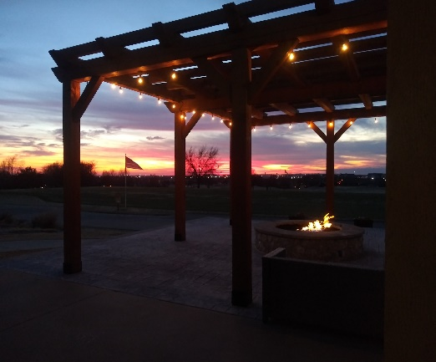
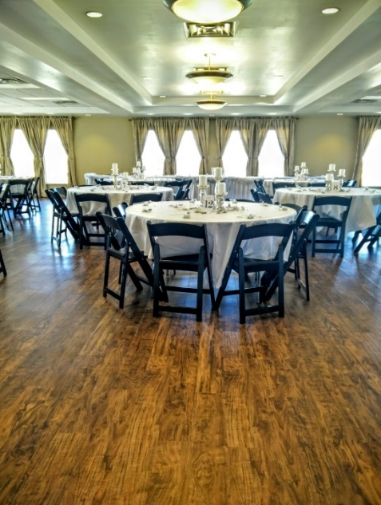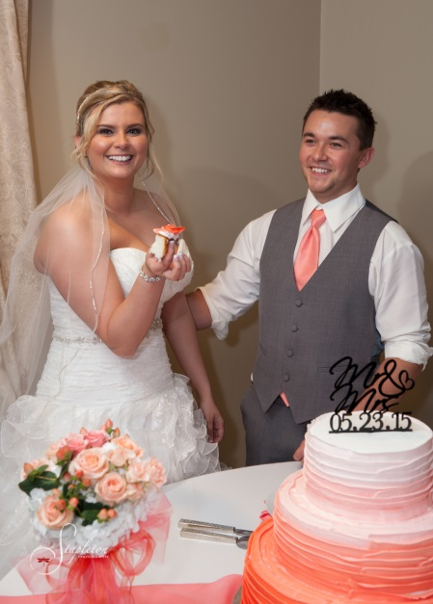

Investment
2022

December-March
Monday-Thursday $695
Friday $1,095
Saturday $1,500
Sunday $1,095

April-November
Monday-Thursday $695
Friday $1,095
Saturday $1,750
Sunday $1,095

Major holidays are $1,750

Outdoor Ceremony
$300
Chair rental and delivery are the responsibility of the client; set up of the chairs is included in rate

50% of rental cost & a signed agreement books your date!
Professionals we recommend

Event Rentals
Party Perfect Linens | 918.258.7368 | www.PartyPerfectLinens.com | 8542 East 41st Street, Tulsa, OK 74145
Catering
Ludgers | 918.744.8899 | www.LudgersCatering.com | 6120-A East 32nd Place, Tulsa, OK 74135
Zio’s | 918.250.5999 | www.Zios.com | 7111 S Mingo Rd, Tulsa, OK 74133
Cake
Ludgers | 918.744.8899 | www.LudgersCatering.com | 6120-A East 32nd Place, Tulsa, OK 74135
Anne’s | 918.834.2345 | www.AnnsBakery.com | 7 North Harvard Avenue, Tulsa, OK 74115
DJ
Lions Road Entertainment | 918.955.3491 | www.LionsRoad.com | 4909 East Dallas Street, Broken Arrow, OK 74014
Florist
The French Bouquet | 918.747.6750 | www.TheFrenchBouquetTulsa.com | info@theFrenchBouquetTulsa.com
Photo Booth
Route 66 Photo Booth | 918.694.7113 | www.Route66PhotoBooth.com
Bartender
Blue Label Bartending | 918.671.5222 | www.BlueLabelBartending.com | 3303 South Peoria Avenue, Tulsa, OK 74105
HAIR & MAKEUP
Primp Hair & Makeup Studio | 918.638.9661 | www.PrimpTulsa.com | 8917 S Yale Ave Suite G Tulsa, OK 74137

Local Hotel & Lodging
Holiday Inn Express | 918.355.3200 | www.IHG.com | 2201 West Stone Wood Drive, Broken Arrow, OK 74012
Valet Services
Exquisite Valet | 918.481.2070 | www.Exquisite-Valet.com | Valet & coat check services
On-Site Child Care Services
Seeking Sitters | 918.749.3588 | wwwSeekingSittersTulsa.com | Event & in home child care services
Other services available

Rentable Items
Use of portable keg fridge with tap $50
Golf cart rental $25
Utilizing the Club House after house, starting at $150 (without opening the kitchen/bar)

Drink Services
¼ Barrel Keg of domestic/import beer + use of portable keg fridge with tap + 16 oz. cups $145-165*
½ Barrel Keg of domestic beer + use of portable keg fridge with tap + 16 oz. cups $250*
*Beer Keg pricing does not include liquor excise tax or sales tax
Unlimited tea + lemonade + water beverage station $1 per person, per 4 hours of event time
Unlimited canned sodas $2 per person / 4 hours
Unlimited Ice $30
Coffee Station $35 per percolator urn (1 urn serves about 15 cups of coffee)

Event Services
Battle Creek bartender $30 per hour, per bartender beer, wine & champagne only

