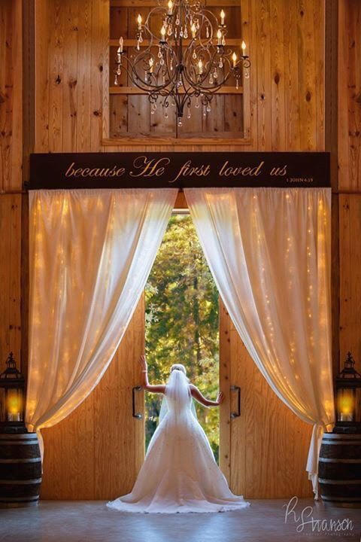  “because He first loved us”  Our Products and Services  2 Day Package  - Cost: $4,400  - Friday set up and decorate and also have rehearsal that evening from 8am-7pm.  - Saturday wedding/event day from 8am-midnight.  - 200 guests  Saturday Package  - Cost: $3,600  - 10am-midnight  - 175 guests  Friday Package  - Cost: $3,000  - 10am-11pm  - 150 guests  Additional Cost  - $250 to add 50 more guests  - Sunday available on request | Who We Are  Union Springs is a wedding and event venue in East Texas. It sits on 33 acres surrounded by the beautiful woods. It has the look of a rustic western horse barn but the amenities for the modern brides. The barn is 5000 sq. ft. and will accommodate 250 guests comfortably. There are 2 covered porches that can seat another 65 guests. The barn has a bride’s dressing room with her own bathroom and vanity area. There is also a separate room for the groom to dress. Each dressing room has a private entrance through the unique Dutch doors on the front the barn. The venue also has a catering kitchen off the buffet area. The kitchen is equipped with a commercial refrigerator, warming cabinet, ice machine and prep tables for your caterer to use. There is a separate entrance to the kitchen for easy access. There are many added touches to make this venue special for your event. Make an appointment to come and tour the facility. | Union Springs  200 CR 162  Garrison, TX 75946  (936) 462-3323 unionspringsevent@gmail.com http://unionspringsvenue.com
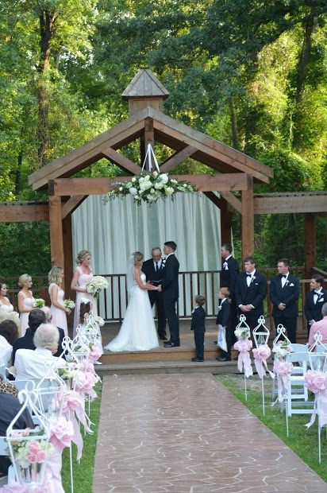  Get married under our beautiful archway.  Why We Built Union Springs  “It has been a dream of mine for years to find a place where I could coordinate and hold weddings. I grew up in a preacher’s family and have attended more weddings than I can count! I love weddings! It is one of the most special days in a girl’s life. One that she has thought about, dreamed about and planned for since she was a little girl. I wanted to have a place where a bride can make those dreams come true. I think we have achieved that goal. The barn is rustic enough to have that Texas appeal on the outside, but it is finished on the inside to fit any style wedding. A bride can dress it up or leave it as it is. I want to assist the brides as much as they | need so that they look back on this time as one of fun, excitement and joy with as little stress as possible. I have tried to add some special touches to the barn that will make your day special. Having this venue has made one of my dreams come true. I would like nothing more than to help you accomplish your dream wedding.” Kathy Strong, co- owner  “This venue has so many great things to offer and every feature of the property is picturesque.”  Not Just Weddings  Unions Springs is available for all types of events from corporate meetings to parties. If you are looking for a special place to get away from your normal meeting rooms, Union Springs is just the place. We can accommodate groups up to 300 individuals. Tables, chairs, tablecloths are included in your rental fee. We also have a sound system available for your use during your event. If your meeting requires a meal the catering kitchen is available for your use also. | 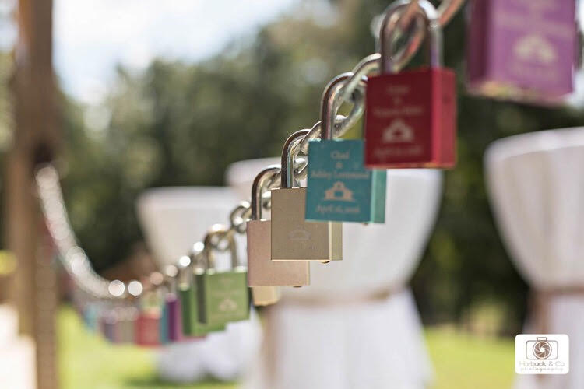  Add a lock to commemorate your special day here at Union Springs.  Included in the Packages  - Bridal Suite  - Grooms dressing room  - Catering kitchen for caterer of choice or you can do the food yourself.  - 500 chairs to set up outside for the wedding and inside for reception.  - 26 round, 10 rectangular, and 10 barista tables with white tablecloths for each.  - Table runners in 8 different shades  - Outdoor sound system with a wireless mic plus 2 hand held mics.  - Other decorations your welcome to that we provide.  - Offers coordination for rehearsal, wedding, and reception if you need it.

