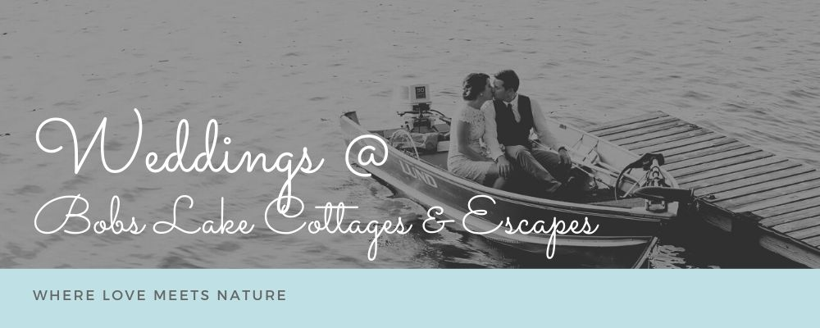

Consider Bobs Lake Cottages and Escapes for your Spring or Fall wedding.
We are your perfect destination-wedding setting. Our four modern and well-equipped cottages are a few feet from Bobs Lake, one of the most beautiful wilderness lakes in Ontario. It is the ideal setting in which the guests you most treasure, your family members, and the best of your friends, can swim, fish, canoe paddleboard, bike, and hike together in a setting of utter relaxation. There is no better way to bring together two people, two families and a whole community.
Invite up to 150 guests to join you as you say “I do” on a deck overlooking the water. After the ceremony, your guests can enjoy a cruise on the pontoon boat, or you can set up a pre-dinner refreshment stand at our Tiki Bar. Have young guests? Our playground is available. Keep the party going once dinner is wrapped up! Roast marshmallows and s’mores in the firepit, dance the night away at our screened-in porch, or hang out by the lake. We work with our partners to provide you with everything you need at a reasonable price.
You will stay at the Little House—the ideal setting for a couple in love.
Your immediate family or closest friends (up to 14) will stay at the Great House, a cottage with five bedrooms and five baths.
The rest of your guests who want to spend the weekend with you can stay in the Eagle and the Lake House. Combined, they will accommodate up to 18 people.
We at Bobs Lake Cottages and Escapes are eager to tell you what we can offer to make your destination wedding an event that meets your needs for beauty, celebration, and just plain fun. Let's find a time soon to get on a Zoom call to talk about what you want and what it will cost.
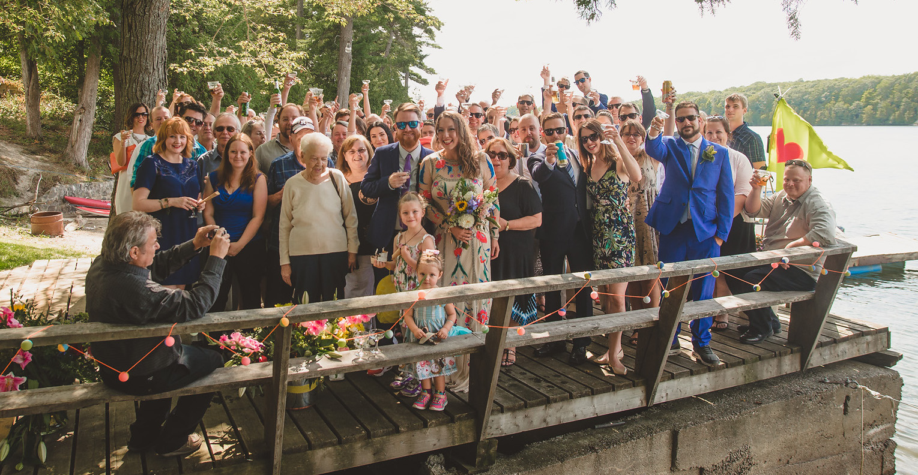
Your wedding venue includes:

- Exclusive use of the resort
- Free docking, launch, and trailer parking for two boats
- Tiki Bar for cocktail hour (beverages not included)
- Evening bonfire
- Welcome basket for the couple
- Playground, badminton, ping-pong, horseshoe areas
- Complimentary use of canoes, kayaks, stand-up paddleboards, paddle boat, water trampoline, hot tubs, and our six bicycles
- Parking for up to 40 cars with a parking attendant
- Boat cruises for your guests after the ceremony
- Use of pontoon boats for the ceremony

To view more information about the properties:
Great House – https://www.bobslake.com/the-great-house/
Eagle – https://www.bobslake.com/the-eagle/
Lake House Lower – https://www.bobslake.com/the-lake-house-lower/
Lake House Upper – https://www.bobslake.com/the-lake-house-upper/
Little House – https://www.bobslake.com/the-little-house/

PLANNING YOUR WEDDING AT BOBS LAKE COTTAGES & ESCAPES

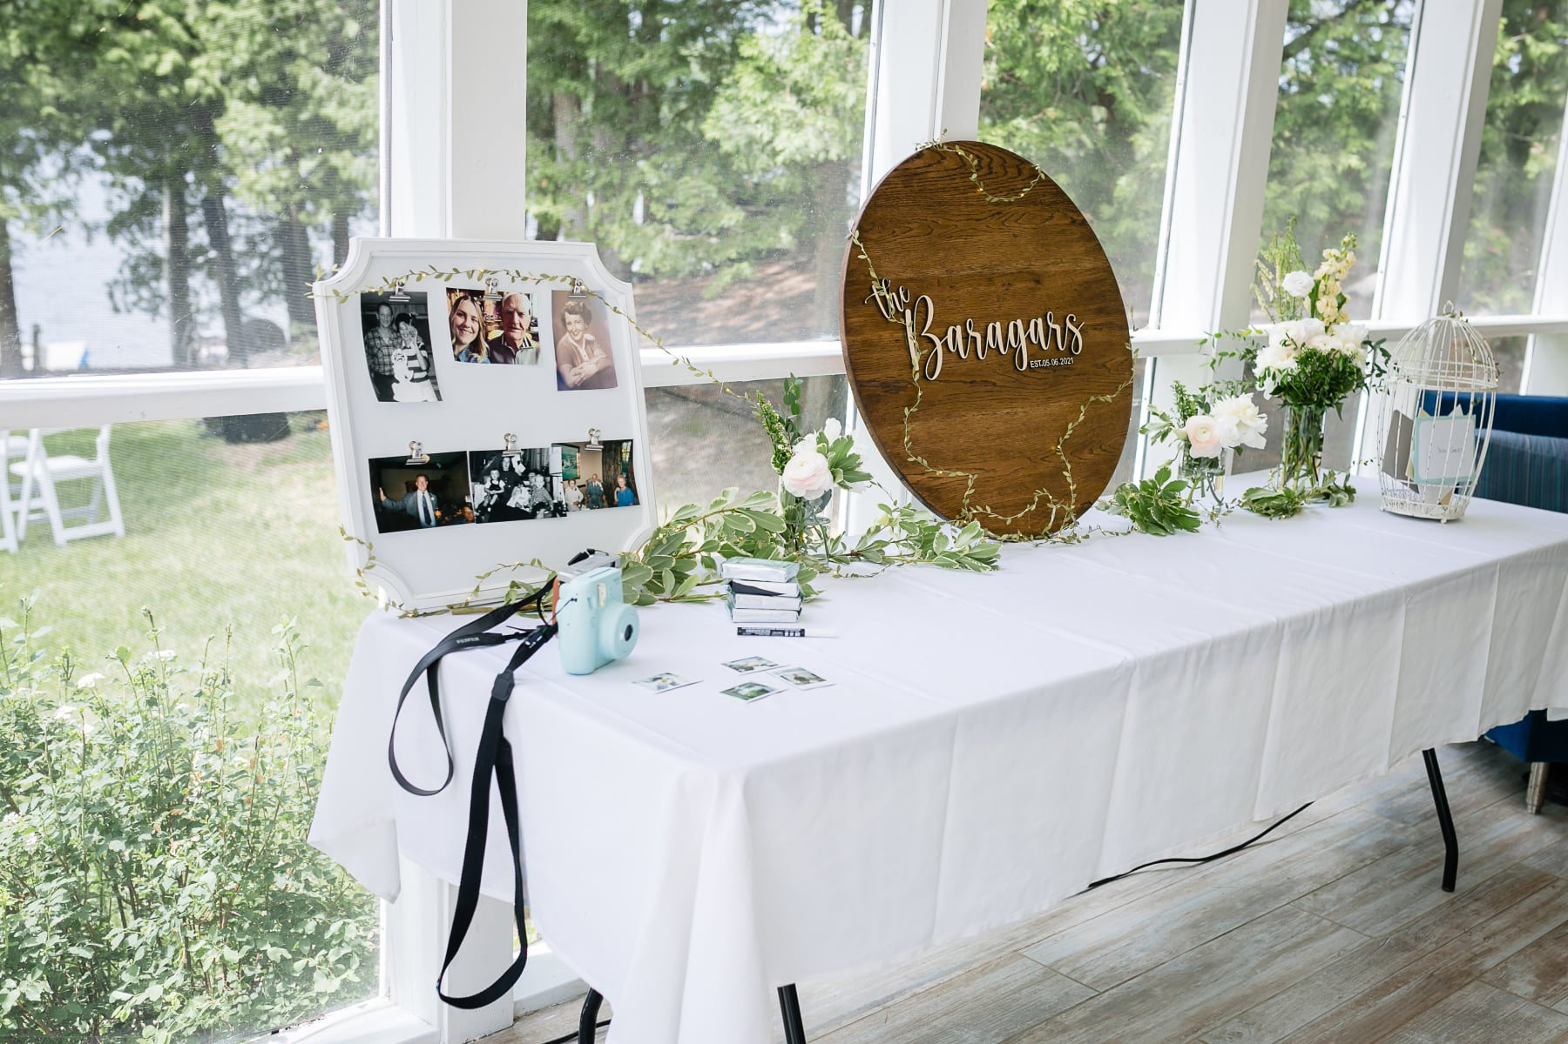 | 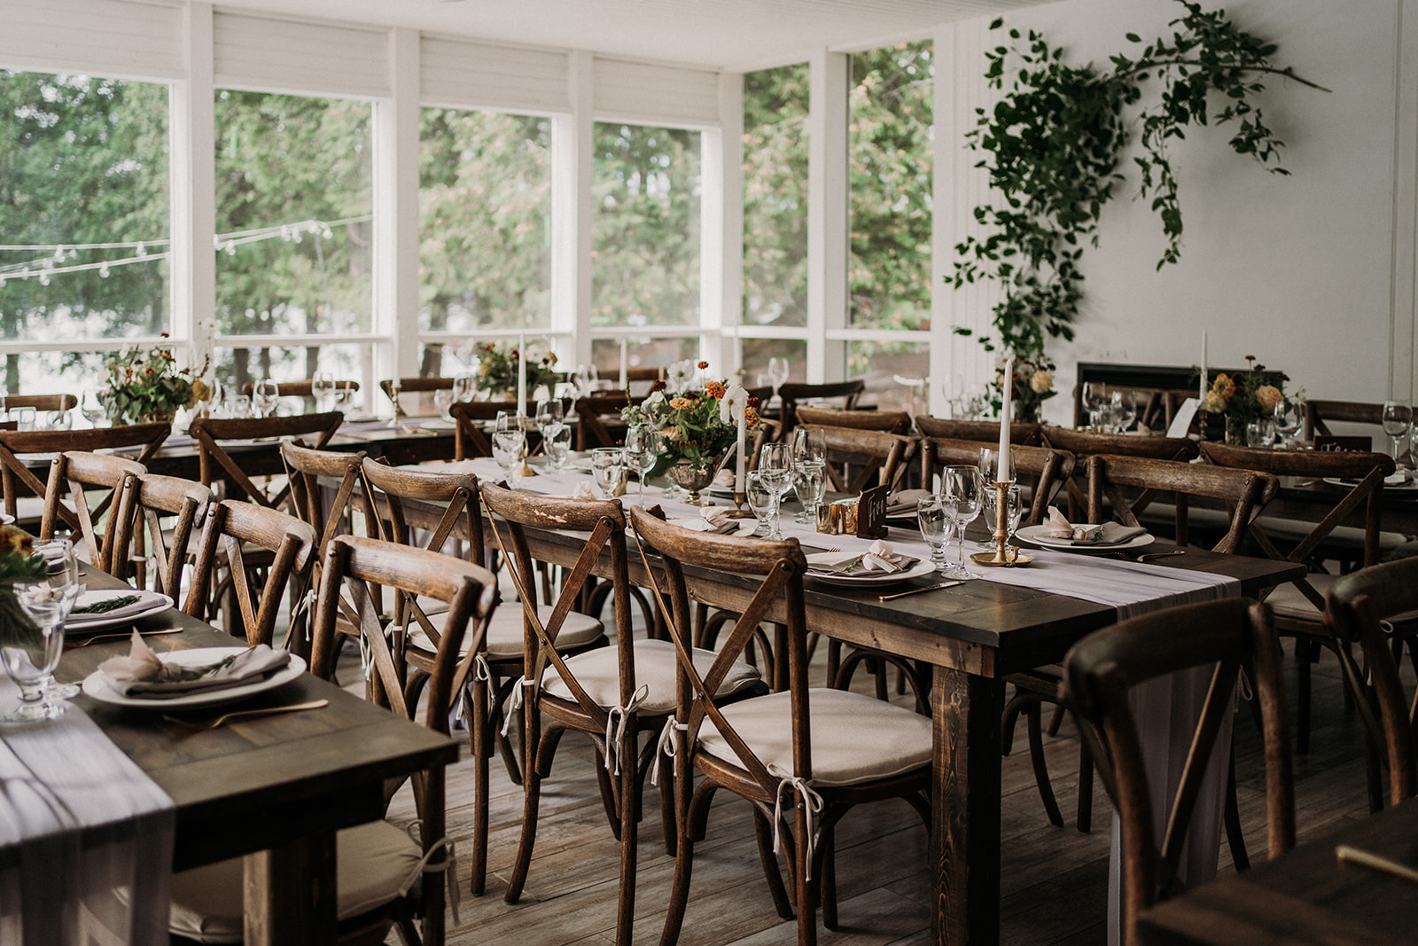

Our coordinator will work with you or with your wedding planner in crafting the wedding of your dreams.

- Catering
- Bartending
- Flowers and decoration
- Officiant
- Make-up and hairstyling
- Tent setup
- Table, chairs, and linens
- Photographer and videographer
- DJ and sound system

