Wedding Packages

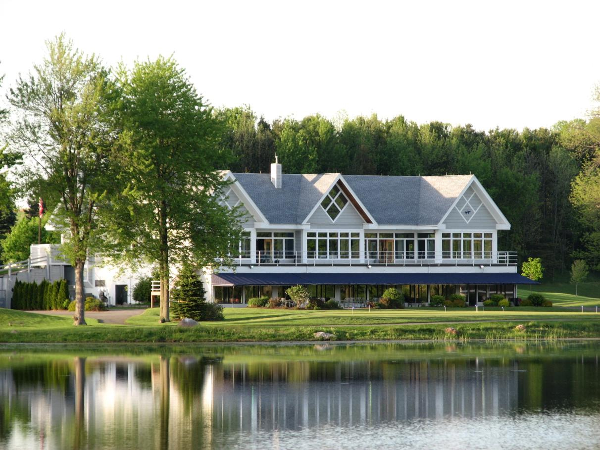
The Golf Club at Blue Heron
ONE COUNTRY CLUB DRIVE, MACEDON, NY 14502
(315) 986-5888 x 24

www.Blueheronhillsgc.com
Banquet & Event Manager | events@blueheronhillsgc.com

Y our S t or y Begins Her e

Thank you for considering The Golf Club at Blue Heron Hills for your wedding reception. As you plan for your special day, we will work with you each step of the way to insure we meet and exceed your expectations. With its scenic Lake and manicured grounds, The Golf Club at Blue Heron Hills is the perfect place to hold your wedding ceremonies! Our wedding packages offer an outstanding value that can include up to 4 hours of open bar, a free champagne toast for you and your guests, dinner, hors d’oeuvres, and an elegant coffee bar with.

W eddings at Blue Heron Incl ude:

• Private use of entire second floor of
club house and its two expansive balconies.
• Onsite head chef during your reception, events coordinator, servers, and bartenders.
• Choice of table linens and napkins.
• Centerpiece option of vases or rose bowls,
tea lights, and 12-inch table mirrors
• Cutting and service of the wedding cake
• Coffee and hot tea service
• Champagne toast
• Complimentary set up of your centerpieces by our staff
• China, glassware, and flatware
• Secure bride’s area
• Dance floor
• Ample complimentary parking

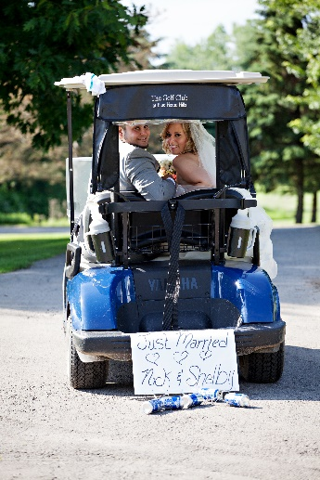
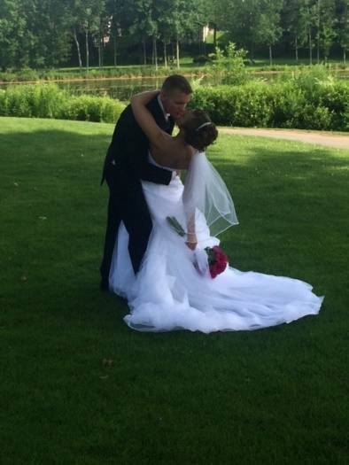
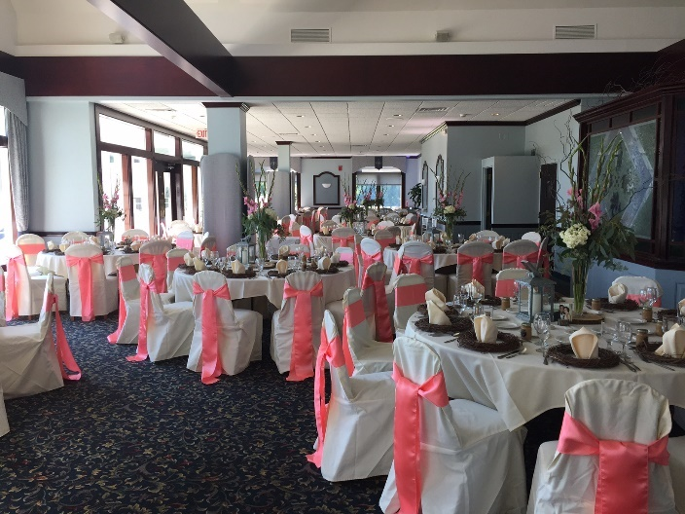

www .blueheronhillsgc.com
Banquet & Event Manager | events@blueheronhillsgc.com
A 20% Facility Fee and 8% NYS Sales Tax will be added to all products and services. Prices subject to change
Served Dinner Menu
Hors D’oeuvre
International Cheese Board | Imported & Domestic Cheeses w/ fruit garnish & assorted crackers
Fresh Vegetable Crudités w/ Creamy Garlic Dip | Meatballs Stroganoff
Tomato/Basil Bruschetta On Crostini | Tapenade on Flatbread
Soup Course
Choose one of the following items:
Italian Wedding Soup | New England Clam Chowder | Butternut & Apple Bisque
Fresh Fruit Cup with Sherbet

Salad Course
Choose one of the following items:
Traditional Caesar Salad with Garlic Croutons | House Salad with White French dressing
Baby Spinach Salad with Craisins, Bleu Cheese, Pecans & Raspberry Dressing

Entrée Selections
Select up to two of the following entrée items. Dinners served with vegetable of choice, fresh rolls with butter, and choice of rice pilaf, garlic smashed potato, or red bliss herb roasted potatoes.
SEASIDE | LAND | BEEF
Baked Stuffed Haddock  with Lobster Sauce | Roasted Honey Lemon Chicken  with honey-lemon thyme glaze over caramelized onions and mushrooms | Roast Loin of Pork  with sweet onion gravy and seasonal chutney
Swordfish Steak  (add $2 per person) | Chicken Chardonnay  lightly battered, sautéed in a chardonnay sauce | Roast Rack of Lamb  (add $5 per person)  slow roasted with mustard and herb crumb topping
Jumbo Baked Stuffed Shrimp  with seafood stuffing | Chicken Florentine  stuffed with spinach, fontina cheese and mushroom duxelle stuffing | Grilled NY Sirloin Steak  (add $3 per person)  topped with caramelized onions and mushrooms
Sole Limon  Topped with Shiitake mushrooms and white lemon butter sauce | Chicken Divan  sautéed then baked & stuffed with ham, broccoli & cheese with a supreme sauce | Filet Mignon  (add $6 per person)
Grilled Salmon  with cucumber, dill and yogurt tzatziki | Cranberry Roast Chicken  stuffed with cranberry sage dressing, sliced and topped with a light chicken gravy | Prime Rib of Beef auJus

Includes Coffee & Tea Display w/ Assorted Mints and Chocolates | One Glass of Wine/Champagne per Guest for Toast
Served Dinner Selections | $53.00 per person

Bar Package Options and Pricing on Pages 9-10

A 20% Facility Fee and 8% NYS Sales Tax will be added to all products and services. Prices subject to change.
Deluxe Buffet Menu
Hors D’oeuvre
International Cheese Board | Imported & Domestic Cheeses w/ fruit garnish & assorted crackers
Fresh Vegetable Crudités w/ Creamy Garlic Dip | Meatballs Stroganoff
Tomato/Basil Bruschetta on Crostini | Tapenade on Flatbread
Wedding Buffet

---- SALAD ----

Seasonal Greens Mixed Salad romaine and field greens served with garnish and choice of dressing.
---- SELECT TWO ----  Baked Pasta in a Vodka Tomato Sauce  Rice Pilaf  Garlic Roasted Potato  Oven Roasted Red Potato with Fresh Rosemary  Creamy Carbonara Cheese Tortellini | ---- SELECT TWO ----  Oven Roasted Chicken  Roast Prime Rib of Beef  Carved Roast Beef  Chicken French  Chicken Marsala  Italian Sausage with Peppers & Onions  Glazed Ham with Pineapple and Teriyaki Sauce  NY York Strip Steak (+$3.00 per person)  Filet Mignon (+$6.00 per person)  For one additional meat selection from above choices, please add $2.50 per person.
---- SELECT ONE ----

Green Beans with Toasted Sesame Seeds
Baby Carrots in a Cinnamon Butter Glaze
Green Beans & Baby Carrots in Garlic Butter

Includes Coffee & Tea Display w/ Assorted Mints and Chocolates | One Glass of Wine/Champagne per Guest for Toast
Deluxe Buffet Selections | $43.00 per person
Bar Package Options and Pricing on Pages 9-10
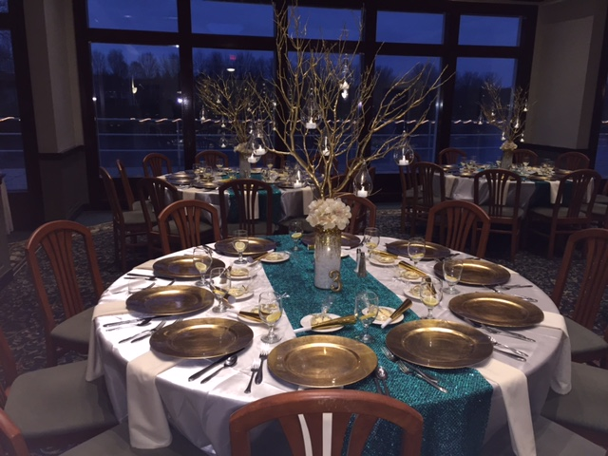

A 20% Facility Fee and 8% NYS Sales Tax will be added to all products and services. Prices subject to change.
Grazing Buffet Menu
Hors D’oeuvre
International Cheese Board | Imported & Domestic Cheeses w/ fruit garnish & assorted crackers
Fresh Vegetable Crudités w/ Creamy Garlic Dip | Meatballs Stroganoff
Tomato/Basil Bruschetta Mushroom or Tomato/Artichoke Tapenade
Grazing Stations
Select up to three of the following items.

Chef-Manned Pasta Station
Tortellini Carbonara & Shells Marinara
Chef-Manned Chicken Caesar Station
Romaine lettuce, bacon, croutons, tender chicken breast, imported cheese, & red onions tossed to order with Caesar dressing
Chef-Manned Carving Station
with garlic smashed potatoes, assorted rolls & dipping sauces and choice of: Carved Ham, Turkey or Roast Beef
Chef-Manned Paella Station (additional $3.00 per person)
Scallops & Shrimp, Shredded Chicken & Pork, Rice, Vegetables, and Cheese
Strip Steak (additional $4.00/person)

Includes Coffee & Tea Display w/ Assorted Mints and Chocolates | One Glass of Wine/Champagne per Guest for Toast
Deluxe Buffet Selections | $43.00 per person

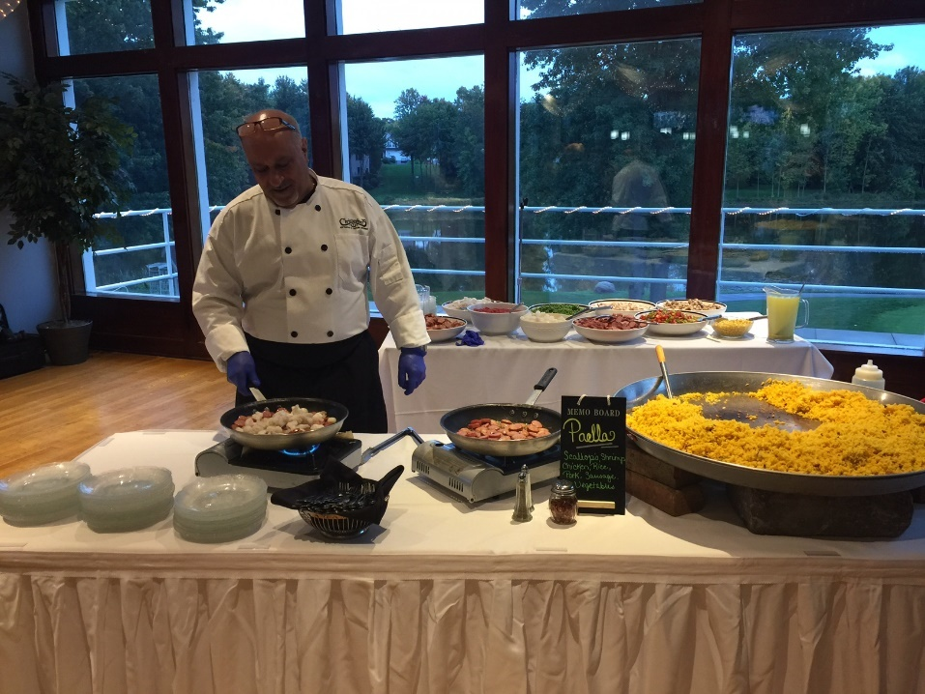
Bar Package Options and Pricing on Pages 9-10
A 20% Facility Fee and 8% NYS Sales Tax will be added to all products and services. Prices subject to change.
Hors d’oeuvre Selections

Items below may be added onto a wedding package. Pricing to be determined based on type and quantity requested. Typical consumption rate of hand-passed hors d’oeuvres is 4-6 pieces/person/hour.

Butler Passed Hors D’Oeuvres

Scallops Wrapped in Bacon | Mini Chicken Cordon Bleu
Phyllo wrapped asparagus | Chicken or Cheese Quesadillas
Spinach & cheese spanakopita | Chicken Pot Stickers
Puff Pastry Assortment | Pork Pot Stickers
Cocktail Frank Pastry Puffs | Coconut Chicken
Mini Quiche Assortment | Shrimp Wonton
Vegetable Roasted Tartlets | Yogurt Dipped Pineapple Chicken Kabob
Chicken Teriyaki Satays | Vegetable Spring Rolls
Beef Hibachi Skewers | Mini Reuben Puffs
French Chicken Hibachi Skewers | Vegetable Eggrolls
Beef Empanadas | Crab Ragoon Roll
Jalapeno Cheese Poppers | Macaroni & Cheese Bites

Hot Stationary

Fried Ravioli | Chicken & Artichoke
Mini Meatballs | Clams Casino in a Half Shell
Buffalo Chicken Wings | Sausage with Peppers & Onions
Sausage Stuffed Mushroom Caps | Baked Brie with Raspberry preserves in a Puff Pastry

Cold Stationary
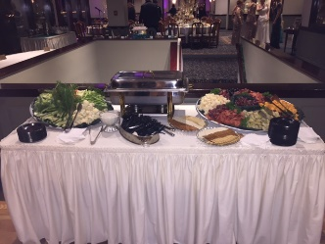
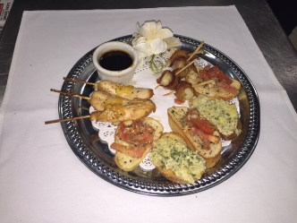
Smoked Salmon
Shrimp Cocktail
Fresh Fruit Display with Honey
Guacamole Station ($3.00 per person)

Desserts

Fresh Baked Cookie Display
(chocolate chip, peanut butter, white chocolate, macadamia nut)
Italian cookie assortment
Assorted Pies & Cakes
Chocolate dipped strawberries

www .blueheronhillsgc.com
Banquet & Event Manager | events@blueheronhillsgc.com
A 20% Facility Fee and 8% NYS Sales Tax will be added to all products and services. Prices subject to change.
The Golf Club at Blue Heron Weddings
“My husband and I had our wedding reception there on October 15th of this year. I can't express enough how perfect this entire day was! The staff did everything to make our day amazing! Paul was so accommodating with the food selection, I received SO many complements on the food. The view at Blue Heron is outstanding with so many options to take great pictures. I recommend Blue Heron for any event!”

“The wedding coordinator kept the ceremony and reception running smoothly. I didn't have to think of a thing. The food was exceptional. I received many compliments from guests who had been to weddings where the food was not so good. Paul was easy to work with and the wait staff he provided were very attentive to all the guest needs. Many happy memories for us as our wedding day was perfect! We couldn't be happier with our selection of the The Golf Club at Blue Heron Hills.”

“When I started planning my wedding, initially, I had a few different venues in mind. Blue Heron Hills ended up being the only place I looked at. The moment I sat down with the events coordinator I was hooked! Blue Heron Hills is an exceptional venue for people looking for lots of space, with a great view. You have access to the entire floor, unlike most venues that only give access to a single room. Anything I wanted, the answer was, "Yes!" Paul (catering) is a spectacular human being. He genuinely wanted to know how he could accommodate my guests best. I was able to adjust the menu to whatever I wanted, and felt completely in control of my wedding. This is definitely not the case at all wedding venues. While Blue Heron Hills is slightly out of the way from Rochester, it is definitely an ideal location for a wedding reception. My guests were unbelievably impressed with the entire night, and it was very clear to me how much time and effort everyone at Blue Heron Hills put into our night. We are forever grateful!!!”

“On October 29, 2016, my daughter had the wedding of her dreams at Blue Heron Hills. They accommodated an outdoor wedding although the weather was questionable until that day. Paul, the chef, out did himself with the food service, we were able to work with him on the menu and everything was beautifully presented and delicious, from the appetizers to the presentation of the desserts. The wedding went exactly as planned, and the staff were professional and efficient. The guests enjoyed the large dance floor, and deck, and beautiful views., the events coordinator, found a way to say, "yes" to my many requests, even remoting in the bride to the planning meetings, and running the event perfectly. Thank you, The Golf Club at Blue Heron Hills.
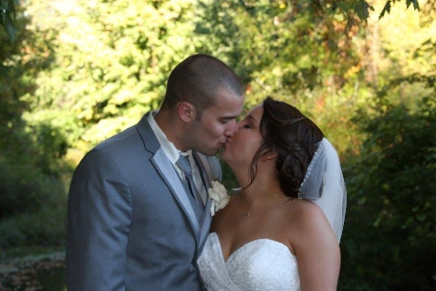
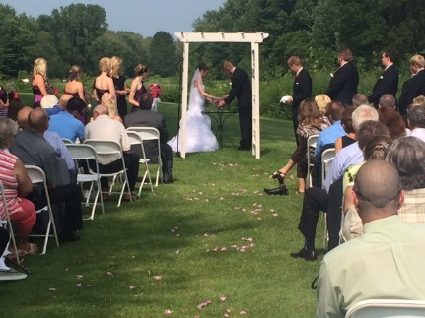
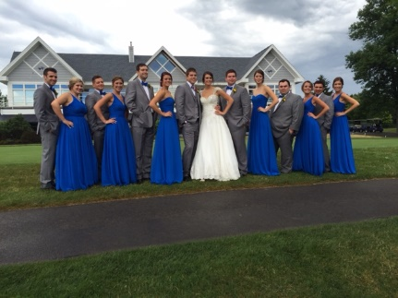

www .blueheronhillsgc.com
Banquet & Event Manager | events@blueheronhillsgc.com
A 20% Facility Fee and 8% NYS Sales Tax will be added to all products and services. Prices subject to change.
Service Amenities

Weddings Include: Private Use of Entire Second Floor of Club House and its Two Expansive Balconies Table Centerpiece Option of Vases or Rose Bowls, Tealights, and 12-inch Table Mirrors Choice of Table Linens and Napkins, Guest Tables, Head Table, Chairs, and Tables for DJ, Cake and Gifts. China, Glassware, flatware. Onsite head chef during your reception, events coordinator, servers, and bartenders.

ROOM CHARGE: $500
LOCKER ROOM USE FEE: $75 (refundable!!!)
ONSITE CEREMONY FEE: $300 (Chair Fee- $1.50 per chair, Set up charge-$50.00)
CAKE CUTTING: Complementary

ITEMS AVAILABLE AS SEPARATE RENTAL: Chair covers with sash, Tented Deck (to accommodate higher guest count), folding chairs for onsite ceremony, we have access to a variety of other items not listed and would be happy to assist you in the rental of those items upon request.

DEPOSITS: Upon signing of contract for space, a deposit of $500 will be required to book the event. This deposit is non-refundable and will be applied to the balance of your event. 30 days prior to your event, an additional deposit of 60% of the estimated final bill is due. Menu selections are due at this time. Seven (7) days prior to your event, the balance will be due. Within 72 hours of the conclusion of the event, a final bill will be presented. The final bill will include any increase to the final count and/or any additional food or beverage items ordered within seven days before the event.

GUARANTEES: A guarantee of 125 guests is required to reserve the Ballroom on a Saturday. Thirty (30) business days prior to your event, a tentative count is due. Seven (7) calendar days prior to your event, a final count is due and is not subject to a reduction within this period. If the 125 guarantee is not met, Blue Heron Hills will charge you/your organization for that 125 guarantee.

SPECIAL REQUESTS: We have chosen our menus with special care to include our most popular selections and to accommodate most tastes. However, if there is an item or dish you would like that is not on the event menu, we will work with you to honor your request with appropriate pricing. Due to fluctuations in market price of certain items, pricing of menu items cannot be guaranteed more than six months prior to the function.

FACILITY CHARGE AND TAX: A 20% Facility Fee and an 8% New York State Sales Tax will be added to all products and services purchased for your event.

FINAL PAYMENTS are accepted in the form of cashier’s check, money order or cash, personal checks and credit cards.

CLEANING: The throwing of rice or confetti is prohibited and will incur a $350 cleaning fee.

RENTAL ITEMS: Should your event require additional items that we do not carry, we will be more than happy to make arrangements to acquire these items at a pre-determined price.

ENTERTAINMENT, DECORATIONS, DISPLAYS FOR YOUR SPECIAL DAY: You may arrange for your own entertainment with prior approval of the event coordinator. Management reserves the right to limit the volume of your entertainment to acceptable levels and hours. Any special requirements for receiving or setting up of displays, decorations, floral arrangements, computers, etc. should be discussed with the event coordinator in advance. No material or decorations may be attached to the walls or wood trim by nails, pins, staples, tape, glue or any other substances.

RESPONSIBILITY: The Golf Club at Blue Heron Hills will not assume responsibility for any items brought in either prior to, during, or following the event. Special arrangements must be made with the Management when it is necessary to leave any items. These items must be picked up within 72 hours. After 72 hours, The Golf Club at Blue Heron Hills will no longer be responsible for the security of these items

CANCELLATION: All deposits are non-refundable and non-transferable.

Cocktail & Beverage Service

House Open Bar
1 hour: $10.95/pp | 2 hours: $13.95/pp | 3 hours: $16.95/pp | 4 hours: $19.95/pp

House Alcohol is Recipe 21 which includes; Vodka, White Rum, Gin, Tequila, Scotch, Whiskey, Bourbon, Peach Schnapps, Amaretto, Blue Curacao, Mr. Boston Slow Gin, Kahlua, Malibu Rum
House Wine is CK Mondavi which includes; White Zinfandel, Chardonnay, Pinot Gregio, Moscato, Merlot, Cabernet, Scarlet 5 Blend as well as Swedish Hill Blue Waters Reisling
Beers Included: Blue, Blue Light, Bud, Bud Light, Coors Light, Mich. Ultra, and Miller Light, O’Douls
Draft Included: Blue Light, Yuengling, Southern Tier IPA
Soda includes Coke, Diet Coke, Sprite, Ginger Ale, Club Soda and Tonic
Juice includes Orange, Cranberry

Premium Open Bar
1 hour: $15.95/pp | 2 hours: $18.95/pp | 3 hours: $21.95/pp | 4 hours: $24.95/pp

Alcohol Includes: Baileys, Canadian Club, Captain Morgan, Crown Royal, Seagrams 7, Seagrams VO, Jack Daniels, Jose Cuervo, Johnny Walker Black, Johnny Walker Red, Southern Comfort, Tanqueray, Absolute, Bacardi, Beefeaters, Bombay Sapphire, Black Velvet, Grey Goose, Jameson, Titos
Beers Included: Blue, Blue Light, Bud, Bud Light, Coors Light, Mich. Ultra and Miller Light, O’Douls, Corona and Corona Light, Stella, Angry Orchard and Blue Moon
Wine Included: is CK Mondavi which includes; White Zinfandel, Chardonnay, Pinot Gregio, Moscato, Merlot, Cabernet, Scarlet 5 Blend as well as Swedish Hill Blue Waters Reisling, Relax Reisling, Matua-Sauvignon Blanc, Ecco Domani, Josh Cabernet, Alamos Malbec, Apothic Red
Draft Included: Blue Light, Yuengling, Southern Tier IPA
Soda includes Coke, Diet Coke, Sprite, Ginger Ale, Club Soda and Tonic
Juice includes Orange, Cranberry

Beer and Wine Only
1 hour: $9.00/pp | 2 hours: $12.00/pp | 3 hours: $15.00/pp | 4 hours: $18.00/pp

Beers Included: Blue, Blue Light, Bud, Bud Light, Coors Light, Mich. Ultra, and Miller Light, O’Douls, Corona, and Corona Light, Stella, Angry Orchard and Blue Moon
Wine Included: is CK Mondavi which includes; White Zinfandel, Chardonnay, Pinot Gregio, Moscato, Merlot, Cabernet, Scarlet 5 Blend as well as Swedish Hill Blue Waters Reisling, Relax Reisling, Matua-Sauvignon Blanc, Ecco Domani, Josh Cabernet, Alamos Malbec, Apothic Red
Draft Included: Blue Light, Yuengling, Southern Tier IPA
Soda includes Coke, Diet Coke, Sprite, Ginger Ale, Club Soda and Tonic Water
Juice includes Orange, Cranberry

www .blueheronhillsgc.com
Banquet & Event Manager | events@blueheronhillsgc.com
A 20% Facility Fee and 8% NYS Sales Tax will be added to all products and services. Prices subject to change.

Hosted Bar

A HOSTED bar will be charged on a per drink basis. There is a $400.00 minimum in sales required. If the minimum is not met, a $75.00 set up fee will be assessed for the first hour and $15.00 for each additional hour will be added.

Alcohol Includes: Baileys, Canadian Club, Captain Morgan, Crown Royal, Seagrams 7, Seagrams VO, Jack Daniels, Jose Cuervo, Johnny Walker Black, Johnny Walker Red, Southern Comfort, Tanqueray, Absolute, Bacardi, Beefeaters, Bombay Sapphire, Black Velvet, Grey Goose, Jameson, Titos

Beers Included: Blue, Blue Light, Bud, Bud Light, Coors Light, Mich. Ultra and Miller Light, O’Douls, Corona, and Corona Light, Stella, Angry Orchard and Blue Moon

Wine Included: is CK Mondavi which includes; White Zinfandel, Chardonnay, Pinot Gregio, Moscato, Merlot, Cabernet, Scarlet 5 Blend as well as Swedish Hill Blue Waters Reisling, Relax Reisling, Matua-Sauvignon Blanc, Ecco Domani, Josh Cabernet, Alamos Malbec, Apothic Red

Draft Included: Blue Light, Yuengling, Southern Tier IPA

Soda includes Coke, Diet Coke, Sprite, Ginger Ale, Club Soda and Tonic

Juice includes Orange, Cranberry

www .blueheronhillsgc.com
Banquet & Event Manager | events@blueheronhillsgc.com
A 20% Facility Fee and 8% NYS Sales Tax will be added to all products and services. Prices subject to change.

Additional Information

- Pricing does not include current sales tax and 20% facility fee. | - Receive $2.00 off Friday or Sunday Wedding Packages, April – December (excludes holiday weekends).
- Vegetarian and dietary restricted meals available with advance request.
- Children’s menu available upon request.  - Preferred vendor list upon request.  - All wedding packages require a minimum of 75 guests. Saturday weddings require a minimum of 125 guests. | - A $500 non-refundable deposit is required to secure the date and will be applied to the final balance. Additional 60% estimated balance is due 30 days prior to the reception date. Final count is required 7 days prior. Final payment is due 7 days prior.

www .blueheronhillsgc.com
Banquet & Event Manager | events@blueheronhillsgc.com
A 20% Facility Fee and 8% NYS Sales Tax will be added to all products and services. Prices subject to change.

Revised 3/2017

