Starkey’s Lookout
Starkey’s Lookout Weddings
“Where Lifetime Memories are Made”

Congratulations!

Thank you for considering Starkey’s Lookout, the best view on Seneca Lake, for the location of your wedding reception or event. The breathtaking view from Starkey’s Lookout, as well as the outstanding wine and craft beer, has inspired many to choose it as the venue for special events. The North Tasting Room and the Courtyard accommodate about 150 people and can be booked together or separately. Both rooms have access to a patio(s) featuring a beautiful pergola and an amazing view of Seneca Lake. Near the main building is “The Terrace”, a magnificent tent site next to a picturesque view of the lake in the distance, makes the perfect backdrop for photos of memories that will last a lifetime!

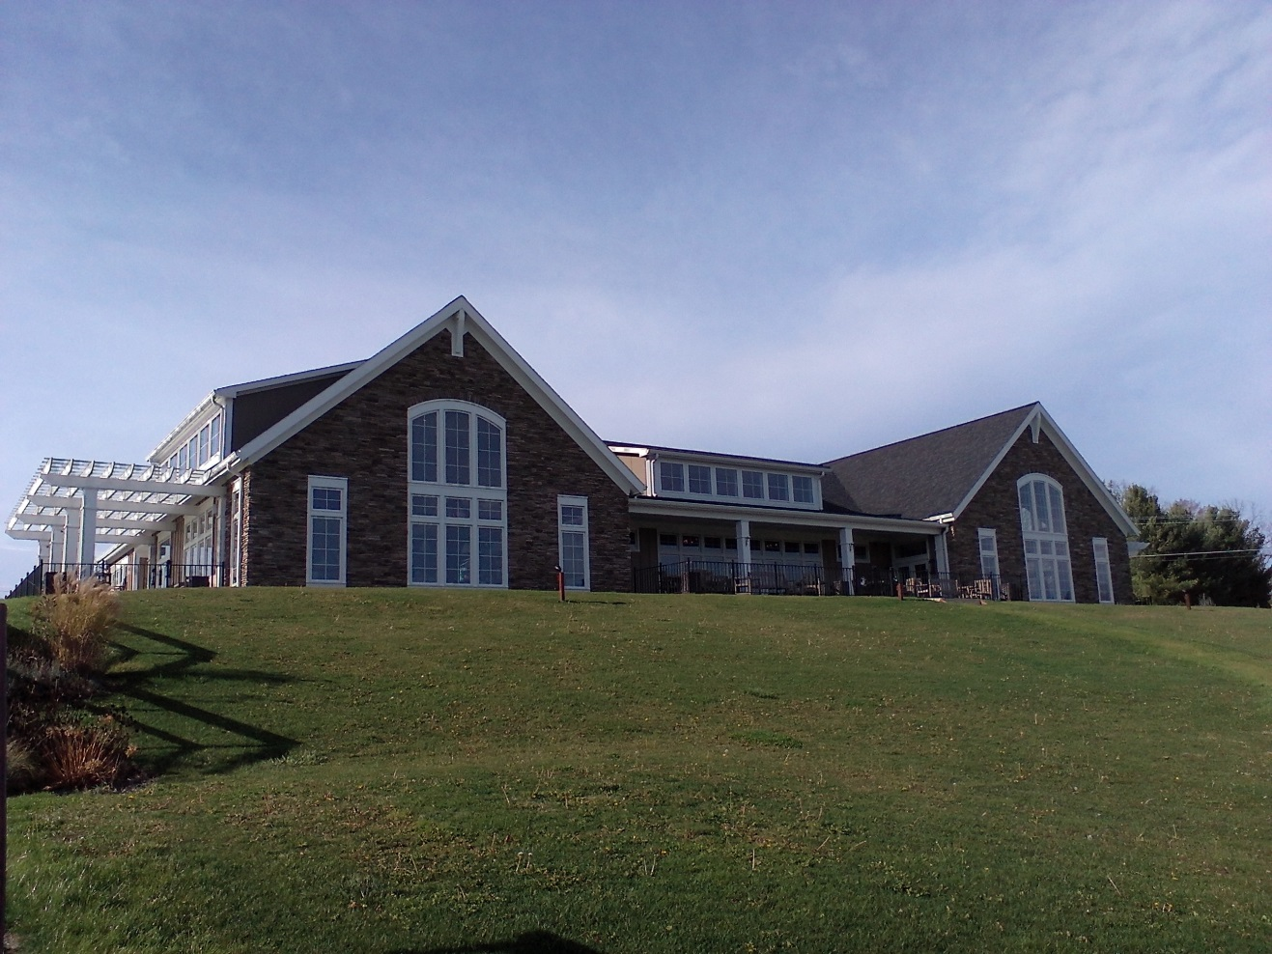

The Terrace

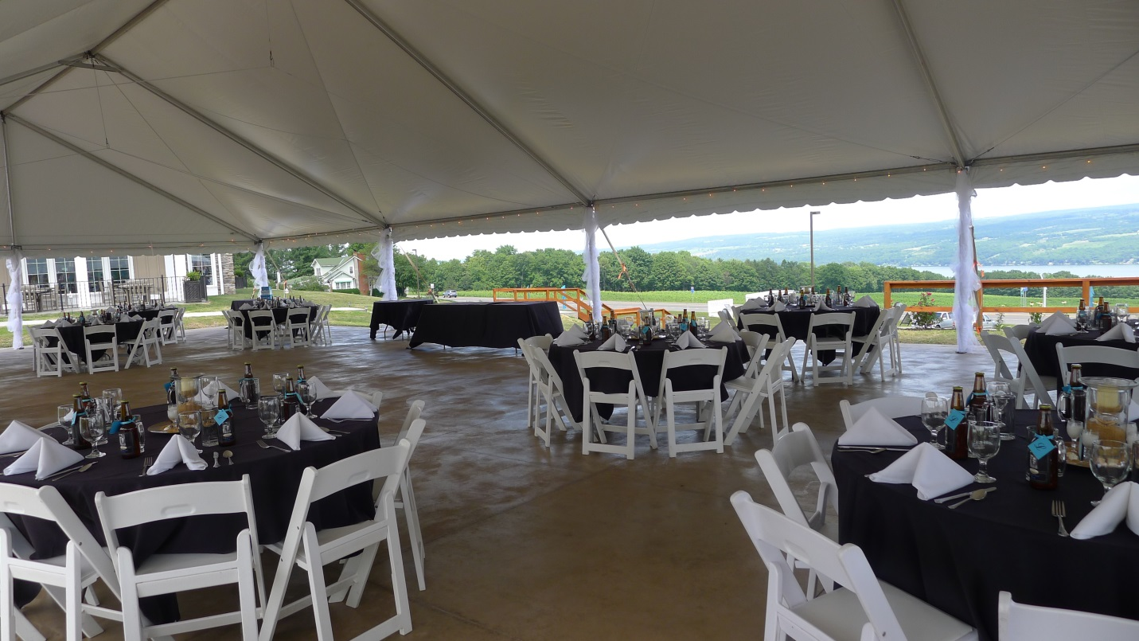

Starkey’s Lookout has just completed work on a gorgeous new event space in the summer of 2013, The Terrace, just south of our main building. The site, overlooking a breathtaking view of Seneca Lake, is the perfect spot to host a wedding. Our Terrace can accommodate up to 40’ X 80’ pole or frame tent.

Terrace Rental Pricing is as follows:

Saturday- $4,250 or $750/hour
Friday or Sunday- $3,250 or $550/hour

Included in the rental is as follows:

Starkey’s Lookout Professional Event Coordinator to help you Plan, Coordinate and execute your event
Professional Bartending Staff
An Employee available to greet guests and direct them to the reception area

Starkey’s Lookout will provide you with our professional catering team.
All other outside caterers with a valid catering license and insurance are acceptable for events.

Starkey’s Lookout is happy to provide a quote for tent, chairs and table rentals.

The Courtyard & North Tasting Room Weddings

Each bride and groom has their own idea of what they would like to happen on their special day and at Starkey’s Lookout, we are here to accommodate them! Well in advance of your day, you will enjoy a full wine and beer tasting. At that time, you will select a variety of wine and beer to be served at your wedding or event. If you are having small affair and light appetizers are desired or if the couple wants a more elaborate meal, we have Lake Country Catering who will design a catered event that will be just what you’ve dreamed. Our Event Coordinator is here to see that even the smallest detail isn’t overlooked.

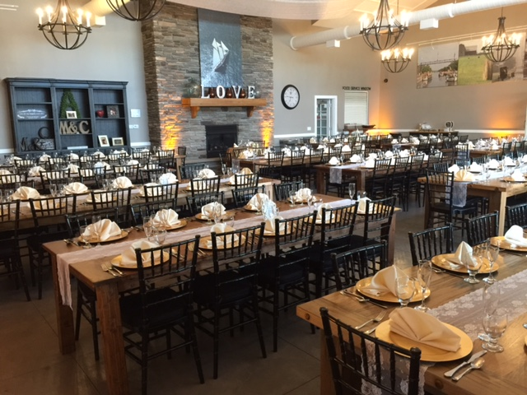

Inside Rental Pricing starting at (does NOT include holiday weekend pricing):

Monday-Thursday- $400 (North Tasting Room Only) (Mid November-April)
Monday-Thursday- $850 (Courtyard & North Tasting Room) (Mid November-April)
Saturday- $2,250 (Courtyard & North Tasting Room) (Mid November-April)
Friday or Sunday- $1,750 (Courtyard & North Tasting Room) (Mid November-April)
Front (Courtyard) Patio Addition (Optional) - $500

Monday-Thursday- $500 (North Tasting Room Only) (May-Mid November)
Monday-Thursday- $1100 (Courtyard & North Tasting Room) (May-Mid November)
Saturday- $3750 (Courtyard & North Tasting Room) (May-Mid November)
Friday or Sunday- $2750 (Courtyard & North Tasting Room) (May-Mid November)
Front (Courtyard) Patio Addition (Optional) - $500
Private Party Pricing

Here at Starkey’s we host many different private events; from baby showers to retirement party’s. Our Private Party’s run from 1-6 hours with 3 being our most popular. Below you will find a list of options for your private party.

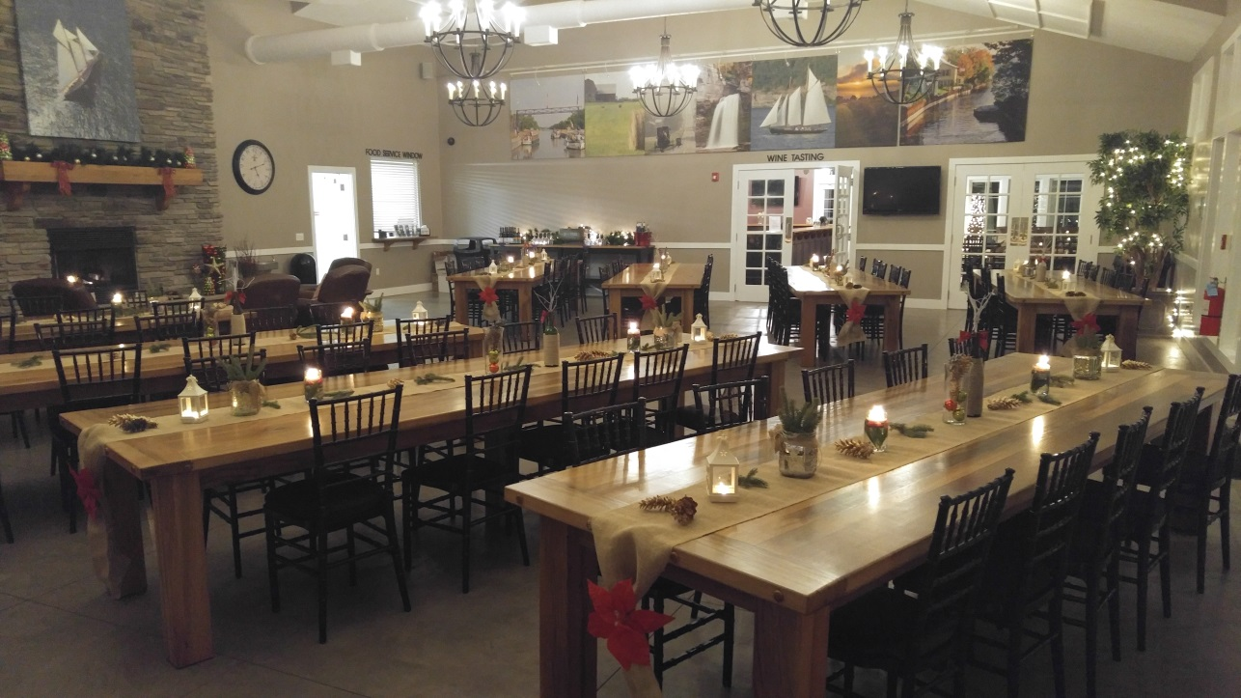

North Tasting Room (40 people max)
Mid November-April
Monday-Thursday- $100/hour
Saturday- $350/hour (3 hour minimum)
Friday or Sunday- $150/hour
May-October
Monday-Thursday- $125/hour
Saturday- $625/hour (3 hour minimum)
Friday or Sunday- $275

Courtyard & North Tasting
Mid November-April
Monday-Thursday- $150/hour
Saturday- $425/hour (3 hour minimum)
Friday or Sunday- $275/hour
May-October
Monday-Thursday- $200/hour
Saturday- $625/hour (3 hour minimum)
Friday or Sunday- $375/hour
All hourly events are priced at 5pm or later start time
Any other times will be adjusted

Ceremony

On your special day you will have the option of having your ceremony with us here at Starkey’s. Starkey’s Lookout offers inside seating for a ceremony up to 100 and outside up to 200 plus.

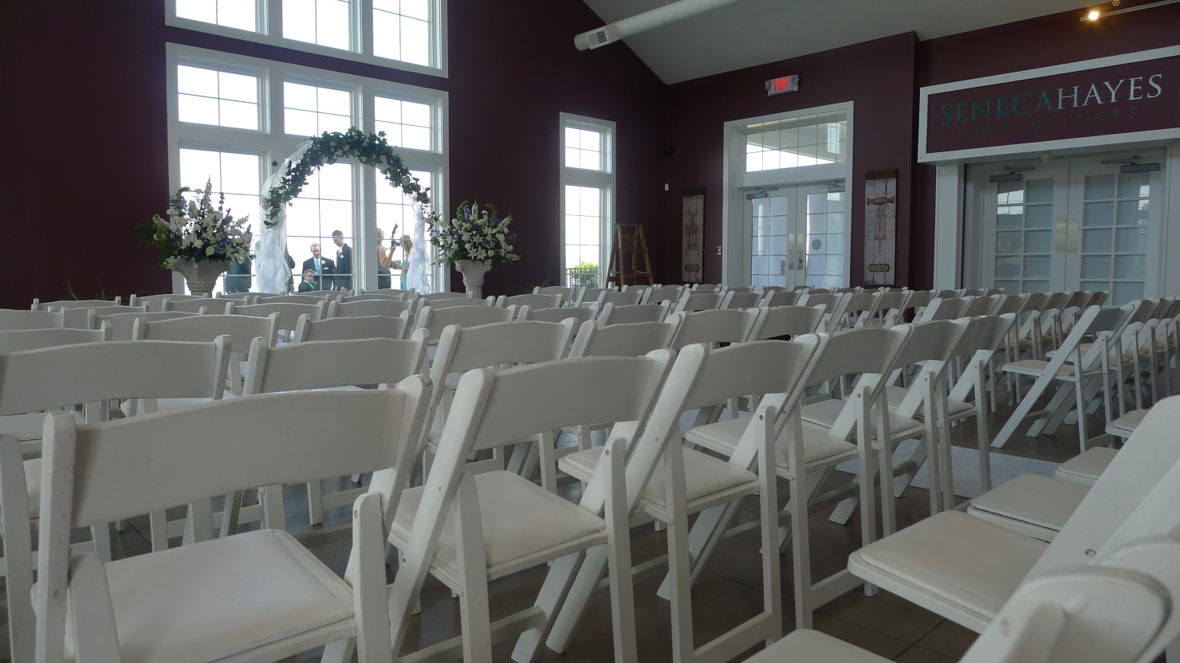

Ceremony Pricing (Does not include additional chairs or décor):

Inside North Tasting Room (Seating 100) - $500-$750
Outside Front Patio (Standing 120) (Some Seating) - $250-$500
Outside Terrace (Seating 200+) - $500-$750

Prices above are only if reception is with Starkey’s Lookout as well.

Beverage Packages

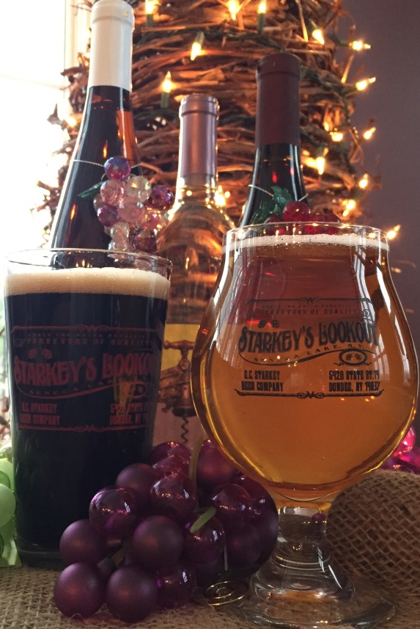

Consumption Bar Pricing ($200 bartender fee applies, per bartender for two hours):

Wine by the glass $6.00
Beer by the glass $5.00
Mixed Drinks (not provided) $5.00
Starkey’s Soft Drinks $4.00 each
Other Soft Drinks $2.00 each

Open Bar Pricing:

 | 1 Hour | 2 Hour | 3 Hour | 4 Hour | 5 Hour | 6 Hour
Beer & Wine | $10 Per Person | $14.50 Per Person | $18 Per Person | $22.50 Per Person | $26 Per Person | $30 Per Person

Beer & Wine Bar
Select 6 wines & 4 beers.

Wine Selection:

Dry, Semi-Dry:
~Dry Rosé ~Chardonnay ~Dry Riesling ~Riesling
~Riesling Gewurztraminer ~Whirling Dervish ~Cabernet Franc
~Pinot Noir ~Merlot ~Meritage ~Vertigo Red

Sweet:
~Twisted White ~Twisted Pink
~Twisted Red

Beer Selection:

~Pilsner ~Belgian White ~Margarita Wit
~Tangerine Wit ~Raspberry Wit (Seasonal)
~Pumpkin (Seasonal) ~Snickerdoodle (Seasonal)
~Scotch Ale ~Vanilla Porter ~Amber ~IPA

Craft Soda:

~Root Beer

Standard open bar and consumption based pricing includes: Your choice of any six Starkey’s Lookout wines, four Starkey’s Lookout craft beers and one Starkey’s Lookout craft soda. Ice water is always available. All tastings for wine & beer selection will be presented by a manager unless stated otherwise.

For Sparkling wines of champagne, a $7/bottle corkage fee will apply. For inquiries regarding outside liquor, a cash bar or any other special requests please contact our general manager.

Rentals
White Padded Chairs- $5.95 each

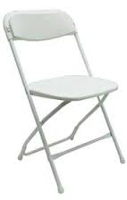
White Plastic- $2.50 each

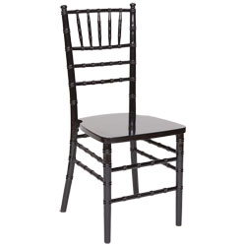
Chavari Chairs- $7.95 each

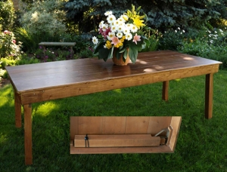
Farm Tables- $100 each

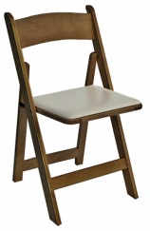
Fruitwood Padded Chairs- $5.95 each

All of the above items are optional extras
Delivery Fee Not Included!

