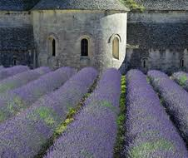
French Wine Dinner
Enjoy a selection of boutique wines from
the Rhone, paired with a 4 course dinner
created by
German Master Chef, Michael Ober

Menu
brie fondu avec baguette fraiche
et l’oignon et l’herbe de la confiture
-melted brie w/ fresh baguette-
onion & herb jam
DOMAINE LES PALLIERES AU PETIT BONHEUR ROSE 2015
*
quenelles de brochet a la nantua
avec legume a la nage
-pike dumplings in creamy crayfish sauce-
w/ blanched vegetables
ST COSME COTES DU RHONE BLANC 2015
*
grillades de boef a la moelle
avec haricot vert e gratin dauphinoise
-grilled beef steak w/ bone marrow-
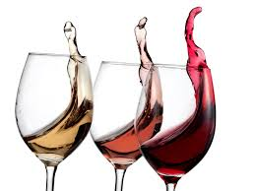
w/ fine green beans and gratin potatoes
DOM GARRIGUE VACQUEYRAS LA CANTARELLE 2014
*
tarte au chocolate
avec bleuet espuma
-chocolate tarte-
w/blueberry espuma
LA TOUR VIELLE BANYULS RIMAGE 2015
*

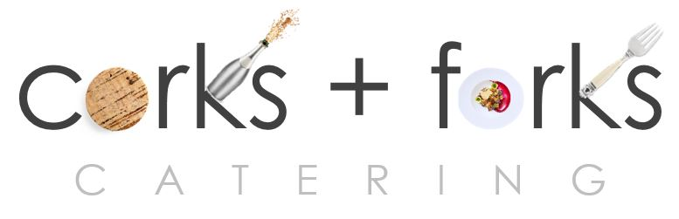

PO Box 8762 WPB FL 33407 PH: 561 339 2444
www.corksandforkscatering.com

