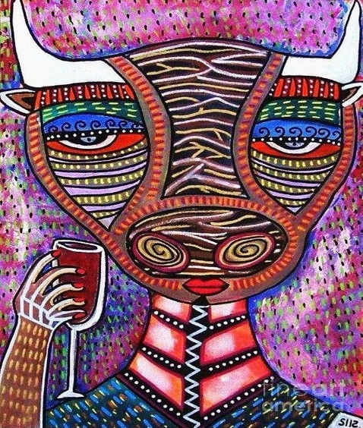
Spanish Wine Dinner
Enjoy a selection of boutique wines from Spain
paired with a 4 course dinner
created by German Master Chef Michael Ober

Menu
lobster salad
w/ orange filets & arugula
in naval orange vinaigrette
Juve y Camps Essential Xarello Brut 2013 – Catalonia
*

poached monkfish medallion
in lemon, saffron, caper jus
w/ shaved green asparagus
Vina Somoza Godello Sobre Lias 2013 - Galicia
*

crispy roast pork suckling
w/ vegetable medley &
baby potatoes in rioja
Finca Valpiedra Rioja Cantos de Valpiedra 2011 – Rioja
*
tarta de santiago
Spanish almond cake
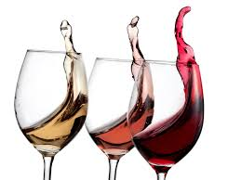
w/ flamed meringue
J Ordonez Moscatel Seleccion Especial #1 2012 – Malaga

PO Box 8762 WPB FL 33407 PH: 561 339 2444
www.corksandforkscatering.com

