Sunset Villages Event Venues
There are several venues on our property available to rent for your event. See below for further details.
Map Location | Name | Description | Max Capacity | 1 Hour Min Price | 3 Hour Price | Additional Hour Price
S1 | Lakeside Sunset Park | Gently sloping lakefront lawn with gazebo and beautiful lake view with mountain backdrop | 150 | $1000.00 | $4500.00 | $750.00
S2 | Sunset Dock | Floating 1350 sqft dock on Deep Creek Lake with mountain views | 125 | $1000.00 | $3750.00 | $1000.00
S4 | Sunset Village Park | Hillside lawn with beautiful view of lake and mountains | 500 | $9000.00 | $15000.00 | $2500.00
S5 | Mountain Sunset Retreat | Hillside lawn above Garrett County Fairgrounds | 300 | $3000.00 | $9000.00 | $2000.00
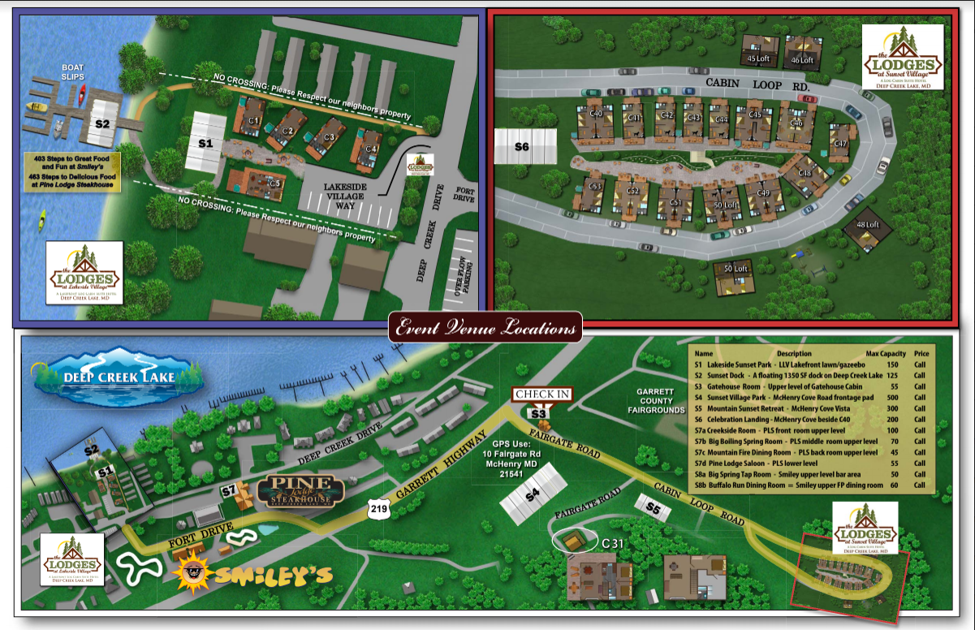
Amenities & Prices
The following is a list of amenities available for rent through The Lodges at Sunset Village and their prices. Prices are subject to change at any time.
Item | Price
30*45 Frame Tent (Lighted) Only available at S4 | $1000.00
Side Walls for 30*45 Tent | $250.00
30*75 Frame Tent (Lighted) Only available at S4 | $2000.00
Side Walls for 30*75 Tent | $500.00
Chandelier | $40.00
6 ft Table | $6.00/per unit
8 ft Table | $8.00/per unit
White Resin Chair | $3.00/per unit
Dance Floor | $250.00 - $500.00
Heater | $125.00/per unit
Fire Pit | $80.00/per unit
6 ft Tablecloth (White) | $3.50/per unit
6 ft Tablecloth (Color) | $4.50/per unit
8 ft Tablecloth (White) | $4.25/per unit
8ft Tablecloth (Color) | $5.00/per unit
13 ft Table Skirt | $8.00/per unit
17 ft Table Skirt | $10.00/per unit
21 ft Table Skirt | $12.00 per unit
Cloth Napkins (White) | $0.25/per unit
Cloth Napkins (Color) | $0.50/per unit

