Ca l l 8 4 7 - 4 3 4 - 1 1 4 4
Se H ab l a E sp an o l

Wedding Package

1 000 BUSSE ROA D
ELK GROV E V I LLA GE, I L 6 0007

Holiday Inn Chicago - Elk Grove

Ca l l 8 4 7 - 4 3 4 - 1 1 4 4
Se H ab l a E sp an o l

Woodfield Ballroom
Ca p a c i t y : u p t o 3 7 5 Gu e s t s Sq u a re F e e t : 4 , 5 5 9 sq . f t .

Woodfield A & B
Ca p a c i t y : u p t o 1 8 5 Gu e s t s A Sq u a re F e e t : 2 , 1 1 5 sq . f t . B Sq u a re F e e t : 2 , 4 4 4 sq . f t .

Village
Ca p a c i t y : u p t o 7 5 Gu e s t s Sq u a re F e e t : 9 5 2 sq . f t .

Elk
Ca p a c i t y : u p t o 5 5 Gu e s t s Sq u a re F e e t : 1 , 03 4 sq . f t .

Grove
Ca p a c i t y : u p t o 4 5 Gu e s t s Sq u a re F e e t : 8 3 6 sq . f t .

1 000 BUSSE ROA D
ELK GROV E V I LLA GE, I L 6 0007
Pri ces are subj ect to 2 2 % Servi ce Charge and A ppl i cabl e State T ax

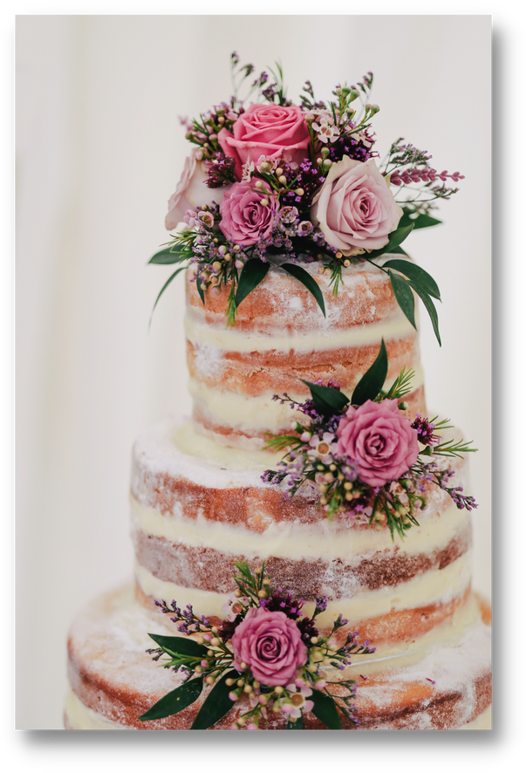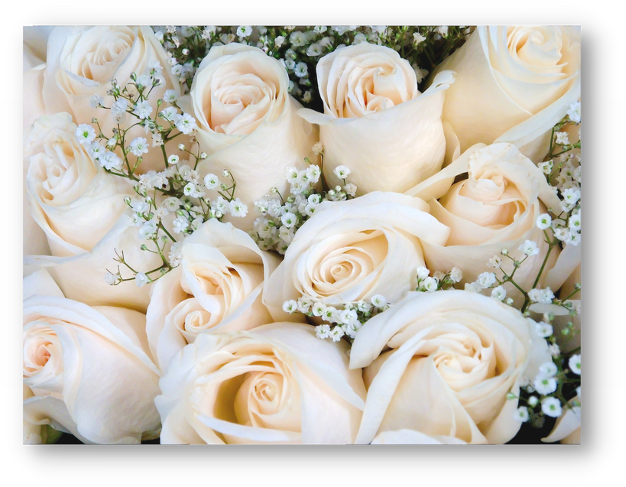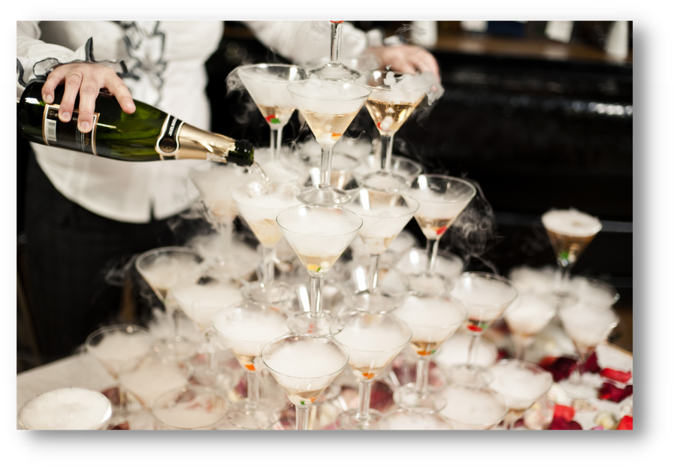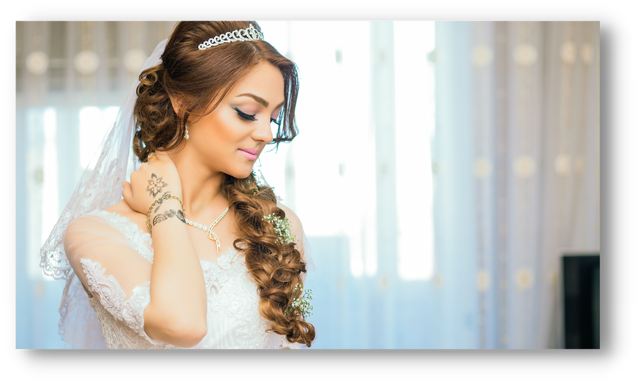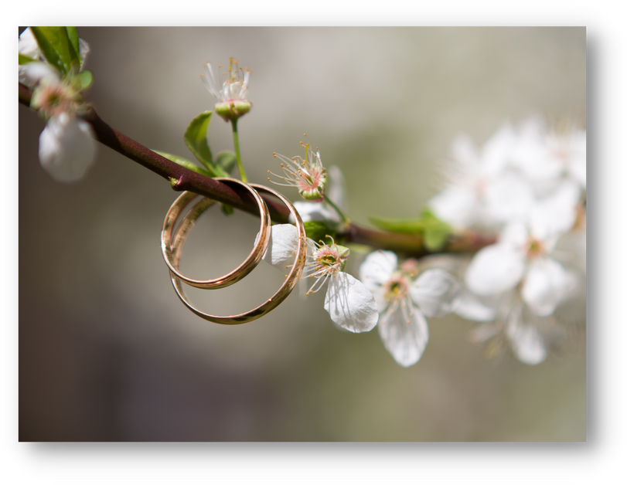Ceremonies

Ce re m o n y Ch a rg e s ta rti n g a t
$ 5 00 . 00

A m e n i t i e s : R o o m R e n ta l
S e t U p a n d B re a k d o w n o f a l l Ch a i rs
Co m p l i m e n ta ry S u i te fo r B r i d e Co m p l i m e n ta ry 1 h o u r o f re h e a rs a l t i m e

1 000 BUSSE ROA D
ELK GROV E V I LLA GE, I L 6 0007

Dates, Deposits, & Cancellations

A l l D a te s a re tre a te d o n a f i rs t co m e , f i rs t s e rv e b a s i s . T o s e cu re y o u r d a te , a s i g n e d co n tra ct a n d d e p o s i t a re

re q u i re d .
W o o d f i e l d B a l l ro o m : $ 1 , 000 W o o d f i e l d A & B : $ 5 00

A 5 0 % d e p o s i t i s re q u i re d h a l fw a y b e tw e e n th e b o o k i n g d a te a n d th e d a te o f th e fu n cti o n .

A l l deposits are non refundable.

A 5 0 % d e p o s i t i s re q u i re d h a l fw a y b e tw e e n th e b o o k i n g d a te a n d th e d a te o f th e fu n cti o n .
Minimums
Y o u r Ca te r i n g S a l e s Ma n a g e r w i l l b e a b l e to g i v e y o u th e fo o d a n d b e v e ra g e m i n i m u m fo r y o u r s p e c i f i c d a te .

Menu Selection and Pricing
A w e d d i n g ta s t i n g d i n n e r w i l l b e s ch e d u l e d a cco rd i n g to y o u r e v e n t d a te . A l o n g w i th th a t d i n n e r , a p e rs o n a l i z e d co n s u l ta t i o n w i l l b e a rra n g e d w i th i n tw o w e e k s a fte r to d e te rm i n e y o u r m e n u a n d o th e r d e ta i l s . P r i ce s a re g u a ra n te e d 3 m o n th s p r i o r to e v e n t d a te . A l l fo o d a n d b e v e ra g e p r i ce s s u b j e ct to 2 2 % s e rv i ce ch a rg e a n d a l l a p p l i ca b l e s a l e s ta x . Final Planning
A f i n a l p l a n n i n g m e e t i n g w i l l b e s ch e d u l e d n o l e s s th a n 1 4 d a y s p r i o r to y o u r re ce p t i o n . A t th i s m e e t i n g y o u r f l o o r p l a n , co n f i rm e d re ce p t i o n d e ta i l s , f i n a l g u a ra n te e d co u n t a n d p a y m e n t a re d u e . On e W e e k b e fo re y o u r re ce p t i o n y o u m a y d ro p o ff a n y i te m s a s d i s cu s s e d th a t w i l l n e e d to b e p l a ce d i n th e ro o m b e fo re y o u r a rri v a l .

A current credit card wi l l be required to be on f i l e should any i ncidentals be i ncurred the n i ght of the reception.

1 000 BUSSE ROA D
ELK GROV E V I LLA GE, I L 6 0007
Pri ces are subj ect to 2 2 % Servi ce Charge and A ppl i cabl e State T ax

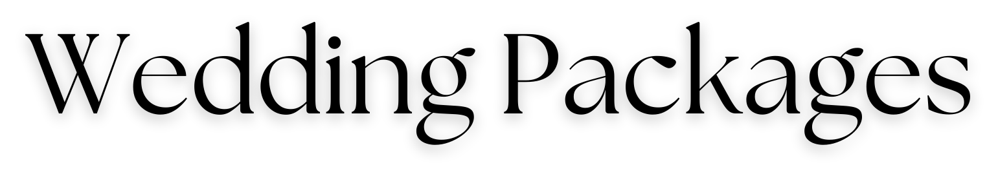

I n c l u d e s : Y o u r o w n p r i v a t e w e d d i n g re ce p t i o n ro o m , h e a d t a b l e , ca k e t a b l e , g i f t t a b l e , D J t a b l e , p l a ce ca rd t a b l e , d a n ce f l o o r , s t a n d a rd ce n t e rp i e ce w i t h m i r ro r b a se a n d t w o v o t i v e ca n d l e s , co ffe e s t a t i o n a f t e r d i n n e r w i t h fre sh l y b re w e d co ffe e . Co m p l i m e n t a ry t a s t i n g fo r t w o . D e l u x e ro o m w i t h ch a m p a g n e a n d b re a k fa s t t h e fo l l o w i n g m o rn i n g fo r t h e B r i d e a n d Gro o m .

Gold Package

F i v e - a n d - a - h a l f- h o u r re ce p t i o n t i m e i n c l u d i n g
F o u r h o u r s o f o p e n g o l d b ra n d sp i r i t s a n d a fo u r - co u r se m e n u I v o ry l i n e n s w i t h y o u r ch o i ce o f n a p k i n co l o r
T h re e - p i e ce b u t l e r s t y l e p a sse d h o r s d ' o e u v re s Ch a m p a g n e t o a s t fo r a l l g u e s t s W i n e w i t h d i n n e r Cu s t o m W e d d i n g ca k e

Platinum Package

F i v e - a n d - a - h a l f- h o u r re ce p t i o n t i m e i n c l u d i n g
F o u r h o u r s o f o p e n p l a t i n u m b ra n d sp i r i t s a n d a fo u r - co u r se m e n u Y o u r ch o i ce o f ch a i r co v e r a n d sa sh co l o r w i t h m a t ch i n g t a b l e
ru n n e r I v o ry l i n e n s
T h re e - p i e ce b u t l e r s t y l e p a sse d h o r s d ' o e u v re s Ch a m p a g n e t o a s t fo r a l l g u e s t s
W i n e w i t h d i n n e r Cu s t o m w e d d i n g ca k e
Sw e e t t a b l e t o co m p l i m e n t t h e co ffe e s t a t i o n

1 000 BUSSE ROA D
ELK GROV E V I LLA GE, I L 6 0007
Pri ces are subj ect to 2 2 % Servi ce Charge and A ppl i cabl e State T ax

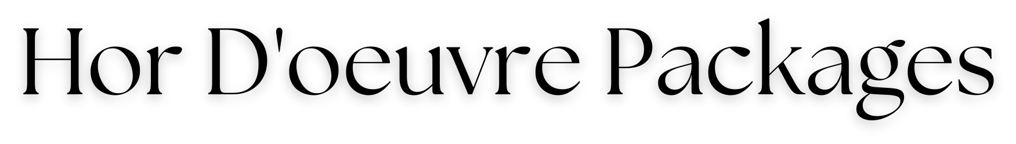
Gold and Platinum Packages include a Three-piece Chef's Selection of Hor D'oeuvres

Additional Available
3 Pieces Per Person $6.00

Coconut Shrimp Florentine Stuffed Mushrooms
Stuffed Wonton Toasted Ravioli
Meatballs - BBQ or Sweet & Sour Mini Deep-Dish Pizza Chicken Quesadilla
Mini Quiche Spinach Roulades Bruschetta

Also Available

Per 100 pieces

Ice Gulf Shrimp | $215.00
BBQ Ribs | $135.00
Chicken Wings | $125.00
Mini Crab Cakes | $150.00
Bruschetta | $100.00

1 000 BUSSE ROA D
ELK GROV E V I LLA GE, I L 6 0007
Pri ces are subj ect to 2 2 % Servi ce Charge and A ppl i cabl e State T ax

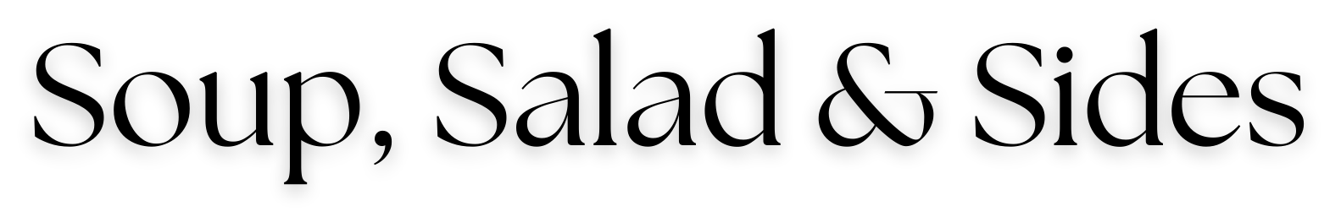

Choice of One

Soup Minestrone Chicken Orzo
Cream of Broccoli Cream of Chicken Fruit Cup $2.00

Salad

Caesar Salad
Spinach Salad with Bacon Dressing
Tossed Garden Salad with Choice of Two Dressings

Starch
Rice Pilaf Double Baked Potatoes Roasted Bliss Potatoes
Garlic Whipped Potatoes

Vegetable Asparagus Spears Zucchini and Squash
Garlic Green Beans Steamed Mixed Vegetables

1 000 BUSSE ROA D
ELK GROV E V I LLA GE, I L 6 0007
Pri ces are subj ect to 2 2 % Servi ce Charge and A ppl i cabl e State T ax

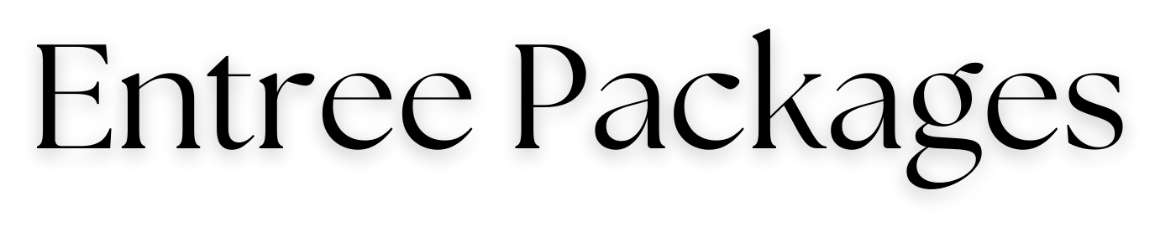

 | Gold | Platinum
Filet Mignon and Atlantic Salmon | $73.00 | $88.00
Filet Mignon and Grilled Shrimp | $70.00 | $85.00
Filet Mignon and Chicken | $66.00 | $80.00
Filet Mignon and Bearnaise Sauce | $70.00 | $85.00
Roast Prime Rib of Beef Au Jus | $68.00 | $83.00
Herb Marinated Atlantic Salmon with Lemon Butter | $64 .00 | $79.00
Roasted Sirloin of Beef au Jus | $60.00 | $83.00
Spinach Artichoke Chicken | $58.00 | $73.00
Caribbean Tilapia with Tropical Fruit Salsa | $57.00 | $72.00
Airline Chicken with Brandy Cream Sauce  Chicken Breast with Champagne Sauce | $60.00  $60.00 | $75.00  $75.00
Vegetarian Option  Pasta Primavera  Portobello Mushroom Napoleon  Vegetable Lasagna | $57.00  $57.00  $57.00 | $74.00  $74.00  $74.00
Children's Options  Spaghetti with Marinara Sauce | $24.00 | $24.00
Crispy Chicken Tenders with Fries | $24.00 | $24.00

1 000 BUSSE ROA D
ELK GROV E V I LLA GE, I L 6 0007
Pri ces are subj ect to 2 2 % Servi ce Charge and A ppl i cabl e State T ax

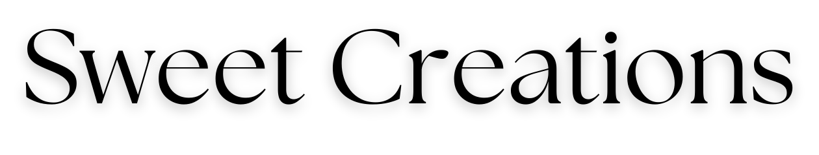

Deluxe Coffee Station
$4.00 Per Guest

Freshly Brewed Regular & Decaffeinated Coffees Selection of Fine Teas
Cinnamon Sticks, Chocolate Shavings, Whipped Cream

The Grand Deluxe
$7.00 Per Guest

;The Deluxe Coffee Station

A Variety of Assorted Pastries that May Include: Fresh Fruit Tarts, Cannoli, Eclairs, Mini Cheesecakes, Carrot Cakes, Petit Fours, Brownies,
Cream Puffs and Napoleons

The Extra Sensational
$9.00 Per Guest

;The Deluxe Coffee Station

A Variety of Assorted Pastries that May Include: Fresh Fruit Tarts, Cannoli, Eclairs, Mini Cheesecakes, Carrot Cakes, Petit Fours, Brownies,
Cream Puffs and Napoleons
Fresh Fruit Display and Chocolate covered Strawberries

1 000 BUSSE ROA D
ELK GROV E V I LLA GE, I L 6 0007
Pri ces are subj ect to 2 2 % Servi ce Charge and A ppl i cabl e State T ax

