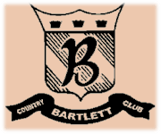
Bartlett Country Club
Hors D’Oeuvres Stations

Caesar Salad Station $6 Per Person Traditional Caesar Salad tossed with Garlic Croutons, Fresh Ground Pepper and Shaved Parmesan
Italian Bread Sticks
Compliments:
- Sliced Grilled Chicken
- Sautéed Shrimp

Taste of Tuscany Pasta Station $7 Per person Choice of Two Pasta:
- Cheese Tortellini
- Rigatoni
- Penne Pasta
- Rainbow Bowtie Pasta
Choice of Two Sauces:
- Marinara
- Creamy Alfredo
- Pesto Sauce
- Bolognese
Choice of Two Compliments:
- Meatballs
- Italian Sausage
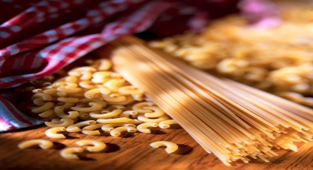
- Sliced Grilled Chicken
Bartlett Country Club
Hors D’Oeuvres Stations

Scallops and Shrimp Station $12 Per Person Jumbo Shrimp and Scallops
Sautéed with Garlic, Tomatoes, Shallots, White Wine Sauce, and Pesto Cream Sauce
Served with Jasmine Rice

Raw Bar Runs Market Price Littleneck Clams on the Half Shell
Oysters on the Half Shell
Chilled Jumbo Gulf Shrimp
Cocktail Sauce and Garlic Aïoli

