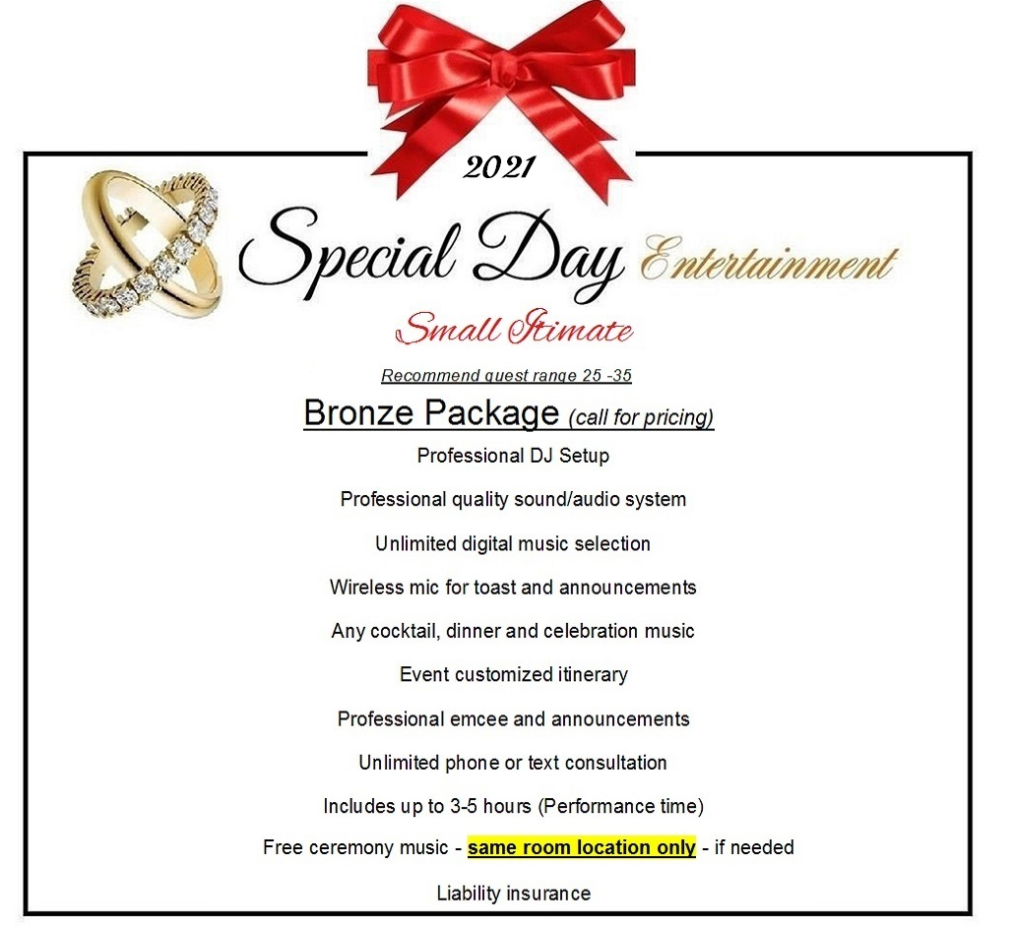

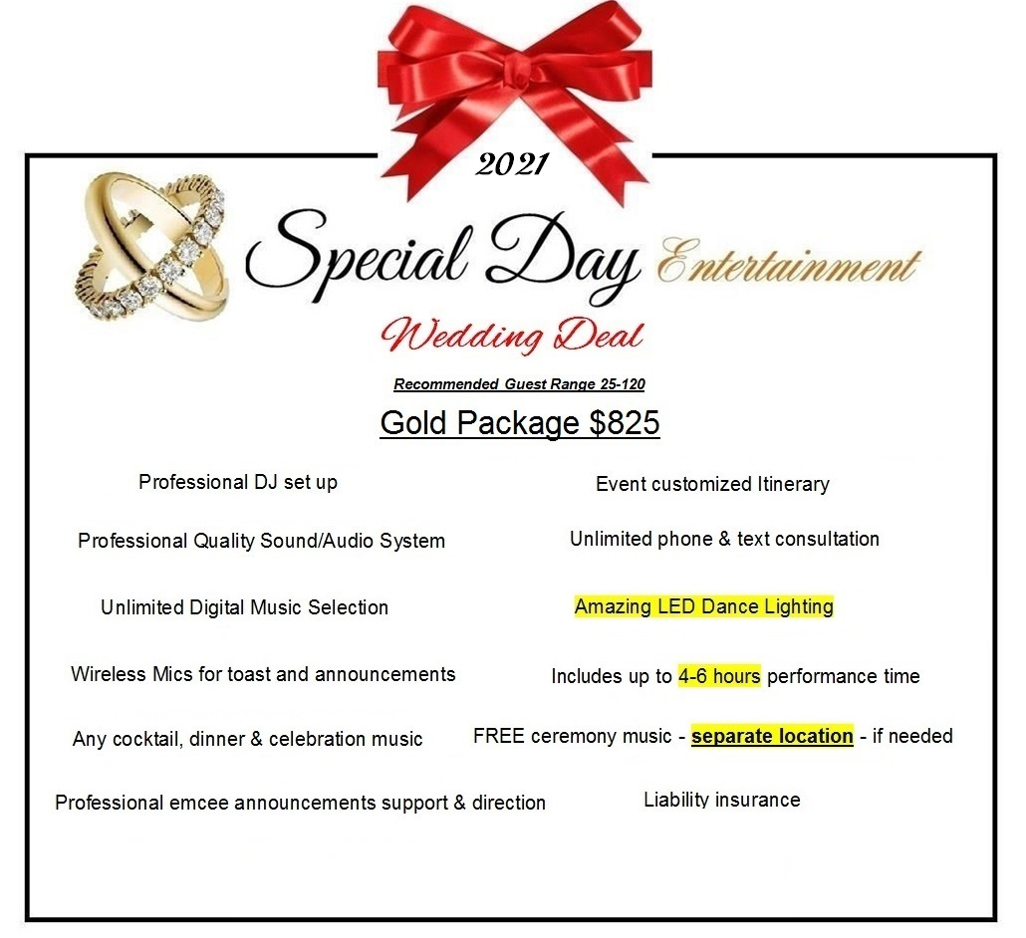

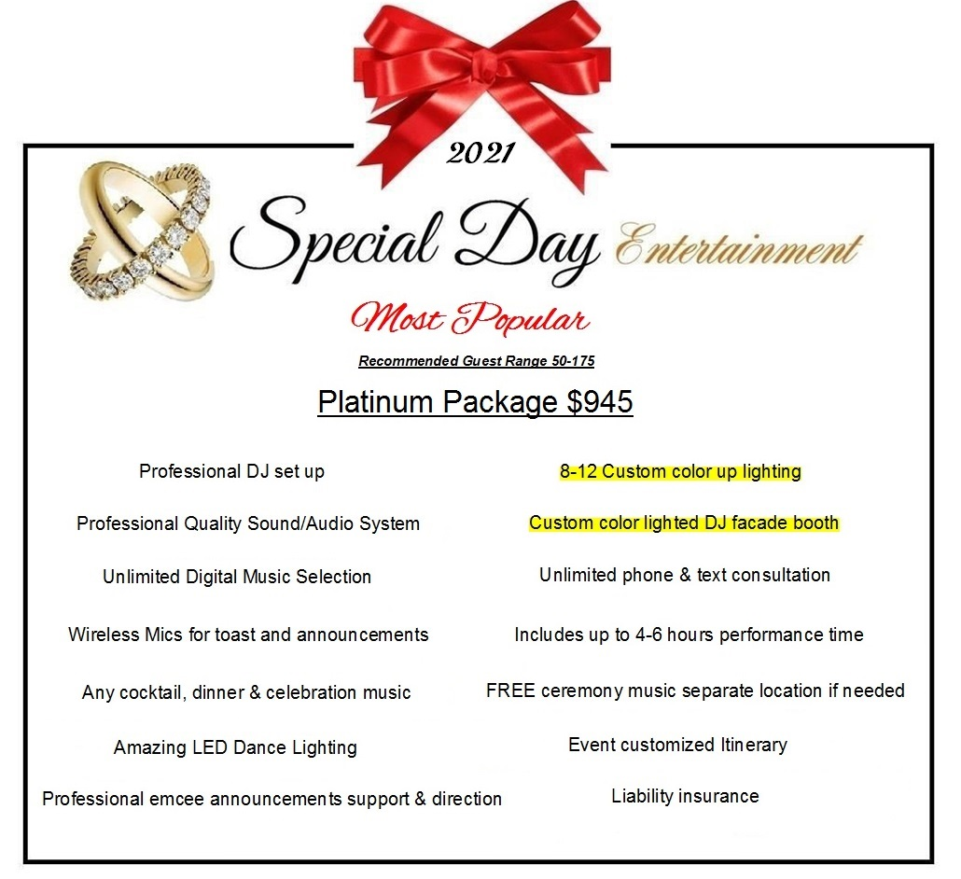

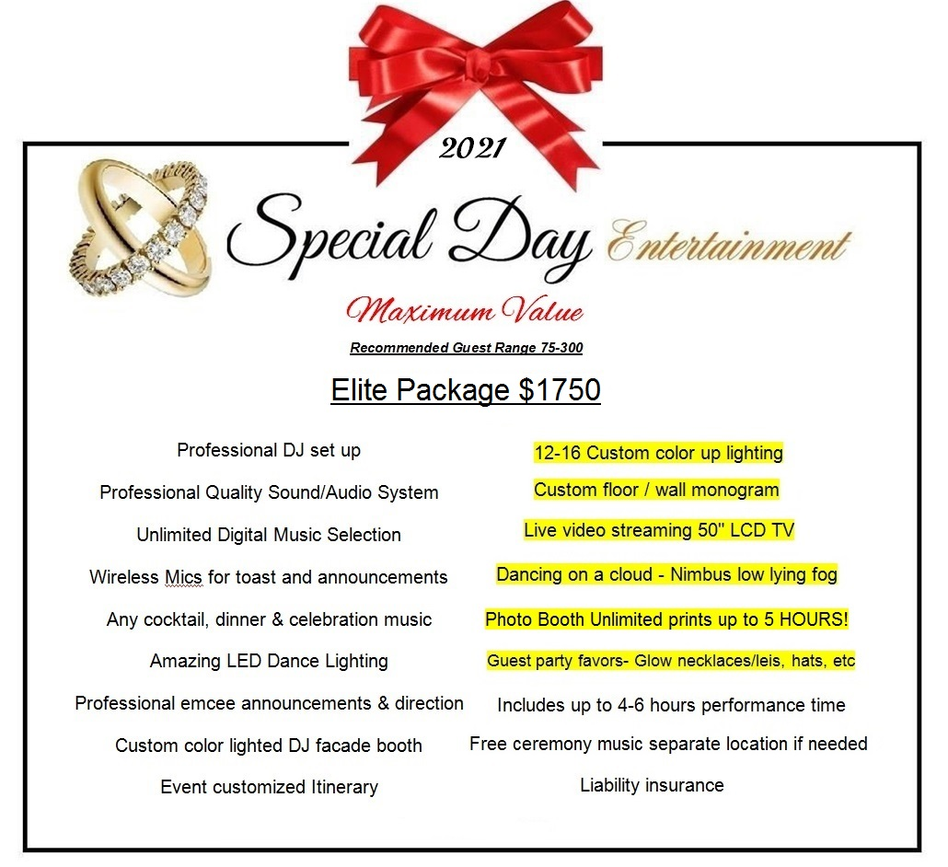

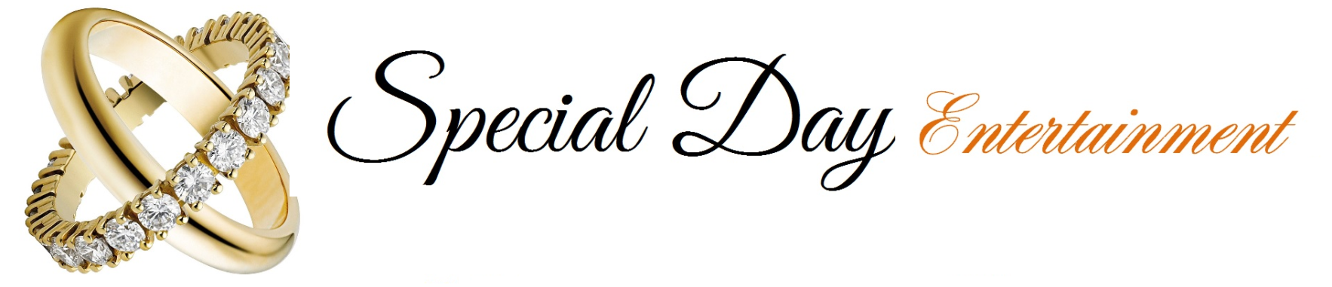
Zap Shot Photography $225  Zap Shots have proven to be the next "must have" at your event. A new popular service our clients enjoy. Zap Shots are Digital Photos taken by our photographer, taking candid photos throughout your event and almost instantly putting them up on our 50" LED TV screens.  Guests love to see themselves up on the TV Screen. After the zap shot slide show, the TV screen becomes high quality wireless in real time streaming for all to watch live! After the event you will receive all of the photos emailed or on a USB drive. Zap Shots add a GREAT touch to your special day! | 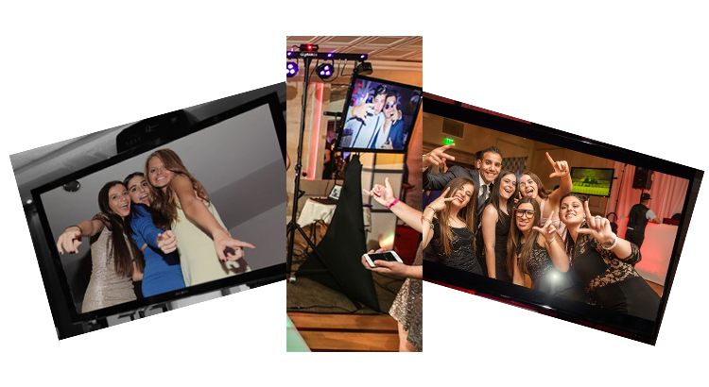

Custom Monogram $185

Special Day Entertainment can customize any North Florida event with the creation and projection of a custom monogram. Take your event to the next level by displaying a custom monogram for your special day.

After this monogram is created, Special Day Entertainment will project the monogram on the dance floor or wall of your venue. Here are some examples of the custom monograms we created.

Dancing on a Cloud $145

Special Day Entertainment has the unique ability to create the perfect atmosphere for a couples first dance. Special Day Entertainment uses low fog to create this magical illusion at any indoor venue in North Florida.

Beautiful first dance pictures to treasure a life time!

Uplighting $25ea

Special Day Entertainment offers the best quality up-lighting in North Florida. We provide custom-color choices for any indoor/outdoor venue. Up-lighting is essential to any atmosphere that a DJ creates. Make your special day venue light up with class!

Photo Booth $475

Special Day Entertainment has partnered up with Jan Spisar Photography and Photo Booth LLC a professional photo booth company to add to our exclusive packages!
Jan Spisar Photography and Photo Booths mission is to provide our Florida clients and their guests with a professional and highly entertaining photo booth experience that they will be able to walk away with and rave about long after the event is over. Make the experience something that you and your guests will remember forever. Let our professionalism and knack for fun be a part of your next event giving you one less detail to worry about."

