Bartlett Country Club
Plated Dinner Options
Poultry Selections
New Orleans Stuffed Chicken Breast $18
with Andouille Sausage and Cajun Pomodoro Sauce
Chicken Normady with Mushrooms and Sundried Tomato $17
Demi-Glace
Grilled Cider Basted Chicken with a Cider Reduction Sauce $17
Italian Baked Chicken Bruschetta $17
French Chicken Breast $17
Long Island Duck with Fig and Balsamic Compote $24

Seafood Selections
Blackened Mahi Mahi with Sweet Thai Chili Sauce $22
Martini Salmon $23
Italian Haddock Bruschetta $18
Red Snapper with Citrus Beurr Blanc $26
Grilled Ahi Tuna Steak $26
Broiled Lobster Tail with Fresh Lemon Butter Market
Crab Stuffed filet of Sole Vin Blanc $21
Italian Baked Shrimp Scampi $22

Meat Selections
Filet of Sirloin $22
Roasted Prime Rib of Beef $25
Filet Mignon with Zinfindel Demi-Glace $32
Filet Mignon with Wild Mushroom Sauce $33
Montreal Crusted Pork Loin with Dijon Demi- Glace $18
Grilled Cider Basted Pork Medallions with Cider Reduction $19
Petite Filet with Two Baked Stuffed Shrimp $30
Petite Filet with Herb Marinated Chicken $27
Rack of Lamb with Fig Compote $32
12 oz.NY Strip with Rosemary Demi-Glace $27

All Selections are Three Course and Priced Per Person
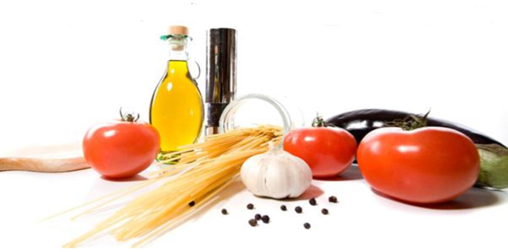
Selections are limited to two Entrees plus a Vegetarian
All Pricing is subjet to 8% NY Sales Tax ang 19% Gratuity

