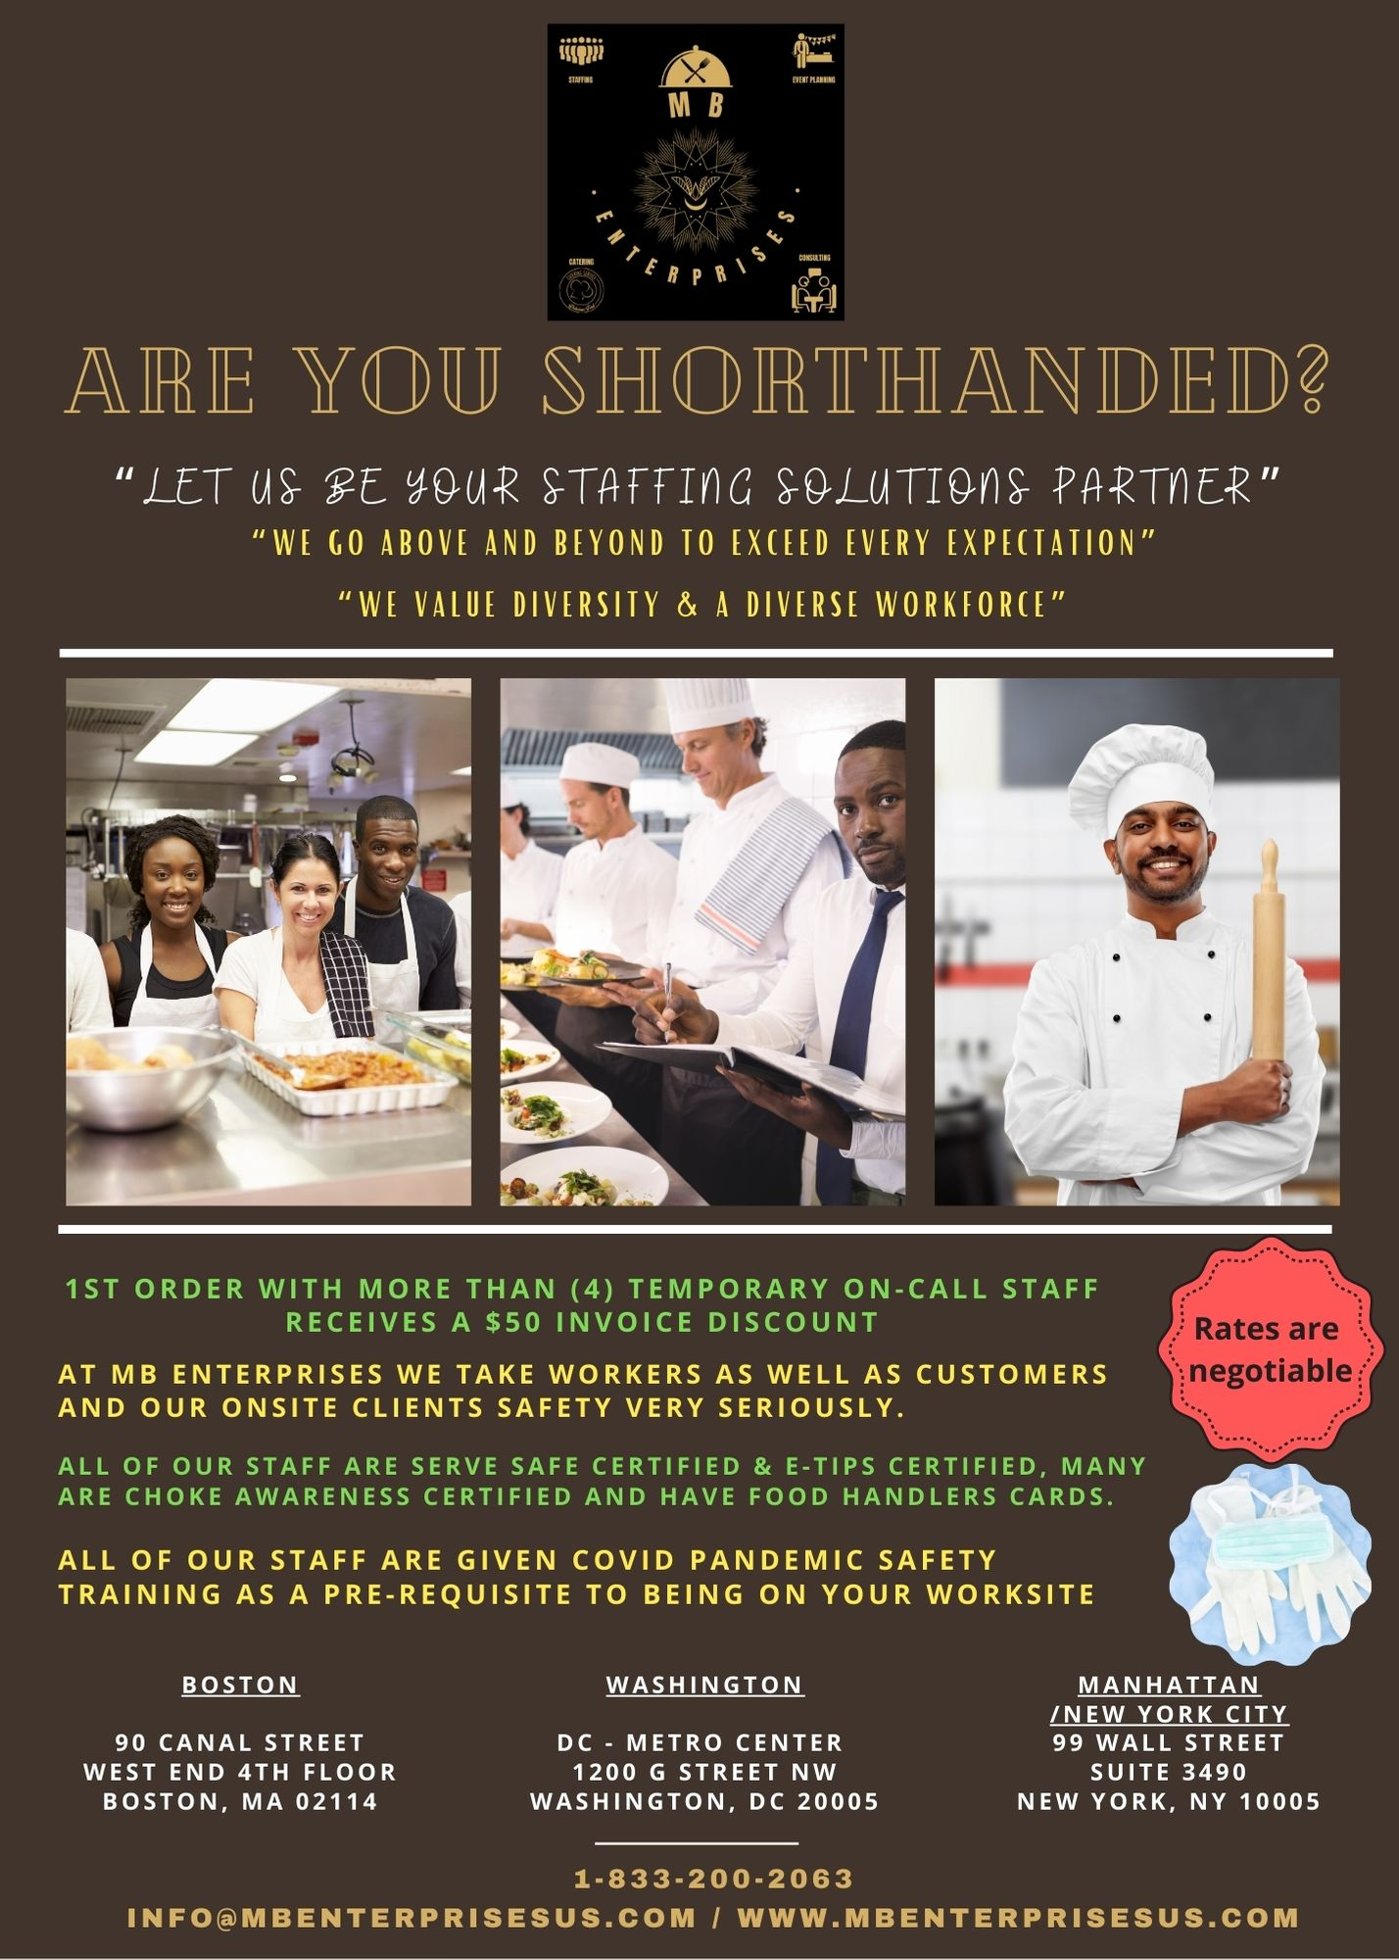

To: Whom it may concern,

MB Enterprises wants to thank you for your interest in our staff for your Event & Catering needs.

At MB Enterprises, we pride ourselves in placing the finest service people in the industry. Each one of our staff has been extensively interviewed and chosen based on experience, efficiency and friendliness. We will provide your guests with the most gracious and caring service possible.

Our staff are now trained to understand all COVID Protocols and procedures and will fallow all state and city ordered mandates to the letter.

We now work with Goodhire.com so we make sure that we will only place with you on long term assignments only the following:

- On-call temporary or temporary to permanent placements that have been fully background checked
- On-call temporary or temporary to permanent placements that have been fully referenced checked
- On-call temporary or temporary to permanent placements that have been fully drug tested to include testing for marijuana
- On-call temporary or temporary to permanent placements that have been fully SORI checked
- On-call temporary or temporary to permanent placements that have been fully CORI checked

What makes “MB Enterprises Staffing Division” unique?

- We are a quality driven company. How we treat our staff impacts how they perform on your events. We realize that people that work for us are our most important commodity. We appreciate their hard work and without them we cannot be successful.
- Our staff are educated and fluent in English. We look for people that are warm, affable, and trustworthy.
- We have a service-training program. We recognized that there are several service levels. Staff are constantly trained and evaluated, and paid accordingly. Training and paying people well helps us retain excellent staff and ensure quality in service.
- We have staffing coordinators available to return calls within 4hrs or less of our regular business hours. Our staffing coordinators are experienced servers and bartenders and event & party planners that understand the business and can help you determine staffing numbers and staffing levels.
- We customize our business to meet your expectations. Every client is unique and has different needs. It is our job to ask the right questions so we can identify the people best people suited to work your event. To us staffing is an art.
- We take great pride in our staff. Each and every staff member is hired based on great references, high performance level of service, trustworthiness and interview results.

A summary of our per-hour rates and services:

Chef $39
Server $29
Bartender $29
Event Manager $39
Cook $27
Utility $25
Executive Chef $49
Chef $39
Sous-Chef $36
Garde Manager $34
Kitchen Manager $39
Kitchen Supervisor $34
Line Servers $27
Line Cooks $29
Prep-Cooks $28
Dishwashers $25
Utility Staff $25

The final cost will be based on the hours each staff works. Volume discounts on the rates could be negotiated. All staffing requests must have sufficient notice. MB Enterprises reserves the right to charge 20% more per hour for any (24) hours or less notice. We spend considerable time and at considerable cost selecting from our in-house database or recruiting what you will need for your establishment so sufficient notice is expected and requested.
All staffing orders will only be filled with a 50% deposit charged upon a signed contract and an official order for the staffing. The balance will be due and charged to your cc on file following the event. We always will follow up prior to billing your cc on file to make sure you were 100% satisfied and that MB Enterprises “Exceeded your expectations”
We thank you for your patronage and look forward to serving you.

Respectfully,

Michael Burris
Founder / President
1-833-200-2063

Hours of Operation

Monday and Tuesday 9 am – 9 pm
Wednesday – Friday 9 am – 11 pm
Saturday & Sunday 10 am -4 pm

After hours and Emergencies call:
1-833-200-2063
Policies

FIRST AND FOREMOST: We aim to accommodate you and will create a plan and relationship based on your specific needs! We are a solutions provider in staffing. We are here to help you solve some of your most complex and challenging staffing needs. We are resourceful. We have (35) plus years of relationships with various entities and we know how to meet the challenge. Staffing is our Love and we are passionate about it.

Our Coverage Insurance: MB Enterprises carries full insurance coverage. Limits of $2,000,000 General Liability—Workers Compensation and Liquor $2,000,000 are covered. A certificate of insurance will be furnished when requested.

Credit Cards: MasterCard, Visa and Amex and checks are accepted.

Gratuities: Most people ask what’s an appropriate ‘tip’ for each staff person. Specifically, since our staff usually exceeds our client’s expectations gratuities typically begin at 20% of the hourly rate charged. This is only a guideline and your gratuity to individual staff should solely be based on your expectations.

Ethics Agreement: You agree to hire “MB Staff” personnel only through “MB Enterprises” and will not attempt to employ any staff person directly.

Cancellation Fee: A $50 cancellation fee will be charged per staff person if the cancellation occurs two (2) days or less on non-holiday bookings and a $100 cancellation fee will be charged per staff person if the cancellation occurs (2) days or less on holiday bookings.

From time to time our prospective clients ask for referrals from our customers in their town. Please let us know if you prefer not to be included on this list.

Should you have any questions or constructive criticisms regarding this information, please contact us directly. I appreciate your support and look forward to serving you.
New York City
Brooklyn Fort Greene
99 Wall Street
New York, NY 10005
Boston
90 Canal Street
West End, 4th Floor
Boston, MA 02114

