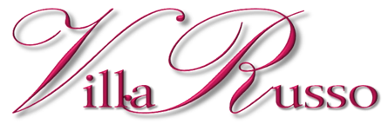
Traditional Buffet (4 Hour Affair)
Champagne March
Our Staff’s Special Presentation of the toast.

Salad
Choice of one for your guests

Classic Caesar Salad  Crispy romaine lettuce tossed in Villa Russo’s classic Caesar dressing topped with croutons | Tricolor Salad  A mix of mescaline, arugula, and radicchio served with a balsamic vinaigrette dressing | Italian Mix  Fresh lettuce, vine ripened tomatoes, cucumber, and olives tossed in a vinegar and olive oil dressing

Pasta
Choice of one for your guests

Ziti Marinara  Tomato sauce seasoned with fresh Italian Spices | Rigatoni Filetto Di Pomodoro  Tomato with sautéed prosciutto and onions | Rotelle Machiate  Tomato sauce with olive oil and garlic | Penne Alla Vodka  Tomato sauce seasoned with prosciutto, heavy cream and a dash of Vodka
Buffet Table
Eight Items

Linguini with Garlic and Oil  Al dente pasta topped with olives, garlic and walnuts. | Mussels  Cultivated mussels steamed with garlic in a marinara sauce | Italian Mixed Salad  Mixed greens with plum tomatoes and cucumber seasoned with balsamic vinaigrette | Spare Ribs  Roasted pork ribs glazed in a duck sauce
Chicken Scarpariello  Oven roasted chicken with Italian seasonings | Roasted Center Cut Pork Loin  Served with granny smith apples served with a bed of rice | Stuffed Artichoke Oreganata  Seasoned artichokes  topped with bread crumbs | Eggplant Rollatini  Eggplant lightly breaded and fried. Stuffed with ricotta cheese and topped with marinara sauce and romano cheese
Includes:
Unlimited carafes of red and white wine, draft beer and soda

