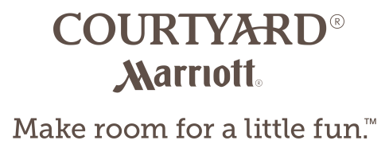
Bronze Wedding Package
Punch, Dinner, Décor $52.00
- Fruit Punch Display with Glasses
- 4 Course Dinner (Rolls & Salad, Pasta, Entrée, Dessert, Coffee & Tea)
- Courtyard Sheer Backdrop with Up-lighting (Available Full Ballroom)
- Courtyard Centerpieces, Table Numbers, Money Box and White Floor Length Linens
- Chair Covers
- Cash Bar or Host Consumption Bars Options Available
- Room Rental Fee Waived, Minimum Package 50 Guests

Silver Wedding Package
Punch, Appetizers, Dinner, Full Décor, Table Wine, Late Night Service $67.00
- Fruit Punch Display with Glasses & Chef’s Selection Hand Passed Appetizers
- 4 Course Dinner (Rolls & Salad, Pasta, Entrée, Dessert, Coffee & Tea)
- Courtyard Sheer Backdrop with Up-lighting (Available Full Ballroom)
- Courtyard Centerpieces, Table Numbers, Money Box and White Floor Length Linens
- Chair Covers with Colour Coordinated Sash or Table Runner
- 2 Bottles Wine/Table & Late Night Buffet
- Cash Bar or Host Consumption Bars Options Available
- Room Rental Waived, Minimum Package 50 Guests

Full Wedding Package
Punch, Appetizers, Dinner, Full Décor, Table Wine, 6 Hour Host Bar, Late Night Service $97.00
- Fruit Punch Display with Glasses & Chef’s Selection Hand Passed Appetizers
- 4 Course Dinner (Rolls & Salad, Pasta, Entrée, Dessert, Coffee & Tea)
- Courtyard Sheer Backdrop with Up Lighting (Available Full Ballroom)
- Courtyard Centerpieces, Table Numbers, Money Box and White Floor Length Linens
- Chair Covers with Color Coordinated Sash or Table Runner
- 2 Bottles of Wine/Table
- 6 Hour Host Bar
- Late Night Buffet
- Room Rental Waived, Minimum Package 50 Guests
- Complimentary Guestroom for the Bride and Groom

Ceremony
With In-house Wedding Reception $600.00 / Without an In-house Wedding Reception $1100.00Outdoor Garden Ceremony set in an Intimate Garden Courtyard, for Vows & Pictures

