Host an Event
Kitchen Sync caters to Weddings, corporate and private events. We can help consult with caterers, rentals and décor vendors. We work closely with you to curate special events, meetings and cooking classes.
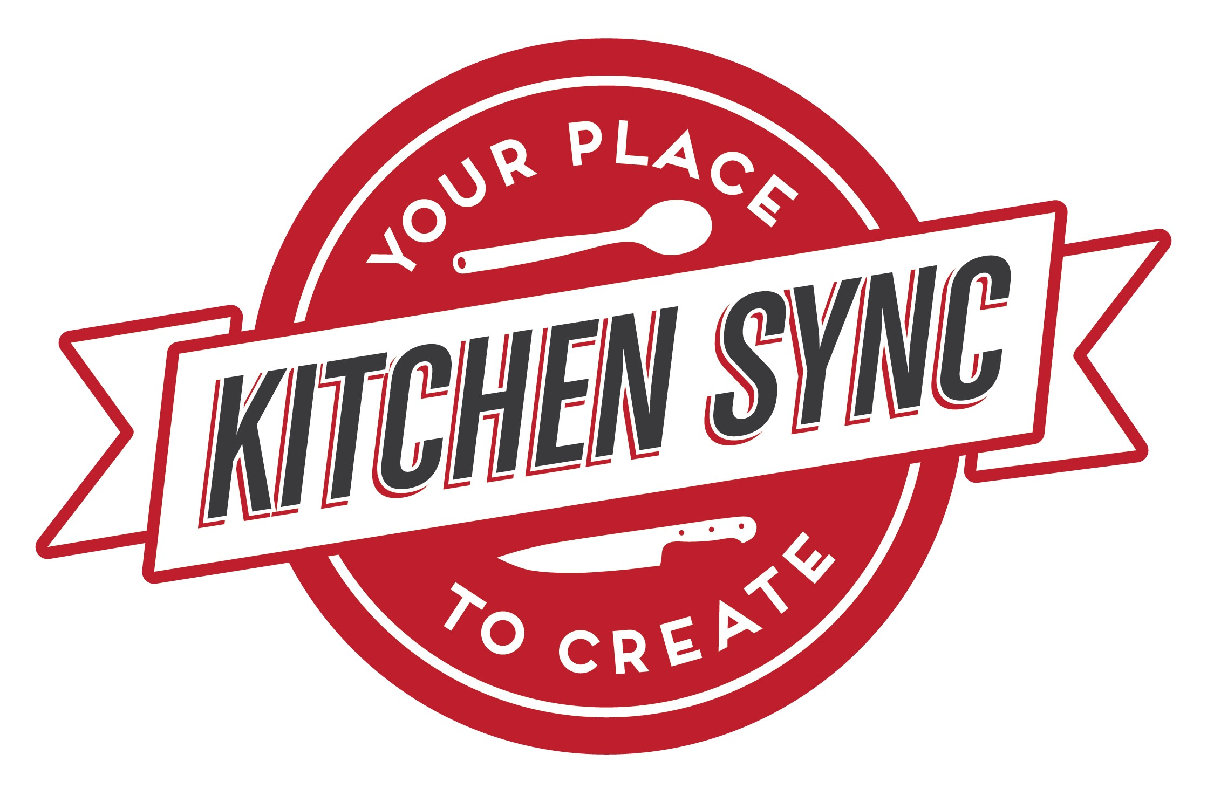
Kitchen Sync is your space to create a private and unique event in the heart of Winnipeg. We work closely with our clients to create memorable and personalized events. We host weddings, birthday parties, cooking classes, meetings and corporate events – our favourite part is working with our clients to curate something their guests will remember. You can watch your vision come to life through our full service event consultation and planning or use our raw space rentals for a more hands-on experience.
We have hosted some of Winnipeg’s most discerning events. From client dinners, intimate weddings or a nightclub style birthday party, it’s your space to create, the sky's the limit.
Our passion is building beautiful events. We invite you to share your vision and help you bring it to life.
Packages:

Essential
Venue rental: Sunday – Thursday $500, Friday and Saturday $750,
Holiday $750 bookings include;
Consultation up to ½ hour
Private room for up to 6 hours
Client set up (event day)
Caterer set up
Basic bar service includes glassware, mix, ice and garnishes

Premium
Venue rental: Sunday – Thursday $750, Friday and Saturday $1000,
Holidays $1000
Booking includes;
Consultation 1 hour
Vendor coordination / receiving 1 hour
Private room for up to 6 hours
Client set up (event day)
Caterer set up (event day)
Basic decor available
PA system, apple music playlists
Basic bar service plus one feature hand-crafted cocktail / mocktail

Elite
Venue rental: Sunday – Thursday $1000, Friday and Saturday $1500,
Holidays $1500
Private room for up to 6 hours
Event curation and consultation/ 2 hours
Vendor coordination / receiving 2 hours
Rental drop off the day prior
Assisted set up and tear down, next day tear down available Basic decor available.
PA system , Apple playlists
Premium bar service plus 2 feature hand-crafted cocktails / mocktails 1 additional beverage server.

Additions to your package
Ceremonies prior to 4PM |  | $500 max 2 hours
Consultations |  | $75 per hour
Vendor coordination / receiving |  | $50 per vendor
Morning teardown / pick up |  | $150 max 2 hour
Set up day prior if available |  | $150.00 max 2 hours
Bartender and serving staff |  | $25 per hour
Coat check |  | $20 per hour each staff
Photo sessions |  | $125 per hour
Podium |  | $150
PA system and microphone |  | $75
Cake plating  Vases and tea lights  Patio lights |  | $2.50 per person  $2 per  $25
Linens |  | varies with table size, will quote

What you need to know
- Kitchen Sync is licensed for 100 people which includes all staff and vendors. We have room for up to 60 for seated events.
- Bookings are confirmed with a deposit equal to the venue rental fee pre-tax. This is a non-refundable deposit. It is transferable to a new date if changes 90 days out.
- Final number of guests must be confirmed 10 days from your booking.

- All beverages are provided by Kitchen Sync. Mocktails $4, coffee, tea, juice and soda are $2 each.
Beer 355ml and Spirits 1 ounce are cost + $3 and wine is cost +$15 750ml. for example wine cost is $14.99 + $15= $39.99

- Minimum of $750 in bar sales is required with bookings. When the minimum is not met the difference will be added to the room rental.
- Kitchen Sync welcomes professional, insured caterers for your events. All food served must come from a licensed kitchen. Caterers are responsible for all things food service, they need to arrive with their servers, dishware, cutlery and anything else they need to serve the food. The kitchen will be cleaned and sanitized on arrival and they must leave it in the same condition. All garbage and food must be removed. Caterers accept all liability for the food they prepare and serve.
- Full payment is required at the conclusion of your event, visa, MC, Debit and e-transfers accepted.
- Kitchen Sync has a dining room liquor license, all alcohol must be purchased served by Kitchen Sync staff and in accordance with the LCGA . Food must be served at event with alcohol.
- To respect our neighbours above last call is 11:30 PM with all guests leaving by 12 AM.
- Kitchen Sync assumes no responsibility for lost or damaged property. Anything brought in for your event must be taken out with you. Next day pick up can be arranged in advance for a fee.

