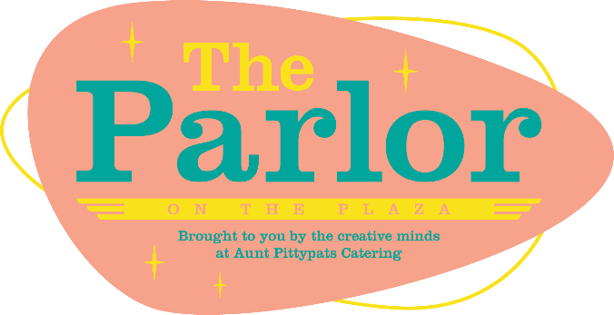
The Parlor on the Plaza
1738 NW 16th Street

405.942.4000 – booking & information

Jared Robinson – Venue Manager - 405.763.9513 - tours

RENTAL FEES are charged at $200/hour with a 3 hour minimum - we suggest that you allow for a minimum of 30 minutes to an hour on the front and back end depending on how much you will need to bring in for the event regarding decor, alcohol, etc. Amenities information can be found on our website at www.theparlorontheplaza.com
Outside catering is allowed with proof of licensing & insurance and we charge a $250 outside catering fee. Aunt Pittypat's Catering is the preferred caterer - no fee. There is a $500 food & beverage minimum required. You can find menus at www.auntpittypatscatering.com/menu.html to help get you started.
You are allowed to bring in your own alcohol - liquor, wine, and/or beer - mixers if you would like to do this. We do offer a mixer/fruit garnish package at $1.50 per person. We do require that you use our bartender ($24/hour based on the length of the event + set up & breakdown time). There will be a $1/head liability fee, and cups & napkins can and are provided at $1 per person. We will provide all equipment needed for serving & Ice.
We do offer bar packages if you would prefer to not have to bring in your own, www.auntpittypatscatering.com/bar-services.html lists tiers & pricing. We also offer the option of a cash bar, there is a sales minimum based on your head count. ($7/per person)
The PHOTOBOOTH on site is available for rental at $100/hour. If you would prefer to not use this, the door to the room will just stay closed.
Our seasonal FIREPIT (October-April) is available. If you would like to utilize it for your event, there is just a $50 propane charge.
Parking - The Plaza District has limited parking spots up and down 16th street, but there are several parking lots throughout (adjacent from The Parlor is a parking lot across from Empire, there is a parking lot across from lyric theatre & next to Oak & Oar - both of these are free. There is a PAID parking lot at NW 15th & Blackwelder ($5 I believe) & then there is unlimited parking up and down the neighborhood streets.
Please let us know if you would like to set up a time to tour the event space, and we can get that set up. If you would like to investigate using our catering option, we would be happy to discuss what you might be interested in. We will look forward to talking to you soon!

