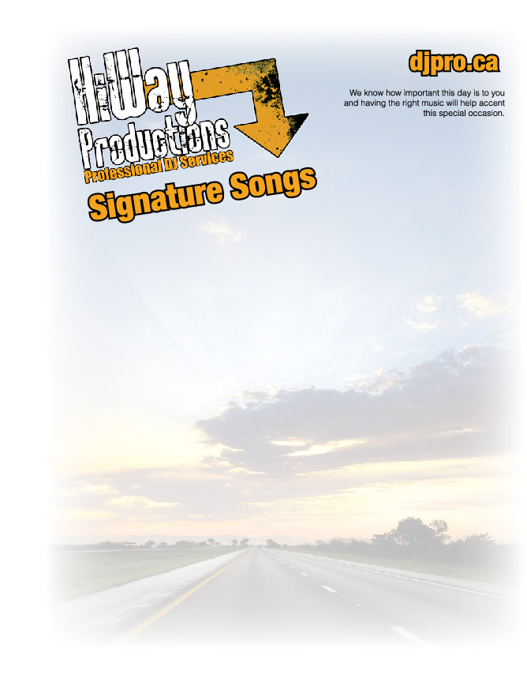

Wedding Day
Bride and Groom
Venue
Start Time Finish Time
Cocktail Music Style
Dinner music Type
Grand Entrance
Cake Cutting
First Dance
Father Daughter
Mother Son
Bouquet Toss
Garter Toss
10 songs you love
Slide show
Games
MC name

