2023-24 Wedding and Special Event Packages
Prices quoted are date based (off-season, in-season)
In-Season is May 1 through October 31
*Full Building Rental Required In-Season Friday, Saturday, Sunday and Holidays
** Holiday Premium +$1,100

Whole Building Off Season – In Season
Monday through Thursday $6,000 - $6,600
Friday and Sunday 8,600 – 9,400
Saturday 9,400 – 10,300
Included with Package:
⭐️Exclusive access to venue
⭐️Ceremony Room with Patio and Arbor ⭐️Ballroom with Patio and Bistro Lighting
⭐️Surrounding Grounds for Exterior Photography
⭐️One Hour Rehearsal
⭐️Bridal and Groom Suites
⭐️Tables and Chairs
⭐️Setup and Takedown
⭐️Audio Visual Equipment
⭐️Accent Lighting in Ballroom
⭐️Lanterns / Easels
⭐️Catering Prep Space (includes ice machine and refrigerators)
⭐️In-House Coordinator (venue detailing, 3D layout creation, coordination of vendors, wedding day timeline, venue supervision)
⭐️Free Parking
⭐️8 Hour Time Block
NOTE: Day of Liability Policy Required for All Events

Enhanced Experience and Décor Items Available
Ceiling Décor Packages – Draping and Chandelier Options
Lighted Backdrop
⭐️ Additional Hours ⭐️Day of Bridal Package
⭐️ Rehearsal and Ceremony Coordination ⭐️ Wedding Day Management Package
Linen Package (over 70 colors to choose from)
Engagement Photography Site Session

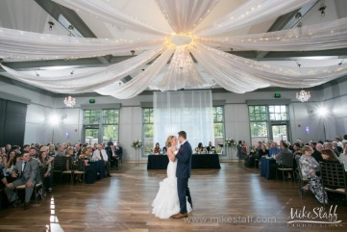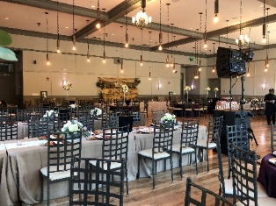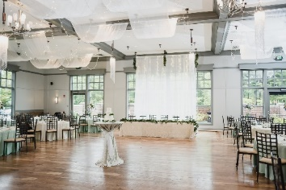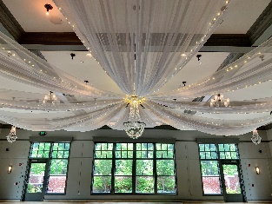
Photos Left to Right:
⭐️ Spoke Ceiling with Traditional Chandelier ⭐️ Edison Bulbs ⭐️
⭐️ Draped Organza and Lighted Backdrop ⭐️ Spoke with Tillie Chandeliers ⭐️

Passionate About Your Exceptional Experiences!
2023 Small Event Packages
Elopements, Graduations, Showers, and Special Events
Not available for Weddings and Receptions
Sunday or Week Day Only
In-Season is May 1 through October 31
*Full Building Rental Required In-Season Friday, Saturday and Holidays
** Holiday Premium +$1,100

*Large Half / Ballroom, 47’ x 65’ (3,044 sf)
or
*Small Half / East Suite 20’ x 40’ (800 sf), Executive Suite 20’ x 40’ (800 sf), Ceremony Room 36’ x 61 (2,196 sf)

Six Hour Block, up to 100 people $3,500*
Each additional Hour $500 per hour
**Full Building Rental Required In-Season Fridays, Saturdays, Sundays and Holidays

Included with Package:
⭐️ Tables and Chairs
⭐️Linens
⭐️ Setup and Takedown
⭐️ Audio Visual Equipment
⭐️ Catering Prep Space (includes ice machine and refrigerators)
⭐️Client Experience Experts
⭐️ Free Parking
NOTE: Day of Liability Policy Required for All Events

Enhanced Experience and Décor Items Available
Ceiling Décor Packages
Lighted Backdrop

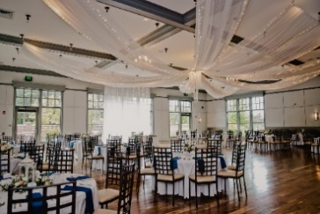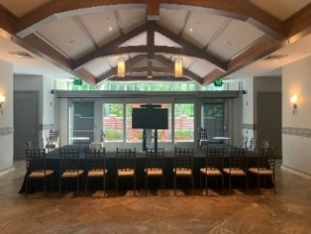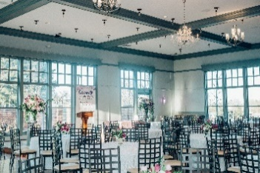

Passionate About Your Exceptional Experience!

2023 Corporate Event Packages
☆ Board Meetings ☆ Sales ☆ Trainings ☆ Seminars ☆ Professional Retreats ☆
☆ Conferences ☆ Awards Dinners ☆ Holiday Parties ☆

Week Days - Monday thru Thursday
*Full Building Rental Required In-Season Friday, Saturday and Holidays
In-Season is May 1 through October 31

Included:

✔️ Free Parking
✔️ High Speed Wifi
✔️ Tables & Chairs
✔️ Black & White Linens for Groups Less than 50
✔️ Podiums & Easels
✔️ Stage (Ballroom only)
✔️ AV .... microphones and in-house sound, flat screen TV's (monitors), Bose 5.1 surround sound speaker
✔️ Set up and break down of all 2Gather items
✔️ Room Resets
✔️ Catering Prep Space (includes ice machine, refrigerator, and sink)
✔️ Experienced On-Site Coordinator

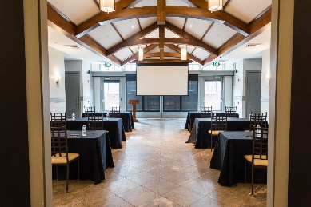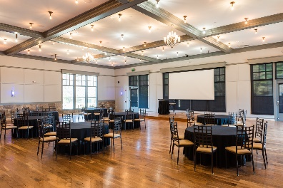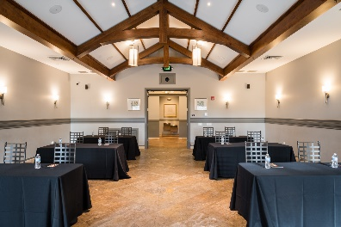

Passionate About Your Exceptional Experience!

