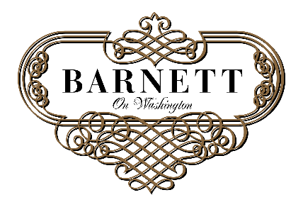

2016 Evening Event Rates
Evening Event
Low Season (Jan, Feb, Mar, Jul, Aug, Nov)
- Sunday – Thursday $2,000
- Friday $2,500
- Saturday $3,000

Evening Event
High season (Apr, May, June, Sept, Oct, Dec)
- Sunday – Thursday $2,500
- Friday $3,000
- Saturday $3,500

Rates Include:
- 4 Hour Event Space Rental ($350/additional hour)
- Event Coordinator
- All Tables and Chairs
- In-House Sound System
- Access to Barnett Room (Cigar Lounge)
- Access to Barnett Patio (weather permitting)
- Valet Parking for up to 150 guests for 4 hours ($125/additional hour)
- On-Site Security

