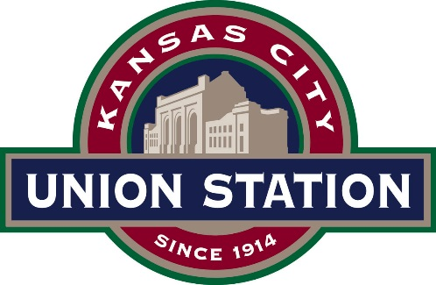
Grand Plaza … ……… …………………..$10,000
*Up to 8 hours. Rental rates are not available by the hour. Events must conclude by 11 p.m.
*Non-Profit Rate- 20% discount.
Corporate Events
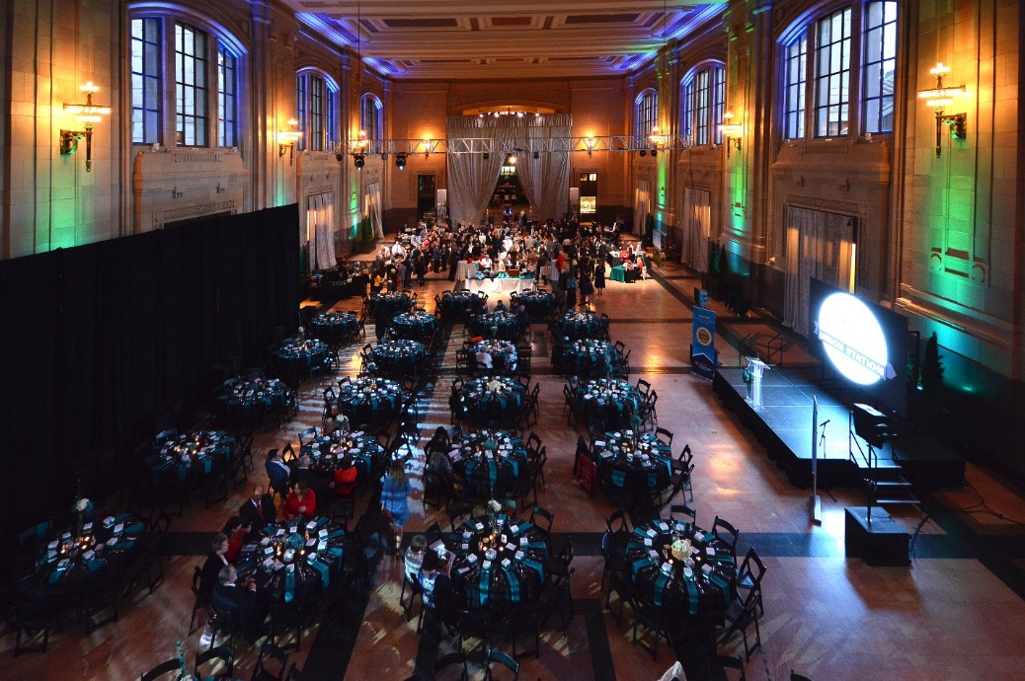
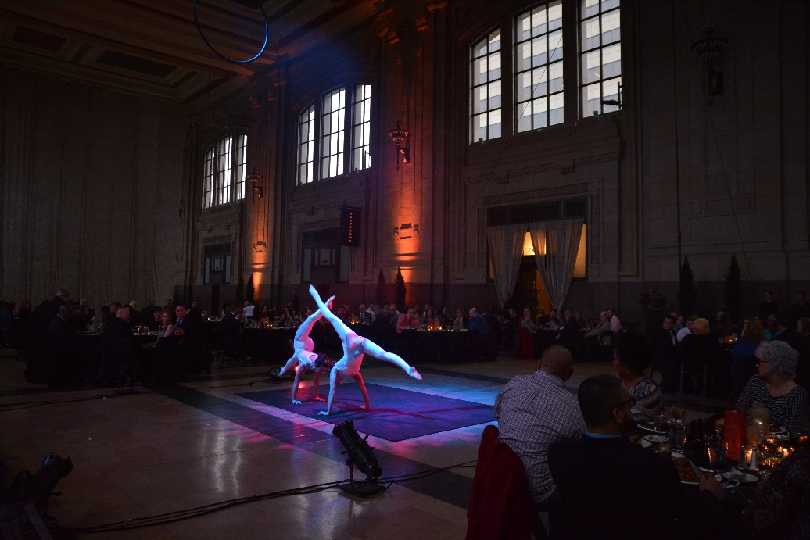

Weddings
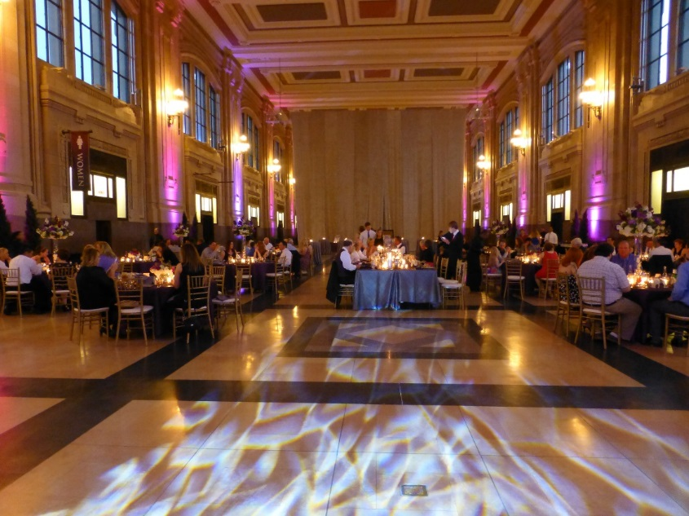

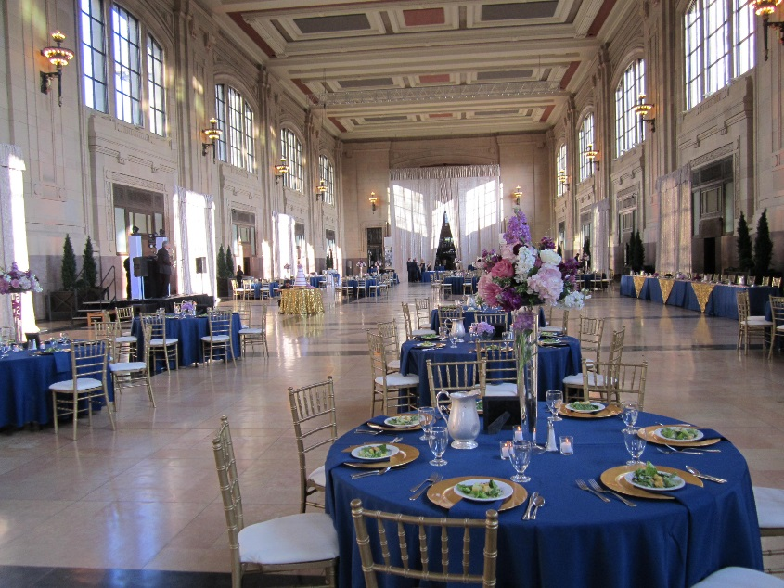

Galas
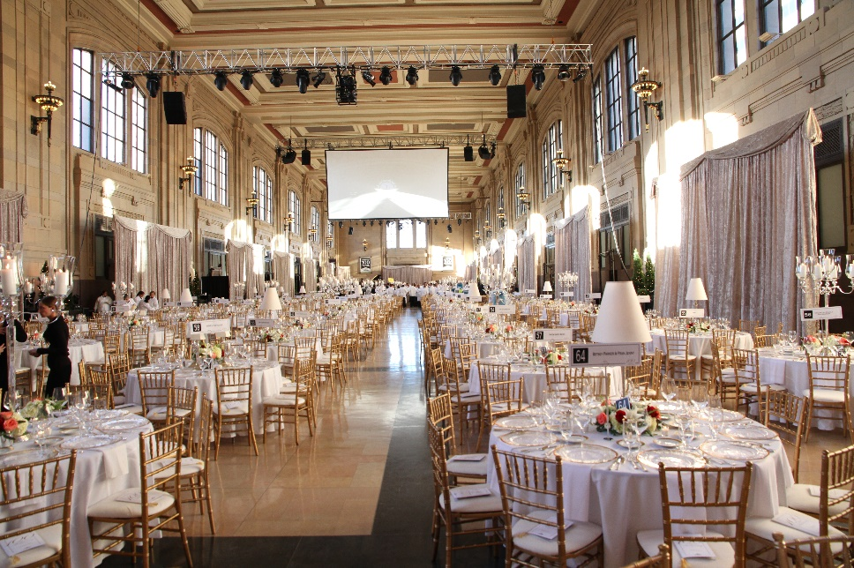
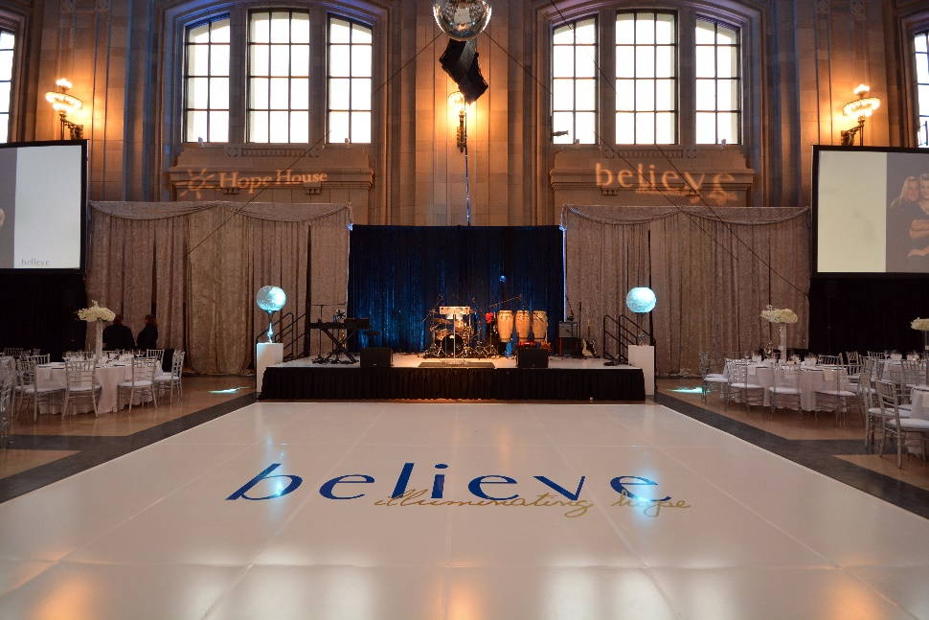

Theme Parties/ Galas
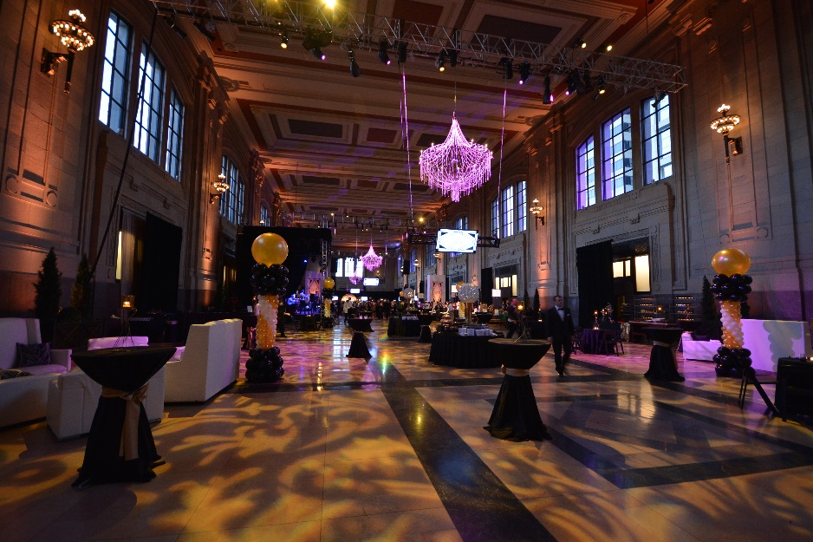
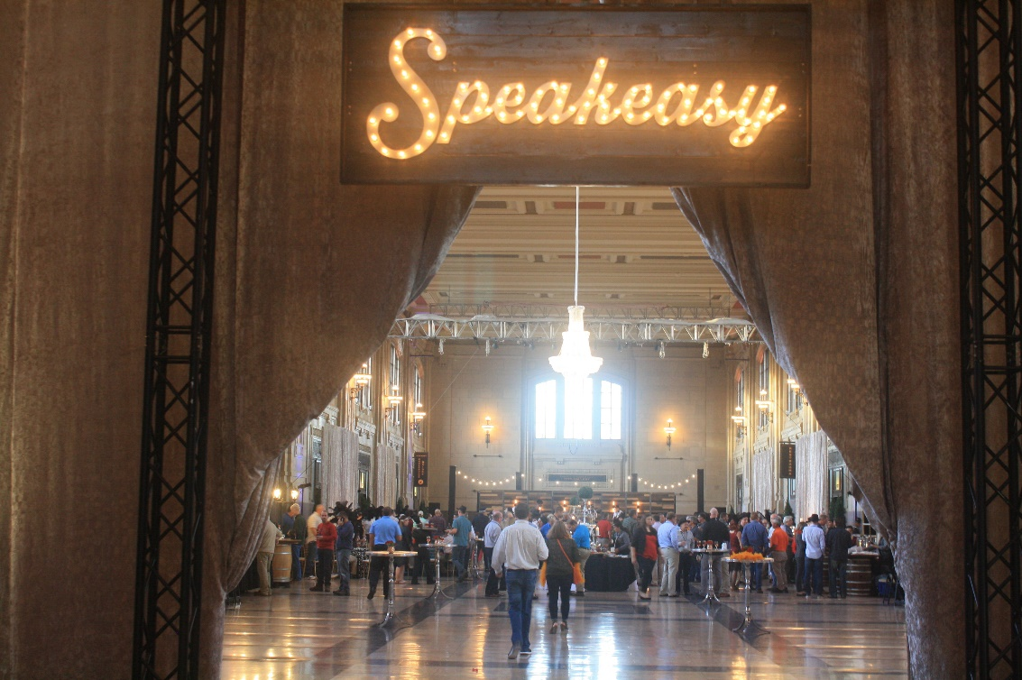

Grand Plaza Room Rental Package Includes the following:
Furniture:
  - 40- 66” rounds (seat 10)
  - 40- 108” black cotton/poly linens
  - 400- Black Bistro folding chairs
  - 4- 6’ tables for registration (includes black linen & 2 chairs)
  - LED up lighting in all planter boxes and windows
  - 40’ x 50’ entrance drapery for added privacy
  - 35’ x 50’ décor drapery (sheer/ivory) for separation of room

Audio Visual Package: Optional Add-On (Union Station equipment) - $3,450
- BOSE sound system w/ 8 elite speakers and 2 handheld wireless mics
- Stage (up to 18’x16’) w/ skirting and stairs
- Acrylic podium
- 9x11 LED Digital Video Screen
- Acoustic enhancing décor drapery panels
- 3-Phase Power (large productions)
- AV Production Tech
*Union Station AV package can accommodate events with up to 400 guests, events above 400 guests or needs that expand beyond this package can be contracted with an outside vendor.

Audio Visual Vendors: (recommended not exclusive)
- Platinum KC- Kris Nardini kris@platinumkc.com 816-550-0992
- Landers Vision- William Bonikowski, will@landersvisions.com 816-442-8012

Catering: (exclusive vendors)
- Pierpont’s at Union Station- Robbie McGowan, Catering Director rmcgowan@pierponts.com
- Brancato’s Catering- Jennifer Fuentes, Catering Manager, jfuentes@brancatoscatering.com
- Q39 BBQ- Michael Naegele, Catering Manager, michael@q39.com
- Jack Stack BBQ- Scot Kautzi, Director of Catering, scottk@jackstackbbq.com
- Lon Lane Inspired Occasions, Jeff French, Catering Manager, jeff@inspiredoccasionskc.com
- Sheraton/ Westin Crown Center, Chrissy Frazier, Chrissy.Frazier@starwoodhotels.com

Bar Service: (no other vendors permitted to provide this service)
- Pierpont’s at Union Station
- Brancato’s Catering
Rentals: (exclusive provider)
- All Season’s Event Rental, Arlon Sloop, asloop@allseasonseventrental.com

Entertainment/ DJ Services:
- Any vendor of choice can be used for these services.

Cake, Cupcakes, Desserts:
- Any vendor of choice can be used for this service.

Floral/ Photography:
- Any vendor of choice can be used for these services.

Valet:
- In-house contracted vendor, quotes can be provided upon request.

Décor Policies:
- No open flame candles (LED/ battery operated)
- No helium balloons
- No Confetti/ Glitter
- No taping to walls or surfaces

Considerations:
- Union Station does not provide carts or dollies for vendors.
- Union Station does not provide power/extension cords.
- No carts or dollies permitted on the marble floors that do not have non-marking white or grey wheels.
Parking:
Self-Parking for guests will be provided complimentary on the top front far West side surface lot, maximum of 100 spaces. Additional spaces can be requested, additional cost will apply.
Signage will be provided for guest’s directional guidance.

Booking Process:
Contract to confirmation-
- 7 days from the receipt of the contract signed copy is due.
- 50% non-refundable deposit is due when contract is returned.
- Checks (payable to Union Station), Cash, Credit Card or Debit Card accepted.
  - *if paying by check or cash, Union Station still requires a CC on file.
- Final balance due 30 days prior to the event date.

Cancellation Process:
- Deposit is non-refundable, date is transferrable with the deposit within the same calendar year.
- 31 days or more before the event date, no additional monies due.
- 30 days or less, full payment will be due.

