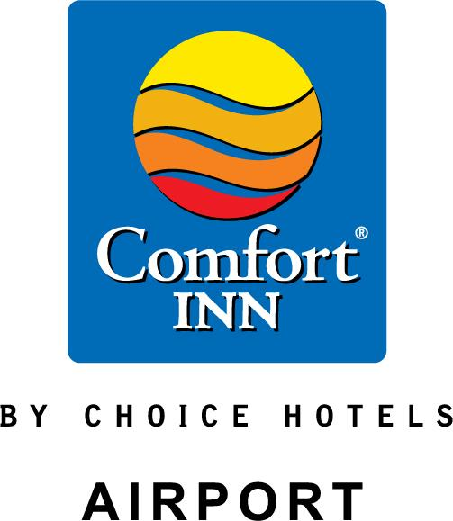

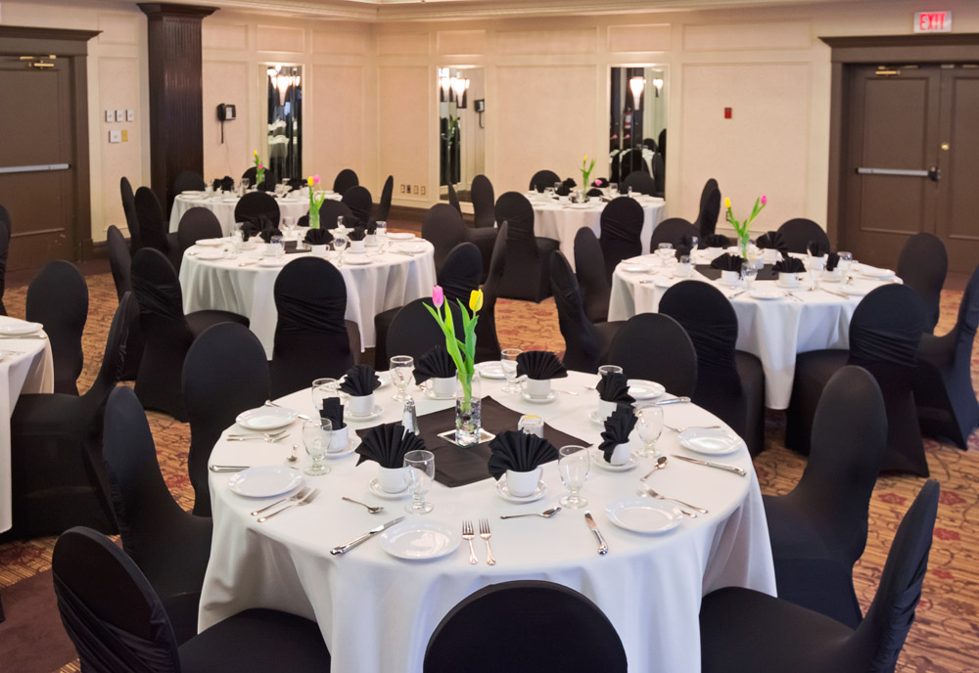

We take care of the million little things.
Comfort Inn Airport combines excellent facilities with professional customized service. Our experience team is always ready to make your special day even more memorable. We look forward to being of service to you and thank you for considering us to host you event.

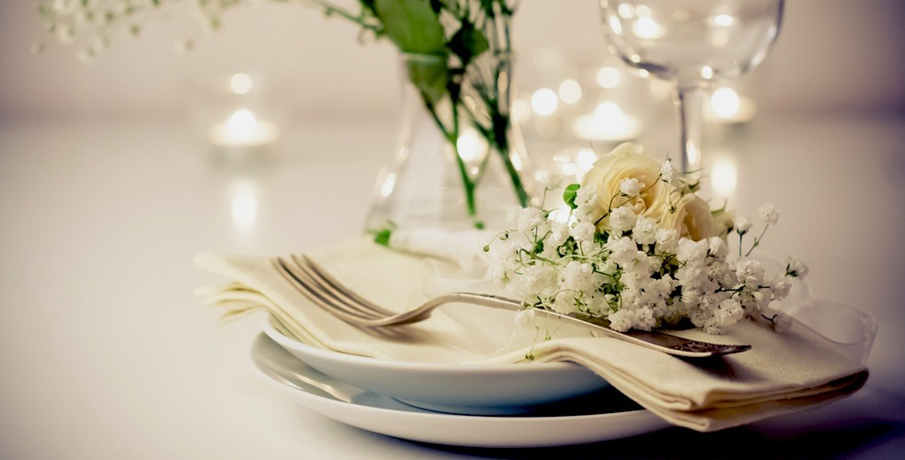

Three Course Plated Dinner Menu
The prices listed below include Dinner Rolls, Appetizer, Entrée, Dessert, Coffee or Tea

Appetizer
Garden Salad with House Dressing

Entrée
Chicken Supreme with Orange & Cranberry Stuffing $34
Atlantic Salmon with Lemon Dill $34
Savory Stuffed Chicken Breast $34
Roast Turkey with all the Trimmings $34
Traditional Roast Beef with Pan Gravy $34
Roast Loin of Pork with Apple Raisin Herb Stuffing $34
Prime Rib of Beef au jus with Yorkshire Pudding $41

All entrees served with your choice of potato-Whipped, Oven Roasted or Croquette
&
Honey Glazed Carrots and Broccoli

Desserts
Carrot Cake
Lemon Crème Layer Cake
Old Fashioned Chocolate Layer Cake
French Cream Cheesecake with Newfoundland Berry Topping

Coffee and Tea
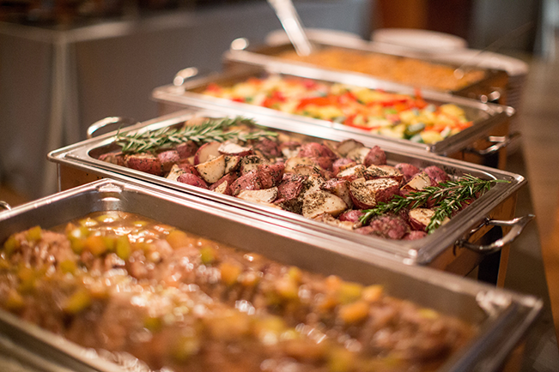

Dinner Buffet
House Garden Salad
Potato Salad and Pasta Salad
Dinner Rolls

Select one of the following:
Apple & Raisin Herb Stuffed Pork Loin
Roast Beef with Pan Gravy
Glazed Baked Ham

Choose two meal selections:
Sliced Stuffed Chicken Breast
Cod au Gratin
Baked Dressed Salmon
Baked Lasagna

Medley of Fresh Market Vegetables
Croquette Potato, Oven Roast Potatoes or Rice Pilaf

Assortment of Desserts
&
Coffee and Tea

$42 per person

Minimum Number: 40 people
Maximum Number: 160 people

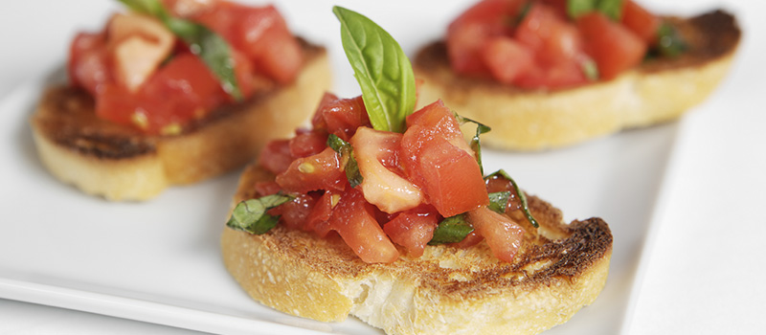

Reception Menu

Hot Hors d’oeurves priced per dozen

Spinach or Cheese Tartlets $16
Stuffed Mushroom Caps $16
Bruschetta Bites $16
Bacon Wrapped Water Chestnuts $16
Spring Roll $16
Mini Fish Cakes $18
Chicken & Pineapple Skewers $18
BBQ Meatballs $18
Chicken Taquitos $18
Chicken Wings per lb. $18
Bacon Wrapped Scallops $22
Coconut Shrimp $22
Tenderloin & Mushroom Skewers $22
Shrimp & Italian Sausage Skewers $22
Curried Beef in Phyllo Pastry $22
Cod Nuggets $22
Jumbo Shrimp $22

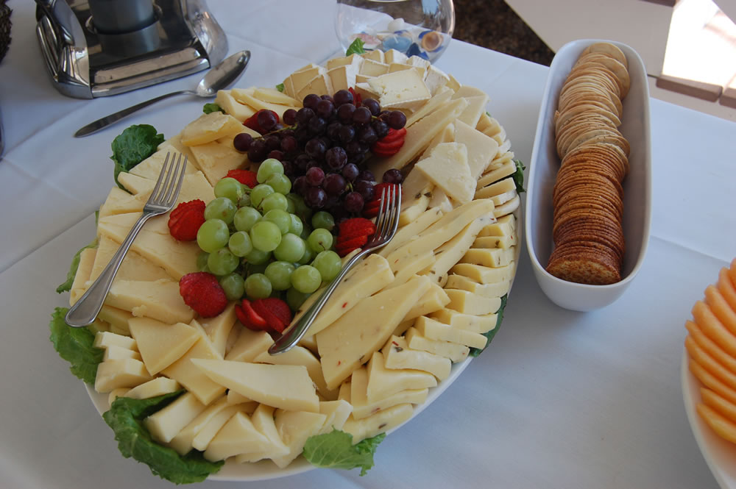

Reception Menu

Cold Canapés priced per dozen $20

Smoked Salmon on Baguette
Butterflied Shrimp on Melba Toast
Curried Chicken Salad on Baguette
Sundried Tomato & Ham Pinwheels

Specialty Items

Vegetable Tray with Creamy Dip (serves 20-25) $60 per tray
Fruit Tray (serves 10-15) $50 per tray
Fruit Tray (serves 20-25) $75 per tray
Deluxe Sandwich Tray (serves 20-25) $90 per tray
Deluxe Cheese & Cracker (serves 25-30) $135 per tray
Spinach & artichoke Dip (serves 10-15) $50 per bowl
Dessert Squares Assortment $3 per person

Banquet Bar

Host Bar (Subject to 15% Gratuity and HST)
Local Beer $5.00
High Ball $5.00
Wine $7.00
subject to 15% gratuity & HST

Cash Bar (Includes HST)
Wine $7.90
Local Beer $6.50
High Balls $6.50
Imported Beer $8.00
Coolers $8.00
Premium Brands $8.00
Liqueurs $7.00
Cocktails1.5oz $7.50
Soft Drinks $2.75

Wine
House Wine – Per Litre $42
Peller Estates Pinot Grigio (White)
Peller Estates Shiraz (Red)

Per Bottle
Folonari Pinot Grigio (White) $42
Folonari Pinot Noir(Red) $42

Sparkling Wine -Per Bottle
Freixenet Cordon Negro Brut $42

Punch (serves 30 glasses)
Non – Alcoholic $50 per bowl
Alcoholic $100 per bowl

Thinking about your rehearsal dinner, day-after brunch, or bridal shower party? Inquire about our pre and post wedding meal options. Our menu selections are only suggestions and are by no means the only items available through our Catering Department. We would be please to discuss a custom-created menu to work with your budget.

Please contact
Roberta Chaytor
709.726.3408 x 2439
roberta@claytonhospitality.com

All menu items are subject to 15% gratuity & HST

Terms & Conditions

Menu prices listed are current and guaranteed three months prior to your function. Prices are subject to change without notice to meet increased market costs. All food and beverage prices are subject to 15% Gratuity and HST.

- All food and beverage products must be purchased and consumed within the premises. Alcoholic beverages and food products cannot be brought into areas licensed by the facility.
- Menu selections should be submitted 14 days prior to your function date in order to assure your selection. We offer one menu choice only.
- The hotel requires a guaranteed number of guests attending the function 72 hours prior to the event. Charges will be made on the guaranteed number or the actual number of people served, whichever is greater.
- Please notify the catering department of all dietary restrictions and/or allergies 72 hours prior to function. We offer one meal selection per event.

- A Bartender Fee of $75.00 will apply for banquets of less than 100 people.
- Banquet cancellation charge - Cancellation notice is not eligible for a refund. All cancellations must be received in writing.
- Food & Beverage Cancellation - All food and beverage orders are to be guaranteed 72 hours prior to the function.
- A Banquet Event Order will be sent to the convener and must be signed and faxed or emailed to events@comfortinnstjohns.com in order to confirm your booking. Cancellations of food & beverage within 72 hours are subject to penalty.

- Additional Fees-SOCAN & SOUND
SOCAN tariff + HST (by law) apply for events that include musical entertainment. Events with dancing will be charged $59.17 while events without dancing will be charged $29.56. This will be billed to your account by the hotel. The Sound fee is $26.63.
- Guest Room Block - A block of rooms can be reserved for your group. Please book your rooms early to ensure availability. Guest rooms that are not picked up 30 days prior to the event will be released and any discounted rate for the wedding group will not be available.

- Decorating - The hotel is not responsible to decorate the function room. We will provide the linens & skirting for head table, cake & gift table. Access to the room is 1pm -1am on the day of the function unless prior arrangements have been made with the Hotel. No open flame candles, no confetti on tables, and no nails, staples or tape to be used on walls, ceiling or furniture unless approval is given by the Hotel. All decorations must be taken down after the function.

- Music - DJ’s and bands are permitted to play music until 1am. Function doors must be kept closed at all times and the hotel reserves the right to control the volume if the bass is too high.

- Audio Visual Equipment - Audio visual Equipment may be ordered through the Sales and Catering Department on a rental basis. The AV is based on availability at time of booking. Microphone & podium – complimentary with room

- Floor Plans - We will provide you with a floor plan for seating arrangements based on your final #’s. The positioning of the head table and dance floor is based on the final #’s.

- Comfort Inn Airport takes all responsible precautions to safeguard the property of our guests however the hotel is not responsible for damages or loss of any articles left in the hotel, prior to, during, or following the event.

FAQ’s

- Can we supply our own catering or our own wine?
All catering must be ordered through the Comfort Inn. Provincial liquor laws prohibit the sales or donation of alcoholic beverages not purchased under the liquor license of the Comfort Inn.
- Can we purchase a wine not on your list?
Yes, we will source out the wine and provide you with a cost per bottle.
- How late is bar service available?
1:00 am is last call; however, it is left to the discretion of the banquet supervisor depending on the number of guests and bar sales.
- Is a live band permissible?
Yes, but all set up requirements would need to be discussed with the Event planner.
- What audio-visual equipment do you provide?
We provide a complimentary podium / microphone. A screen of LCD projector is available at an additional cost.
- Is there a coat check available?
Yes – There is a separate coat room from the ballroom, it is unsupervised. There is no charge.
- Do you have wireless internet access?
Yes – At no charge.
- Can we provide our own decorator and DJ?
Yes.
- How many can be seated at your head table?
18 is the maximum however depending on total number of guests in the ballroom, risers may not be suitable and is left to the discretion on hotel personnel. Guest tables are round tables of 8.
- When can we decorate?
The room is available 1 pm to 1 am for your function. Please call the Sales manager the week of your wedding to discuss times for Ballroom availability as you may be able to access it earlier.
- Do you charge for cake cutting?
Yes, $45. plus HST
- Is there a service fee on food/beverage?
A 15% gratuity is charges on all food/beverage (includes meal, wine, host bar, drink tickets).
- Can we have the ceremony at your location?
Yes. Price is $250 plus HST. We require a 3-hour window after the ceremony to set up for the reception.
- Is there a charge for the ballroom?
Yes. There is a charge of $750 plus HST for the ballroom.
- Can I book hotel rooms for my out of town guests?
Yes, Rates are based on availability and the season.
- How many meal options can I select?
1 meal option with meal selection given 2 weeks prior to the event and final numbers given 72 hours prior to your event,

