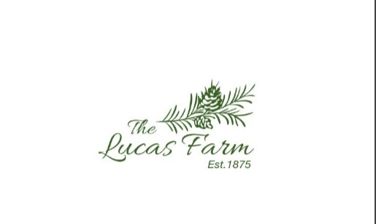 |  | Venue Features  Our 19th century, 450-acre farm offers you a historic venue with a coastal flair and all of the amenities to deliver your special event. We have listed our venue features below, including the fully refurbished barn, farmhouse, schoolhouse, and bar shed, as well as pricing.  Barn  - Refurbished barn with original tongue and groove pine ceilings and original rough-cut timber walls, Air conditioned and heated. Cement slab flooring to get your groove on  - Ceremony seating can accommodate 175 guests  - Dinner seating up to 100 guests  - Full DJ system available and electric capacity for a full band  - 29x26 patio with Edison lights, wrought iron tables/chairs, and Solo fire pit  - 22 x 14 front patio  - Flagstone walkways  Farmhouse  - 3,000 square foot home  - Full kitchen  - 2 bathrooms  - Large sitting room  - Ample space for bridal party to get dressed  - Ample sunlight for hair and makeup  - Large wraparound porch  Schoolhouse  - 1,500 square foot house  - Full kitchen  - 1 ½ bathrooms  - Ample space for groomsmen to get dressed  - Large sitting room  - Additional $250 to stay night before wedding  Bar Shed​  - Original ham house converted into bar  - Surfboard bartop  - Ample space to serve from both sides of shed  - Countertop space and large reach in cooler available  - 12 x 12 back patio  - 10 x 12 front patio  Carriage House/ Caterers Kitchen  - Full newly renovated caterers prep kitchen with ice maker (500 pounds of ice), commercial double door refrigerator, warming oven, 2 carts, and farm style sink  - Two on site renovated bathrooms (hándicap accessible)  Pricing  Venue Rental  - $4,500 (Saturday) - 12-hour access to barn, farmhouse, schoolhouse, and bar shed  - Please call if your wedding falls on a Friday, Sunday, or weekday for availability  - Additional $2,000 - Rehearsal Dinner  - Additional $250 per night to stay at the school house  ​  Decor Available with Rental  (indoor use only)  - 16 church pews (seats 64 people)  - 5 cocktail tables with  high-top chairs  - 12 round tables (seats up to 8 people)  - 6, six foot rectangular tables  - 150 Chiavari chairs  - White table clothes:  -12, 90 inch round white table cloths (lap length)  -12, 120 inch white rounds (floor length)  -6, 60x102 rectangular white table cloths  -2, 52x52 square white table cloths

The LUCas FArm NC
VENUE AND PRICING

CONTACT
PHONE:
704-928-7217

WEBSITE:
https://www.thelucasfarmnc.com/

EMAIL:
thelucasfarmnc@gmail.com

