MANOR MENU
COCKTAIL HOUR INCLUDES:
BUTLER STYLE PASSED HORS D’OEUVRES
Arancini Rice Balls / Mini Meatballs marinara / Caprese Skewers / Mini Cocktail Franks
Sesame Chicken / BBQ Beef Crostini / Antipasto Roll / Tostones ‘n’ Guac
TUSCAN ANTIPASTO TABLE
Herb Grilled Veggies / Mushrooms / Artichokes / Roasted Pepper
Parma Prosciutto / Salami / Soppressata / Mortadella
Cheese Board: Swiss / Cheddar / Fontina
Fusilli Salad / Fresh Mozzarella / Olive Medley / Bruschetta
Cocktail Hour Stations- SELECT ____

The Carvery / choose 2
Slow Roasted Turkey Breast
Smoked Country Ham
Italian Roast Beef // Grilled Pork Loin
New York Style Corned Beef
Rosemary roasted Leg of Lamb
gravies // sauces // accompaniments //
all American Picnic
Hot Dog Cart / onions/sauerkraut/relish
Mac ‘n’ cheese /cheddar /bacon
Bbq Pulled Pork / cole slaw
Grilled Corn on the Cob

Italianissimo
Calamari ‘fra diavolo’ marinara/chilies/parsley
Baked Eggplant ‘rotolo’ ricotta/mozzarella/pomodoro
Sausage ‘n’ Peppers
carmelized onions/tomato/basil

Mashed potato Bar
Sweet Onion Mashed /in a martini glass
Fixins’ / cheese/bacon/chives/sour cream/corn

Tutta Pasta
Fusilli ‘puttanesca’
olives, capers, spicy marinara
Tortellini ‘panna’
prosciutto, peas, alfredo
Both pastas prepared tableside

South Of The Border
Blackened Steak & Chicken ‘fajitas’
Guacamole / salsa/ sour cream / queso
Crisp Plaintains & Beef Empanadas

Fortune Cookie
Sweet ‘n’ Sour Chicken
Ginger Beef teriyaki
shanghai Sesame noodles

SEAFOOD RAW BAR- + $9.p/p+tax
An extravagant display of iced shellfish, shrimp cocktail, seafood salad, little neck clams & oysters on the ½ shell served with all necessary accompaniments
Whole lobster available at market price.

3 course Dinner
Duet App (select one)
CAPRESE // CAPONATA fresh mozz, basil, evoo, roast eggplant, baby arugula
PROSCIUTTO // MELONE parma ham, honeydew, grana, greens, balsamic
ASPARAGUS // RAVIOLI asparagus gratin, asiago rav, pesto drizzle
MUSHROOM // RISOTTO roast cremini, shallots, Arborio, pecorino
BACON // MAC n CHEESE crisp hickory smoked, cheddar, herbed panko
- Hot Antipasto Individually Served + 8. p/p+tax
Eggplant rollatini, Shrimp, Stuffed Mushrooms, Fried calamari
Entrees (select beef/chicken/fish/veg)

CHATEAUBRIAND / sliced filet mignon / chianti-rosemary glaze
PRIME RIB / slow roasted / ‘au jus’ bordelaise
NY STEAK / grilled / peppercorn sauce
BEEF SHORT RIB / slow braised / sage, cabernet sauce

CHICKEN BREAST all natural
FIORENTINA stuffed/ spinach / fontina / marsala-mushroom sauce
AL MATTONE roasted Cornish hen / spice rubbed / natural ‘jus’
AVELLINO prosciutto / mozzarella / spinach /

STUFFED SEA BASS / shrimp & crab filling / citrus-thyme sauce
SHRIMP SCAMPI / vino bianco, parsley, garlic, paprika
CRISP TOFU / mushroom sauté, veggies
EGGPLANT rotolo / mozzarella, ricotta, pomodoro
VEGGIE NAPOLEON / fontina, balsamic drizzle
Veggie Medley & Potato du jour with each entree

THE FINAL TOUCH

Wedding Cake
gourmet tiered wedding cake crafted for you

Dessert Trio
cake served along with chocolate dipped fruit & cannoli

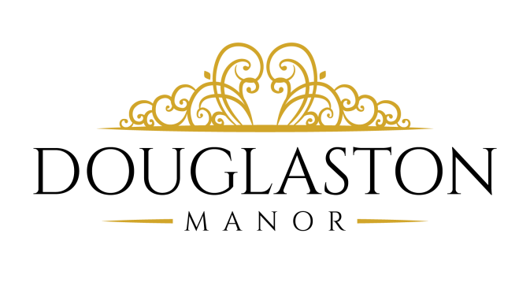

Liquor Selections
Absolut Vodka Jack Daniels whiskey Amaretto
Grey Goose Vodka Dewars Scotch Peach Liquor
Bacardi Rum Seagram’s 7 Whiskey Coffee Liquor
Malibu Coconut Rum Jose Cuervo Tequila Sour Apple Liquor
Captain Morgan Rum Tanqueray Gin
Draft Beer
Samuel Adams Coors light
Wines
Chardonnay White Zinfandel Merlot
Pinot Grigio Cabernet Sauvignon

Upgraded Liquor Package (add $15.00 pp)

Jameson Irish whiskey Hennessy Cognac Wild Turkey
Patron Tequila Bombay Sapphire Gin Johnny Walker Black

Distinctive Touches

~Personal Bridal Suite
~Bridal Attendant
~Maitra D’
~Captain
~White Glove Service
~Elegant Linens
~Personalized Menu
~Signature Cocktail
~Lobby Hostess
~Coat Check
~Handicap Access
~Fresh Flowers in Lobby

Valet Service Is Included for Weddings over 100 guests.
~For events under 100 guests Valet Charge is $300.00
The Party Time line
Payments
Can be mailed in with a regular check, follow your payment schedule listed on your contract. List in the memo section your contract number and date of the party. No credit cards as payments okay as an initial deposit
Menu
A menu appointment will be done 1 months prior to your wedding
1) Menu
2) Wedding cake
3) Floor Plan and Linens
4) Details of the day
5) Timing
Three weeks prior
Will need a final count in this breakdown
Adults / Kids 3-10 60% / vendors 60%
Two weeks prior
Final payment certified funds only
Final floor plan must match final count
Drop off
Thursday prior to you wedding
Place cards, toasting flutes, card box, Favors, etc.
Wedding Rehearsal
Conducted during the week
Tasting
Conducted at Showcase
Arrival Time
Bride & Groom One Hour Prior

Recommended Vendor List

TLC Entertainment:
(Total entertainment Packages) Ultimate Sound DJ’S:
(516) 414-0914 Adrian Zerla (516)350-8735 (718)204-1938
www.tlceventstudio.com www.UltimateSoundDJs.com

PHOTOGRAPHY
GUY HEART PHOTOGRAPHY
  - 630 Ninth Avenue, Suite 1012, The Film Center Building,
New York, NY 10036 Phone: (646) 338-2878
www.guyheart.net

FLORISTS

Cress Florist: (718)423-6255
www.cressweddingflowers.com
Florist Hills: (718)459-8442
www.floristhills.com

OVERNIGHT ACCOMMODATIONS
Adria Hotel: (718) 631-5900 / Best Western Hotel: (718) 631-4900 / Andrew Hotel: (516) 482-2900
www.adriahotelny.com www.andrewhotel.com

LIMOS
Camelot Limousine: Diamond Limo NY:
(516)731-5466 (516)-243-7731
www.camelotlimo.com www.diamondlimony.com

Foxes Gifts: Barbara Chevieux Spa & Salon: Roseanna
917-887-5157 (516)374-1060 www.chevieuxspa.com

Buttercooky Bakery: (516)354-3831 www.buttercookybakery.com

