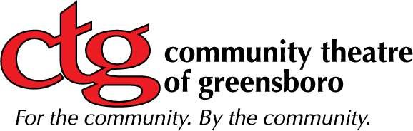

Daily Theatre Rental* | Regular Rate | Non-Profit Rate**
Sunday-Thursday | $800/day | $650/day
Friday & Saturday | $1000/day | $800/day
* Daily constitutes a 10-hour rental of the space. There will be hourly charges added based on the chart directly below for any event that goes over the daily 10-hour threshold.
**To qualify for the non-profit rate, an organization must submit their IRS Determination Letter with their rental request.

Hourly Theatre Rental~ Regular Rate Non-Profit Rate~~
Sunday-Thursday $100/hour $80/hour
Friday & Saturday $120/hour $100/hour
~ | There is a flat-rate charge if the event is three hours or less. The
minimum cost for both regular or non-profits for Sunday-Thursday is $300; the minimum on Friday or Saturday is $400.
~~To qualify for the non-profit rate, an organization must submit their IRS Determination Letter with their rental request.

House Manager
All event prices include the charges of a house manager to be on site for every event inside of the theatre space. Page 1 of 2

Additional Charges
At an hourly rate, you can have someone working the sound and lights to make your production even more spectacular.
Staff | Hourly Rate
Lighting/Sound Technician | $25.00

Box Office
Set-up fee $25.00, plus $1 per ticket and bank card charges (usually 3.75%).

Application Process
The theatre is available for rent via a lease agreement. To apply for a lease, please email Events@ctgso.org with your requested date(s) and times.

Insurance
All clients must have $500,000 or more liability insurance listing the Community Theatre of Greensboro as "additional insured". Proof of this insurance must be received one month prior to the event.

Extended Rentals
There can be arrangements made, in the form of a discount, in renting the theatre for an entire week: Monday – Sunday.

Cleaning After the Event
There will be a $40 cleaning charge added to the rental rate, at the house manager’s discretion, if the following tasks are not completed by the end of the contracted rental: It is the client’s responsibility to sweep any used spaces and collect all trash for easy disposal.
Extra Rentals discount
During or after your event, The Studio @ CTG and/or The Mosh Terrace can be used at a discount. Ask our Events Planner for further details.

Page 2 of 2

