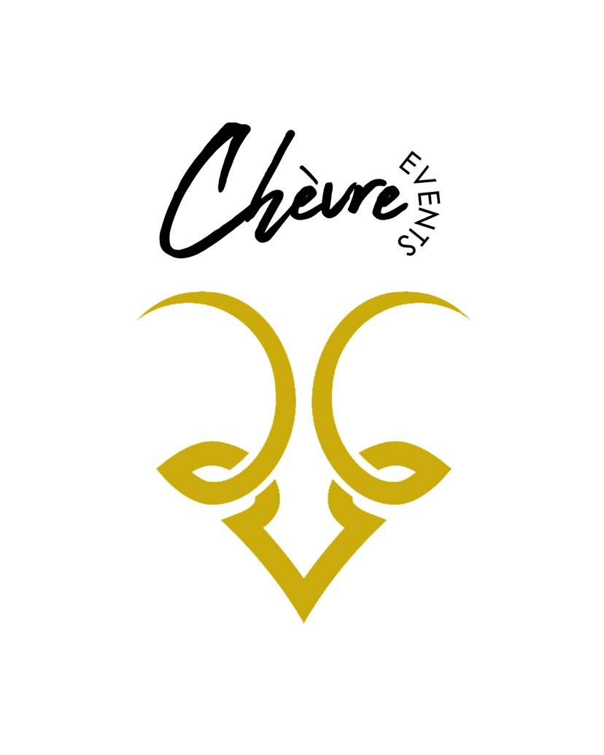
Chévre Events 3rd Floor Rooms

Loft-Style Architecture
Exposed Brick & Hardwood Floors
In House Catering & Bar Options
In House Décor Rental Options
In House Professional Effects Options
Private Use Of The Entire Floor
Serving Staff & Bartenders
Gated Parking Options

The Amour Room 3rd Floor $1500
Our Amour room is perfect for your event! It’s a beautiful all white room embellished with white brick walls & includes a 30 Ft bar. The Amour room has 13 Ft loft style white ceilings, & gorgeous real hardwood floors. 24 very large french & picture style windows bring in a wonderful amount of daylight. At 5300 SQ FT its seats up to 253 people with tables & chairs and or up to 500 people with chairs alone. 19 elegant chandeliers give the room major classy vibes!

The D’or Room 3rd Floor $1000
Our D’or room is perfect to host your event! It’s a beautiful 4700 SQ FT room with white walls, 10 Ft black loft style ceilings, real hardwood floors, & 12 gorgeous gold chandeliers. The D’or room includes a full stage, DJ Booth, & an 11 Ft bar. 14 large french & picture style windows bring in a wonderful amount of daylight. At 4700 Sq Ft it seats up to 220 people with tables & chairs and or up to 400 people with chairs alone.

@chevreevents
www.facebook.com/chevreevents
1624 Delmar Blvd 2nd & 3rd FL Stl, MO 63103 314-492-3003

Chévre Events Venue Information & Guidelines

Time Limits
6 total hours are included for 3rd floor events at Chévre. A 4-hour timeframe is given for the actual event time & 2 additional hours are allotted for set up & break down.

Catering
Our in house preferred caterers will ensure your event is catered with the utmost passion & care. We offer a variety of caterers for you to choose from for your event. Clients may use a caterer who is not on our in house preferred caterer list. The outside caterer must be licensed to perform catering services. They also must sign our outside catering agreement & our waiver. Please note using an outside caterer is subject to a fee of $250. In order to cover the cost of service, culinary & support staff, a service fee is included in all food, beverage, labor & equipment charges.

Parking
Chévre Events offers parking spots on our gated lot that may be pre purchased at the discounted rate of $9.00 per space. The regular cost per space to park is $20.00 per vehicle. Clients must arrange to pre purchase discounted parking spaces at least 60 days prior to the event. Chévre Events also can coordinate valet parking service with a designated 3rd party for an additional fee. The valet parking fees will be line itemed on your bill and must be requested at least 60 days prior to the event. There is also metered street parking available.

Security
Events with over 200 guests must have one mandatory security guard on the premises. Events over 225 guests will require two mandatory security guards on the Premises. Security guards are staffed by Chévre Events for a fee of $35 per hour paid by the clients. Additional security guards can be arranged if the client prefers. Security guards are present to enforce the rules and regulations of the venue and ensure the safety of its guests.

Sound & Technology
Tell the DJ to pump the volume! Chévre Events offers a state of the art QSC sound system available for your use if needed. If you’re bringing in your own DJ they are more than welcome to bring in & use their own sound system. If you would like to use our sound then we offer 2 options. Your DJ can plug into our house system and play for the fee $200 or you can connect to our house system thru Bluetooth and play your own music from your phone or I pad for the fee of $150. Additional A/V items are available for rent as well.

Damage Deposit
Chévre Events does require a $1,000.00 damage deposit for all events. The deposit must be received at least 10 days before your event date. As long as no damage is incurred during your event, you will receive your damage deposit back in full. Please note that hosts are responsible for any damage done by an attendee or subcontractor.

Clean Up
Chévre Events is to be kept in the original condition as you received it. We suggest break down and clean up to start 15-30 mins prior to your event stop time to avoid you being charged a late exit fee of $200. If the late exit fee is incurred it will be deducted from the clients damage deposit. The client has up to 30 mins after the event stop time to clean & exit the venue. It is the client’s responsibility to remove all trash from the tables. If an outside décor vendor was used it is also the clients responsibility to remove all dinnerware & centerpieces from the tables. All trash must be picked up or swept up off of the floor. Chévre is responsible for taking the trash out to the dumpsters, for vacuuming, moping of floors, and further deep cleaning. Please understand that this is a wedding and not a bachelor or bachelorette party and any extreme cleaning or shampooing of carpets will be taken out of the damage deposit. The damage deposit is $1,000.00 and is separate from the contracted amount. The damage deposit is due 10 days before the event.

Projector
Clients may use our projector during their event for a slideshow or video for an additional fee of $50. The venue need to know no later than 1 week prior to the event if the client wishes to use the projector. Please note clients must provide a flash drive containing the media. The flash drive must be provided upon arrival. Chévre does not accept flash drives within less than 2 hours of your ceremony. Chévre is not responsible for corrupt flash drives or files. If audio is required this must be communicated to the venue & your DJ. The following file formats are accepted:
Slideshows –PowerPoint (Windows) or Keynote (MAC)

Rehearsal
Clients may reserve a rehearsal if needed in the evening on the Tuesday, Wednesday, or Thursday prior to their event for $75. The rehearsal time limit is 2 hours & the guest max is 40 people. Clients must reserve their rehearsal time slot no later then 1 month prior to the event. Please note that any time over 2 hours will be charged at the rate of $150 per hour.

Outside Effects
Chévre offers a full line up of professional effects. Please note that outside effects are not allowed. Effects not allowed include sparkles, smoke machines, cloud machines, photobooths, 360 photobooths, up lighting, gobo’s, & Co2 guns. These items are all available for rental thru Chévre Events.

Outside Decor
Chévre Events offers full in house decor. Clients are not required to use Chévre Events for decor and are allowed to use their own outside decor vendor. Outside decor is allowed but please note using a decor vendor outside of our in house preferred décor vendor list is subject to a fee of $250. If you do prefer to use an outside decor vendor please note that there are some restrictions on what type of decor items can be brought in to Chévre Events. Outside decor items that are not allowed include, furniture, chairs, specialty tables, throne chairs, chivary chairs, lighted marquee letters, and champagne walls. These items are all available for rental thru Chévre Events.

Outside Alcohol
Outside alcohol is not allowed under any circumstances. The venue and staff will strictly enforce this rule. It is the responsibility of the client to notify all guest of this rule. If a guest of the client brings outside alcohol they will be escorted off of the property & an alcohol violation fee of $300 will be charged. Please note if any outside alcoholic beverages are found under tables from your guest during clean up there will be an $300 alcohol violation fee charged and taken from the damage deposit. If alcohol rules are not followed the venue has the right to end the event with no refund.

Cake
Clients are permitted to use an outside cake vendor. Chévre is not responsible for providing plates or utensils for your cake. Chévre also does not offer service for your cake cutting. It’s the client’s responsibility to communicate plates and cake cutting service to the cake vendor, caterer, or wedding coordinator.

Chévre Events Bar Package Info

LABOR & GRATUITY
There will be a $65 charge for each bartender staffed. Staffing level is decided by the venue. We staff approximately one bartender per fifty guests. All bar purchases will be charged tax and a 15% service charge.

Cash Bar MINIMUMS
Events with up to 50 guests $1000 bar minimum
Events with up to 100 guests $1500 bar minimum
Events with up to 200 guests $3000 bar minimum
Events with up to 300 guests $5000 bar minimum

OFFERINGS
Offerings are subject to substitution without notice at our discretion based on availability and price changes. Any substitutions made would be with a comparable product.

Chévre Events Open Bar Packages
Open Bar packages require a minimum of 100 guests. If a client wishes to host less than 100 guests a 20% service fee applies

OPEN NON-ALCOHOLIC SOFT BAR $9 per person plus tax & service charge.
(5 hours)
Assorted Soft Drinks, Juices: Cranberry, Orange, Papaya & Pineapple, & Lemonade

OPEN BEER, WINE AND SODA BAR $20 per person plus tax & service charge.
(4 hours)
Bud Light, Budweiser, Michelob & Corona
Cabernet, Pinot Noir, Chardonnay, and Pinot Grigio
Assortment of juices and soda

OPEN DELUXE BEER, WINE, AND SODA BAR $21 per person plus tax & service charge
(4 hours)
Bud Light, Budweiser, Michelob, Corona, One beer of choice, and Hard Seltzers
Cabernet, Pinot Noir, Chardonnay, Pinot Grigio, Riesling and Moscato
Assortment of juices, and soda

OPEN HOUSE BAR $22 per person plus tax & service charge.
(4 hours)
House Vodka, Whiskey, Scotch, Light Rum, Gin, and Tequila
Bud Light, Budweiser, Michelob, & Corona
House Cabernet, Pinot Noir, Chardonnay, and Pinot Grigio
Assortment of juices, mixers, and soda

OPEN DELUXE BAR $27 per person plus tax & service charge.
(4 hours)
Tito’s Vodka, Seagrams Gin, Captain Morgan Spiced Rum, 1800 Tequila, Malibu Coconut Rum, Jack Daniels Whiskey, Dewar’s Scotch, Hennessey.
Bud Light, Budweiser, Michelob, Corona, One beer of choice, and Hard Seltzers
Cabernet, Pinot Noir, Chardonnay, Pinot Grigio, Riesling and Moscato
Assortment of juices, mixers, and soda

OPEN PREMIUM BAR $30 per person plus tax & service charge.
(4 hours)
Grey Goose Vodka, Tanqueray Gin, Casamigos Tequila, Bacardi Light Rum, Sailor Jerry Spiced Rum, Makers Mark Bourbon, Crown Royal Apple Whiskey, Disaronno Amaretto, Glenlivet 12 Scotch, and Dusse.
Bud Light, Bud Select, Budweiser, Michelob, Corona, One beer of choice, and Hard Seltzers
Cabernet, Pinot Noir, Merlot, Chardonnay, Pinot Grigio, Sauvignon Blanc, Riesling, and Moscato
Assortment of juices, soda, mixers, and red bull

- Extended Bar Service An additional hour will be charged respectively $2.00/person for Soft Drink Bar, $3/person for Wine & Beer Bar, $3.50/person for Well Liquor Bar, $4/person for Deluxe & Premium Bar plus tax & service charge.
- Table side wine service during dinner $5/guest service charge

CHAMPAGNE SERVICE
Bar Package Addition: $2.00/person
- Includes House champagne and glassware.

Champagne Toast Station: $3.50/person
- Includes glassware and a self-serve champagne station with one glass per guest.

Served Champagne Toast: $5.00
- Includes glassware and table champagne service, one pour per guest before dinner or during. House champagne included.

Bar Package Addition & Served Toast: $6.50/person
- Includes glassware, House champagne available for the duration of your bar service, and one glass per guest poured at the table.

WINE SERVICE
Table Service with House Selected Wines-$5.00/person
- Includes glassware, service and house selected wines

Table Service with client wine selections-$4.00/person
- Includes glassware and service.
- Client wine selections must be purchased by client.

Additional Information
There are no substitutions within our bar packages. Additional offerings can be added to your package for a fee. Alcohol service will not exceed 5 total hours. Alcoholic beverage service will cease 15 mins before the conclusion of your event, and will not be served past midnight. The legal drinking age is 21 in Missouri. Chévre Events strictly adheres to this ordinance and reserves the right to ask for identification with proof of age for any guest. Chévre Events reserves the right to limit and control the amount of alcoholic beverages consumed by all guests. We do not allow alcohol to be served in the form of a shot with open bar service. Our beverage pricing does not include tax, gratuity and additional fees. Pricing is subject to change without notice. Bar offerings are subject to change without notice based on availability.

