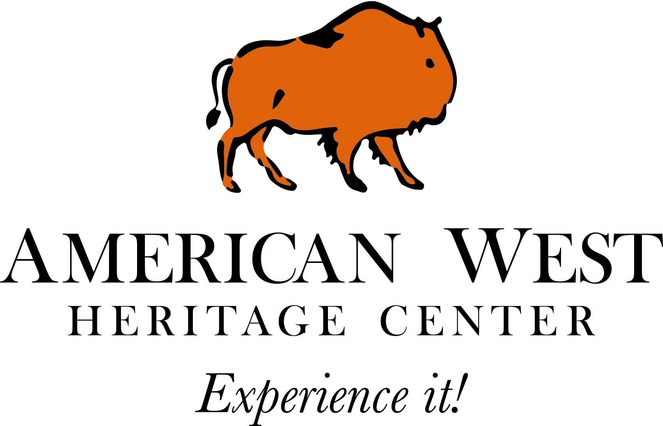

Rental FAQs:

Is there a kitchen facility on site?
Unfortunately at this time, AWHC does not have a kitchen facility. Drinking water is available at each venue. Idea: Some brides have chosen to bring in a camp trailer as one of their vehicles and used this as their “kitchen” facility if necessary.

What size are the tables and chairs?
Round tables are 5 feet
Banquet tables are 8 feet long and 2 ½ feet wide

How many tables and chairs are included in my rental?
There is no limit to the number of tables and chairs.

Are Linens included?
Linens are not included in the rental, but may be rented through AWHC (see decor options on event sheet)

How many tables (round or rectangle) fit in each building?

What are the dimensions of each space?

Is there a charge for outside catering?
No there is no additional charge for outside catering

Do you allow alcohol?
Yes, we do allow alcohol. The policy is as follows:

RENTER must comply with all AWHC policies relating to the consumption of alcohol on the Premises. If a party/individual would like to have liquor served at an event they may do so as long as there is no charge or money exchanged for anything at the event, i.e., drinks, dinners, tips, door/entry fees etc. If renter chooses to use a bartender, RENTER must provide own bartender. If RENTER is charging for anything at the event, a current Utah license and Utah bond is required. (https://utah.com/state-liquor-laws) This process requires approximately 60 days. Alcohol consumption must be confined to the specific areas leased. AWHC maintains a “No Tolerance Policy” with regards to the use of alcohol when it is in violation of AWHC policy. RENTER must provide a copy of the appropriate documentation to AWHC at least one week prior to the event or this agreement is null and void and no refunds will be made. Alcohol Deposit Required: $300
Violation of the AWHC Alcohol/Tobacco policy will result in the retention of Alcohol and or security deposit. Violations may include:
1) Damage to AWHC property 2) Additional AWHC Personnel needed to facilitate unruly behavior 3) AWHC has the right to retain a portion or all of the alcohol deposit if the event guest(s) behavior is considered inappropriate or unruly.

Preferred Vendors:
Catering: Iron Gate Catering
Decorating: Embellish the Moments

Flowers: Leuca Floral

Cakes:

