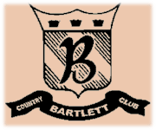
Bartlett Country Club
Dinner Buffet

Clam Bake
(Minimum of Fifty Guests, 1 Lobster Per Guest)
New England Clam Chowder
Seasonal Greens with Gourmet Dressings
Granny Smith Apple Cole Slaw
Steamed Knockwurst
BBQ Quartered Chicken
Marinated Cucumber, Tomato and Red Onion Salad
Corn on the Cob with Melted Butter
Parsley Red Potatoes
Cornbread and Bisquits
Steamed Clams
Grilled Sirloin Steak or 1 ¼ lb Maine Lobster
Mixed Berry Shortcake
$43.00 Per Person

Octoberfest
Beer Cheese Soup
Seasonal Greens with Gourmet Dressings
Articasn Bread Basket
German Potatoe Salad
Knockwurt and Bratwurt steamed in Beer served with Sauerkraut
Braised Autumn Vegetables
Roaste Pork Loin with Braised Red Cabbage
Chicken with Spaetzel
Potato Pancakes with Sour Cream and Apple Sauce
Dessert Display with Apple Strudel
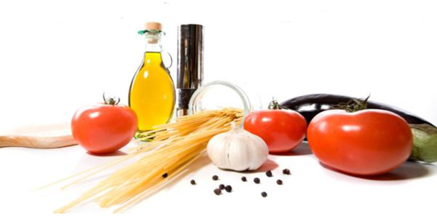
$26.00 Per Person

