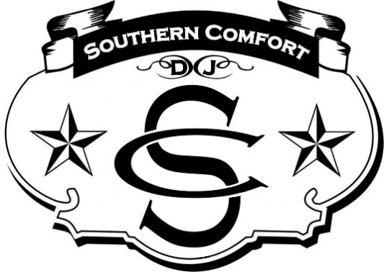

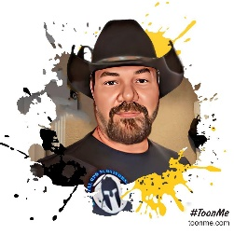

Howdy,

First let me thank you for considering our services. We are a military veteran staffed group offering professional entertainment services to Central Texas. We specialize in Country music but don’t be fooled, we cover every spectrum of genre and decades with over 30 years of experience. We offer several optional packages to suit any needs and budget.

Starting Package:
$500 – up to 5 hours
Included with this package is our main state of the art musical sound system consisting of a lighted DJ Console, speakers/subwoofers, lighted towers with moving head spotlights and a DJ/MC.

Option #1 (Remote Ceremony Kit)
$100 – up to 2 hours
If the ceremony portion of your event is in a separate area where an additional and portable sound system may be required, this additional option is for you. This will include a state of the art portable and battery-operated music system to include a DJ Portable console/tablet, 2 remote 8” speakers and lapel/handheld microphone with stand.

Option #2 (Cocktail Hour Kit)
$100 – up to 2 hours
If the cocktail hour of your event is separate from your reception an additional portable and battery-operated musical system will be required. This will include a state of the art portable and battery-operated music system to include a DJ Portable console/tablet, 2 remote 8” speakers and lapel/handheld microphone with stand (if required).

Option #3 (Up lights)
$100
This option provides a 360-degree specialized and dynamic lighting system consisting of over 30 remotely operated lights. These lights can be customized to fill an entire room/area with designated colors of your choosing and or a mixable array as they move in sync with the music.

Option #4 (Haze and/or Fog)
$100
Haze or Fog will enhance your guest experience and provide an enhanced visual aid to all the lights throughout the venue. NOTE: Some venues do not allow Fog as old fog machines tend to leave a soapy film on the ground and furnishings. New ones as the ones we use do not. But if Fog is an issue, we also offer Haze, Haze is a water-based substance and leaves no residue. When selecting this option, you must confer with the venue to ensure they allow this type of enhancement.

Option #5 (Custom Monogram)
$100
We can create animated and static monograms to suit any occasion. Our monograms can be projected on a suitable surface ranging up to 12 x 12 feet. These are not your standard black & white monograms. This option will also include a 65” display which can also be used to display collage of photos throughout the event.

Option #6 (Glow Sticks)
$100
We offer 75 Pcs of Handheld Glow Sticks… These are party favors with 3 modes colorful flashing with on and off switch and completely reusable.

The going rate for most reputable/professional DJ’s in the country can average anywhere between $1500 - $2500 and up. As you can see, we try to keep costs to a minimum so you can spend more on other services for your event. Keep in mind, the musical portion of your event will be the most remembered one.

Again, thank you for your consideration and if you choose to afford us the opportunity to serve your event, you can do so by contacting us through any of the links or phone number below.

One last note, we are also bilingual (Spanish) and can provide our services in both English and Spanish. A $50 nonrefundable deposit will be required to secure our services on the date you choose. We also have several methods you may utilize to make the deposit.

You may contact or visit our pages below; we encourage you do, and see firsthand the professional services we provide.

Email: dj_southern_comfort_tx@yahoo.com

Visit our Facebook:
https://www.facebook.com/profile.php?id=100089339231712&mibextid=ZbWKwL

Visit our website:
http://www.dj-southern-comfort.com

YouTube:
https://youtube.com/@DJ_Southern_Comfort

For Booking Facebook YouTube

