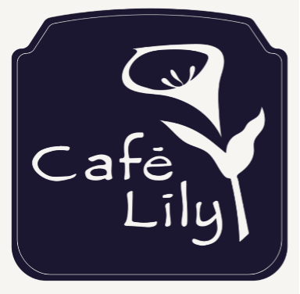
Anthony Pitillo, Executive Chef/Owner
Angelo Pitillo, Co-Founder
Katie McLellan, General Manager/Co-Owner
Sowmya Burugu, Bar Director/Co-Owner

Antipasti

Hummus Bi Tahini – served with warm pita bread and marinated olives $$2.50

Choice of Salad

Caesar Salad – garnished with shredded Grana Padano cheese $6.50

Insalata Mista – field greens tossed in balsamic vinaigrette, garnished with Roma tomatoes

Choice of Entrée

Petto di Pollo alla Parmigiano – breaded breast of chicken and capellini pasta baked in a savory tomato sauce, topped with imported Fontal, Asiago, and Pecorino Romano cheeses

Charbroiled Salmon Steak – garnished with mango-dried sour cherry salsa, served with lemon-garlic mashed potatoes

Gyros – fresh lamb tenderloin, marinated and chargrilled, served on warm pita with lettuce, sweet onion, tomato, and feta-dill sauce, served with French fries

Butternut-Squash Ravioli – pasta filled with a roasted butternut-squash stuffing and tossed in a sage brown-butter sauce, garnished with pecorino Romano cheese

(no substitutions, please)

Choice of Dessert

Lemon-Sponge Custard- Warm and topped with Fresh Chantilly Cream and Raspberry Sauce

$45 Per Person Plus Tax And Gratuity; $43 Per Person Without The Dessert Course

Café Lily
308-B W. Ponce de Leon Ave., Decatur GA 30030
(404) 371-9119
www.cafelily.com

