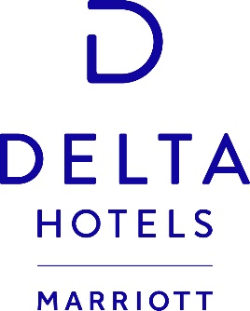
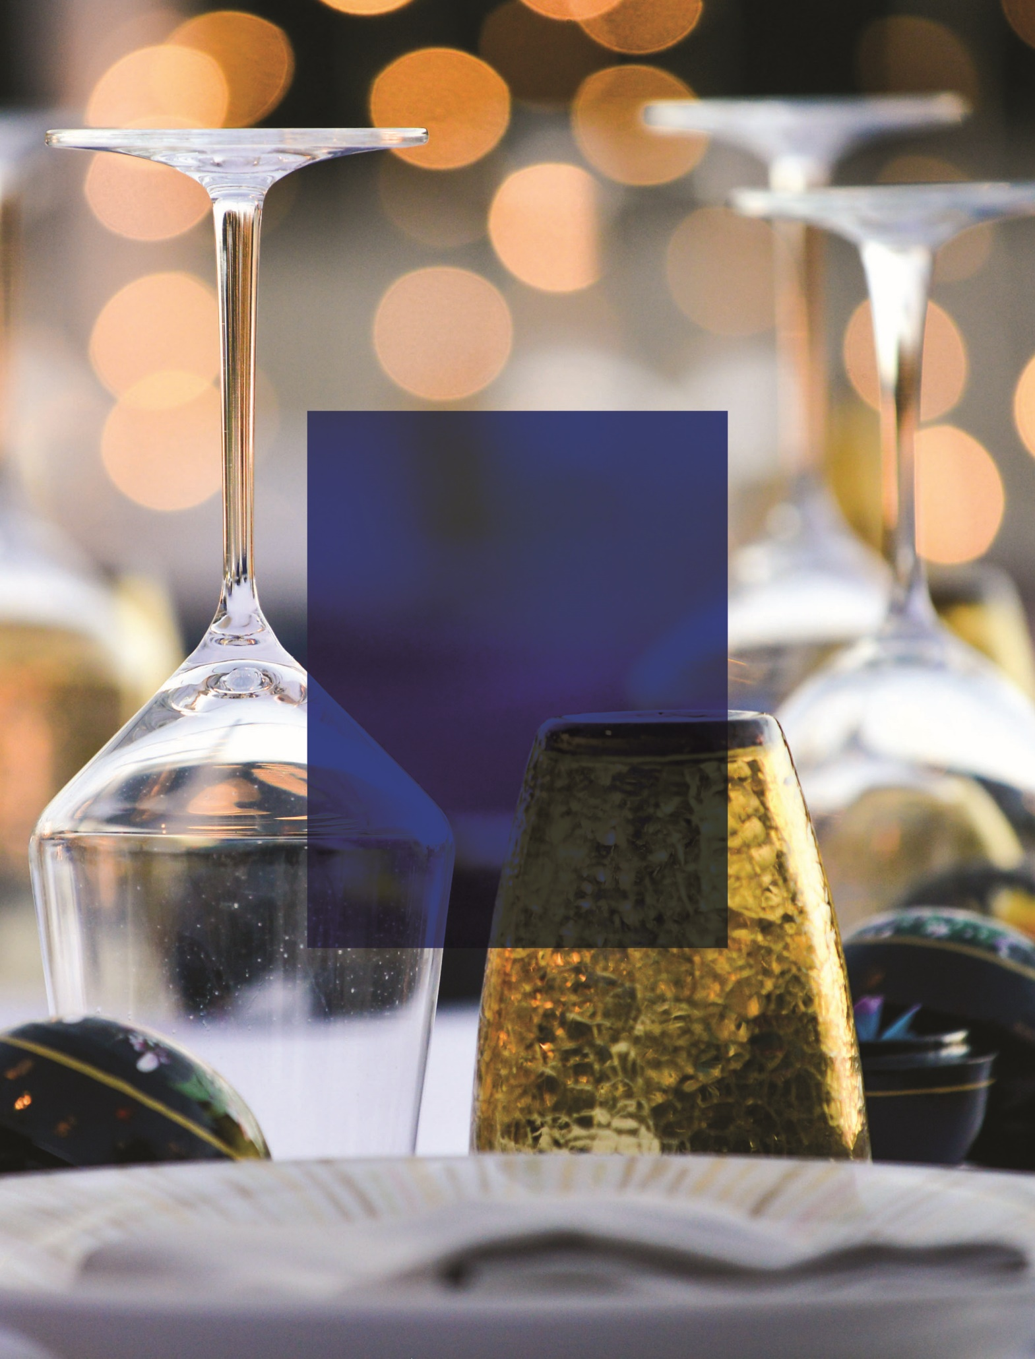
Delta Hotels by Marriott Detroit Novi
37529 Grand River Ave | Farmington Hills, MI 48335
tel 248.653.6060 fax 248.653.6061
Marriott.com/DTWDF
SIMPLY
PERFECT
EVENTS

BREAKFAST

Freshly Brewed Starbucks Coffee, Selection of Teavana Hot Teas, Skim and 2% Milks, Orange Juice, and Apple Juice are Included with Each Buffet Selection

SIMPLE START $12
Assorted Pastries, Muffins, and Bagels
Seasonal Preserves
Whipped Butter
Whipped Cream Cheese

HEALTHY START $15
KIND Bars
Sliced Fresh Seasonal Fruits
Yogurt Parfaits
Hard Boiled Eggs

DELTA DELUXE $16
Assorted Pastries and Muffins
Sliced Fresh Seasonal Fruits
Individual Assorted Greek Yogurts
Scrambled Eggs
Breakfast Potatoes
Choice of: Bacon, Sausage, Ham or Turkey Sausage

BREAKS

Breaks Are Available for One Hour, Minimum Of 15 Guests

EXECUTIVE $16
Fresh Sliced Seasonal Fruit, Vegetable Crudités with Light Dip, Assorted Cookies and Brownies, Assorted Soft Drinks, Bottled Water

TAKE A DIP $14
Hummus and Pita Chips, Salsa and Tortilla Chips, Assorted Soft Drinks, Bottled Water

COOKIES AND MILK $12
Freshly Baked Chocolate Chip Cookies, KIND Bars, 2% Milk, Almond Milk, Assorted Soft Drinks, Bottled Water
ENHANCEMENTS

Farm Fresh Scrambled Eggs $3
Waffles with Whipped Butter & Maple Syrup $4
Choice of: Bacon, Sausage, Ham or Turkey Sausage $3
Individual Assorted Greek Yogurts $3.25 Each
Fruit, Granola, and Yogurt Parfait $5.00 Each
Hard Boiled Eggs – $25 Dozen
Assorted Breakfast Pastries - $30 Dozen
(Blueberry Muffin, Cheese Danish, Chocolate Croissant, Carrot Cake Muffin)
KIND Bars - $2.50 Each
Cliff Bars - $3.25 Each

BEVERAGES

Freshly Brewed Starbucks Coffee, Hot or Iced - $32 Gallon
Hot Water with a Selection of Teavana Teas - $28 Gallon
Fresh Orange Juice or Apple Juice – $12 Carafe
Assorted Bottled Juices $3 Each
Assorted Still and Sparkling Waters – $3 Each
Assorted Soft Drinks (Pepsi products) - $2.50 Each
Lemonade or Iced Tea $22 Gallon

BEVERAGE PACKAGES

Includes Starbucks Coffee, Selection of Teavana Hot Teas, Iced Tea, Assorted Soft Drinks, Bottled Water

All Day Beverages $18 (Maximum 8 hours)
Half Day Beverages $14 (Maximum 4 hours)
Two Hour Beverages $12 (Maximum 2 hours)

LUNCH

BUFFET
Includes Iced Tea, Lemonade and Water Service; Minimum of 20 Guests

FIESTA $22
Mexican Salad with Mixed Greens, Red Onion, Tomatoes, Bell Peppers, Cucumbers, Corn, Garbanzo Beans, Shredded Cheese, and Cilantro Ranch Dressing, Tortilla Chips with Salsa & Guacamole, Cheese Quesadillas, Chicken Enchiladas, Beef Taquitos, Spanish Rice and Black Beans, Fried Mexican Cinnamon Churros, Assorted Toppings, Salsa, Sour Cream, Cheese, Hot Sauce

PIZZA & PASTA $20
Caesar Salad, Garlic Bread Sticks with Marinara Sauce, Assorted Pizzas, Penne Pasta with Alfredo Sauce

Add Chicken, Meatballs, or Italian Sausage +$4

DELI $18
Royal Garden Salad with Dressings, Sliced Smoked Ham, Turkey, Salami, Assorted Deli Cheeses, Ciabatta, Flatbread, Wheat Bread, Kettle Potato Chips & French Onion Dip, Homemade Pasta Salad, Assorted Toppings including Lettuce, Sliced Tomato, Sliced Onion, Pickles, Mayonnaise, Mustard

HOT POTATO! $15
Jumbo Baked Potatoes, Royal Garden Salad
Toppings Bar Includes: Cheddar Cheese Sauce, Steamed Broccoli, Crumbled Bacon, Chicken, Scallions, Sour Cream, Jalapenos

Add Beef or Veggie Chili +$2

BOXED LUNCH SELECTIONS

SANDWICH $16
(Choice of 2)
Roasted Turkey and Swiss Cheese with Lettuce, Tomato, Mayonnaise on Wheat
House Chicken Salad with Lettuce, Tomato on Flatbread
Italian with Ham, Salami, Cheese, Red Onion, Tomato, Lettuce, Vinaigrette on Ciabatta
Falafel Sliders on Brioche Buns

Veggies and Hummus
Freshly Baked Chocolate Chip Cookie

Selection of soft drinks and bottled waters

SALAD $17
(Choice of 2)
Royal Garden Salad with Chicken or Shrimp
Caesar Salad with Chicken or Shrimp
Greek Salad with Chicken or Shrimp
Crispy Asian Salad with Chicken or Shrimp

Warm Flatbread
Freshly Baked Chocolate Chip Cookie

Selection of soft drinks and bottled waters

*ASK YOUR SALES MANAGER FOR PLATED LUNCH MENU OPTIONS*

ALL DAY MEETING PACKAGE

Minimum of 20 Guests
Available from 8AM – 6PM Monday Through Friday

SIMPLY PERFECT MEETING $44

ALL DAY BEVERAGE SERVICE
Starbucks Coffee (Hot or Iced)
Selection of Teavana Hot Teas
Iced Tea
Assorted Soft Drinks
Bottled Water

SIMPLE START BREAKFAST
Assorted Pastries, Muffins, and Bagels
Seasonal Preserves
Whipped Butter
Whipped Cream Cheese
Skim and 2% Milks
Orange Juice
Apple Juice

BOXED LUNCH
Choice of Either Boxed Sandwiches or Salads

AFTERNOON BREAK
Choice of the TAKE A DIP or COOKIES AND MILK Break

DINNER

PLATED SELECTIONS
Includes Freshly Baked Rolls and Whipped Butter, Mixed Greens Salad or Soup Du Jour, Dessert, Starbucks Coffee, Teavana Hot Teas, Water Service

SHORT RIBS WITH RED WINE DEMI-GLACE $32
Served with Garlic Mashed Potatoes and Chefs Choice of Seasonal Vegetables

GARLIC ENCRUSTED PRIME RIB $36
Served with Au Jus, Garlic Mashed Potatoes and Chefs Choice of Seasonal Vegetables

CHICKEN MARSALA $28
Served with Roasted Red Skin Potatoes and Chefs Choice of Seasonal Vegetables

CHICKEN PARMESAN $26
Served over Penne Pasta with Marinara and Chefs Choice of Seasonal Vegetables

GRILLED SALMON $28
Topped with Garlic Herb Butter and served with Wild Rice Pilaf and Chefs Choice of Seasonal Vegetables

PORTABELLA MUSHROOM RAVIOLI $24
Topped with Garlic Alfredo Sauce, Sautéed Vegetables and Parmesan Cheese

CHOICE OF ONE DESSERT:
Cheesecake with Seasonal Fruit Topping
Flourless Chocolate Torte with Raspberry Compote
French Macarons

BUFFET SELECTIONS
Includes Starbucks Coffee, Teavana Hot Teas, Water Service, Cheesecake with Seasonal Topping for Dessert

DELTA SIGNATURE $32
Freshly Baked Rolls with Whipped Butter, Royal Garden Salad with Dressings, Fruit and Cheese Display

Choice of One Entrée Selection:
Southern Fried Chicken Breast, Bistro Chuck Tenderloin + Roasted Garlic Au Jus, Herb Crusted Chicken + Garlic Cream Sauce, Jerk Roasted Pork Loin + Pineapple Salsa, Beer Braised Pork Ribs + Southern BBQ Sauce, Cornmeal Fried Catfish + Cajun Remoulade

Choice of Three Side Accompaniments:
Herb Roasted Petit Potatoes, Mashed Roasted Red Potatoes, Green Bean Almandine, Seasonal Vegetables, Roasted Spiced Butternut Squash, Wild Rice Pilaf, Penne Alfredo, Penne Marinara

SOUTHERN COMFORTS $28
Mixed Greens Salad with Dressings, Pasta Salad, Baked Beans, Grilled Chicken Breast, BBQ Pulled Pork, Baked Macaroni & Cheese, Homemade Cornbread with Honey Butter

TASTE OF ITALY $25
Caesar Salad, Chicken Parmesan, Italian Sausage with Sautéed Peppers & Onions, Penne Pasta with Marinara Sauce, Chefs Selection of Roasted Vegetables, Garlic Breadsticks

HORS D’ OEUVRES

DISPLAYS
SMALL Serves 20 - MEDIUM Serves 50 - LARGE Serves 100

INTERNATIONAL CHEESE BOARD SM $75 MD $150 LG $300
Imported and Domestic Cheeses, Assorted Crackers, Garnished with Fresh Fruit and Berries

SWEET AND FRESH FRUIT SM $75 MD $150 LG $300
Fresh Sliced Fruits and Berries Accompanied by Honey Yogurt Dipping Sauce

VEGETABLE CRUDITÉS SM $75 MD $150 LG $250
Fresh Rainbow Crisp Vegetables Displayed with Chipotle Ranch and Guacamole Dips

INDIVIDUAL COCKTAIL BITES
Priced Per 50 Pieces, Butler Style Service Available

Caprese Skewers $125
Bruschetta $115
Fruit Kabobs $115
Deli Spirals $75
Shrimp Cocktail $165
Franks in a Blanket $90
Crab Cakes with Spicy Aioli $195
Bacon Wrapped Shrimp with Bourbon Maple Sauce $175
Coconut Shrimp with Chili Sauce $175

STROLLING STATIONS

ALL AMERICAN SLIDER STATION $18
Mini Angus Beef Cheeseburgers, Onion Rings, House Fries
Ketchup, Mayonnaise, Mustard, Pickles
(with Portabella Mushroom Burgers +.50)

DOWNTOWN CONEY STATION $14
Hot Dogs and Coney Chili, French Fries, Cheddar Cheese Sauce
Pickles, Relish, Ketchup, Mustard, Diced Onions

FRENCH FRY STATION $12
House Fries, Potato Tots, Spicy Cajun Shoestring Fries, Sweet Potato Fries, Poutine Gravy with Cheese Curds, Chili Sauce, Cheddar Cheese Sauce, Ketchup, Dijon Mayonnaise

DESSERT

NATALIE’S BAKERY MACARONS $2.50 Each, $26 Dozen
Assorted Flavors

NEW YORK CHEESECAKE $6
Choice of Topping: Fresh Strawberry Coulis, Chocolate Drizzle, Salted Carmel

FLOURLESS CHOCOLATE TORTE WITH RASPBERRY COMPOTE $8

NATALIE’S BAKERY CUPCAKES $3.75
Assorted Flavors, Choose up to Three Different Flavors

BAR SERVICE

One Bartender per 100 People
Minimum of 2 Hours of Service
Minimum of 30 Guests Required for Bar Service

HOUSE BRAND LIQUORS
Absolut Vodka, Captain Morgan Spiced Rum, Bacardi Rum, Tanqueray Gin, Jack Daniels Whiskey, Jim Beam Bourbon, Dewar’s Scotch, Jose Cuervo Tequila

PREMIUM BRAND LIQUORS
Grey Goose Vodka, Captain Morgan Spiced Rum, Bacardi Rum, Bombay Sapphire Gin, Crown Royal Whiskey, Maker’s Mark Bourbon, Chivas Regal Scotch, 1800 Tequila

BOTTLED BEER
Domestic Brands – Budweiser, Bud Light, Miller Lite, Coors Light, Michelob Ultra
Imported/Craft Brands – Corona, Amstel Light, Labatt, Heineken, Seasonal Craft Brews

WINE
Selection of Red and White House Wines

BARTENDER FEE $75
Fee is Waived with $500 or More in Bar Sales

CASH BAR
HOUSE BRAND MIXED DRINK $8
PREMIUM BRAND MIXED DRINK $10
DOMESTIC BEER $6
IMPORTED/CRAFT BEER $8
HOUSE WINE $8
SOFT DRINKS $4
BOTTLED WATER $5

HOSTED BAR
HOUSE BRAND MIXED DRINK $6
PREMIUM BRAND MIXED DRINK $8
DOMESTIC BEER $5
IMPORTED/CRAFT BEER $6
HOUSE WINE $6
SOFT DRINKS $3
BOTTLED WATER $4

Cash and Hosted Bars are Priced per Drink

OPEN BAR

HOUSE BRAND LIQUORS
One Hour $12
Each Additional Hour $6

PREMIUM BRAND LIQUORS
One Hour $14
Each Additional Hour $8

BEER AND WINE
Includes Four House Wines, Choice of 4 Beers
One Hour $9
Each Additional Hour $5
DETAILS

PRICING
Unless a specified menu with pricing is contracted, all standard menu prices are subject to change and can be confirmed no more than six months before the function date. Confirmation of the menu prices will be made by our Event and Sales Managers.

GUARANTEES
The final guaranteed number of guests is due by 12:00pm, three business days before the start of your event. Should the final guarantee not be received by this time, the original expected number of guests noted on the contract will be considered your minimum guarantee and may not be lowered.

PROVISIONS OF FOOD & BEVERAGE
To ensure the safety of our guests, all food & beverage must be purchased from our facility. Any non-consumed food and beverage items may not be removed from the facility.

SECURITY
All security personnel must be supplied by a Hotel approved guard or security agency. Please contact your event manager for assistance with these arrangements.

ALCOHOLIC BEVERAGES
If alcoholic beverages are to be served on the Hotel premises, the Hotel requires that only Hotel bartenders/servers dispense beverages. The Hotel’s alcoholic beverages license require the Hotel to (1) request proper identification (photo ID) of any person of questionable age, and (2) refuse alcoholic beverage service to any person who, in the Hotel’s judgment, appears intoxicated.

SIGNAGE
Signs may not be placed in the main lobby or outside the hotel. Your event manager will specify appropriate locations for signs throughout the building.
Under no circumstances are any items to be posted, nailed, taped, screwed, or otherwise attached to walls, floors or other parts of the building or furniture.

SHIPPING AND RECEIVING
Should you be shipping boxes for your event, shipping instructions are available through your Event Manager.

BANNERS
Hotel staff must hang all signs and banners in all meeting spaces. Service charges will vary based on the size and number of banners that you wish to hang.

ELECTRICAL, TELEPHONE, & INTERNET
The Hotel does charge for electrical, telephone, and Internet hook-ups. Your Event Manager can provide current pricing information.

