BREAKFAST PACKAGE
I n c l u d e d i n al l p ac k age s : Freshly Baked | Breakfast Pastri es | Chi l led
Assorted Frui t Jui ces | Freshly Brewed Coffee |

D E L U X E C O N T I N E N T A L
B R E A K F A S T
$18.00 per person

Assorted Bagels with Cream Cheese Fresh Seasonal Fruits
Individual Fruit Yogurt Cups Various Cereals & Granola Served with 2% and Skim Milk

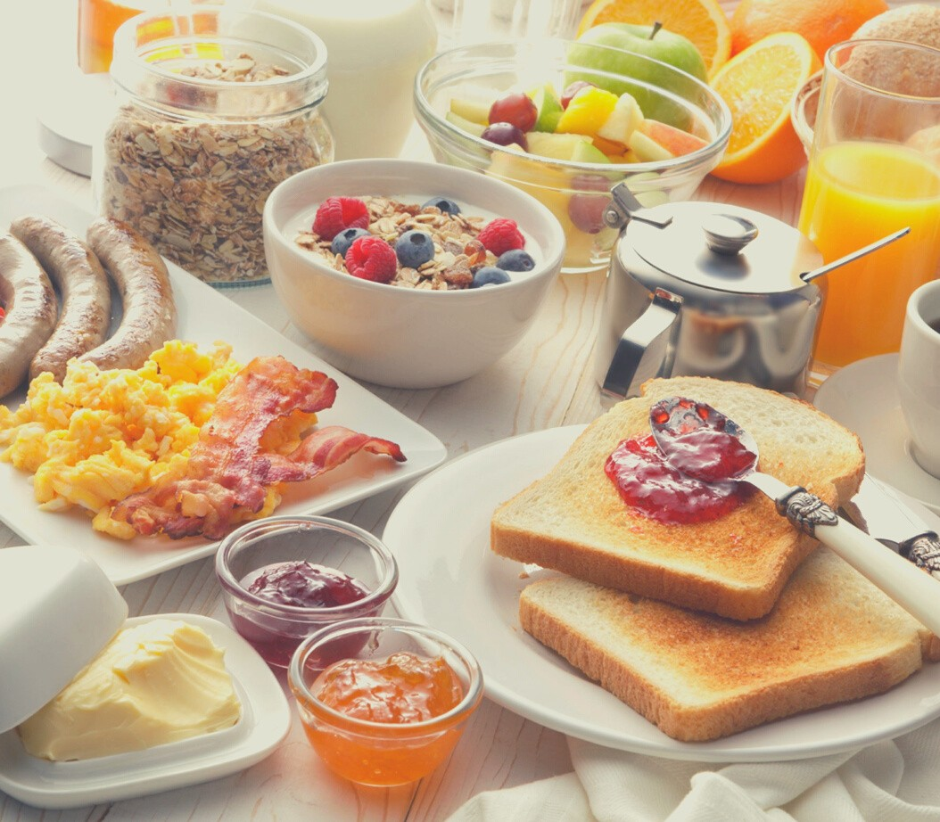
A L L A M E R I C A N B R E A K F A S T
$20.00 per person
Fresh Seasonal Fruits
Farm Fresh Scrambled Eggs with Cheese Applewood Bacon or Sausage Links Breakfast Potatoes

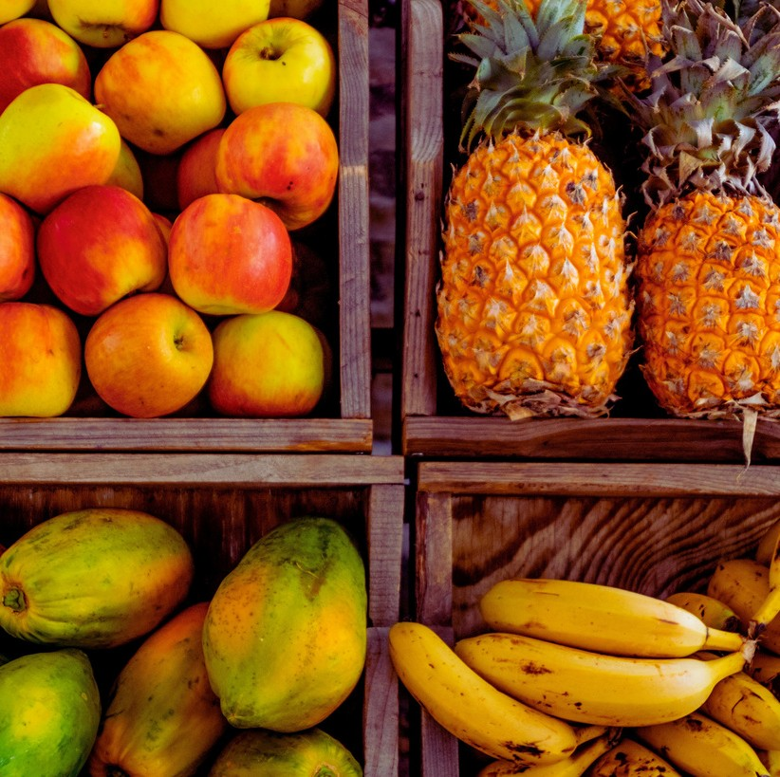
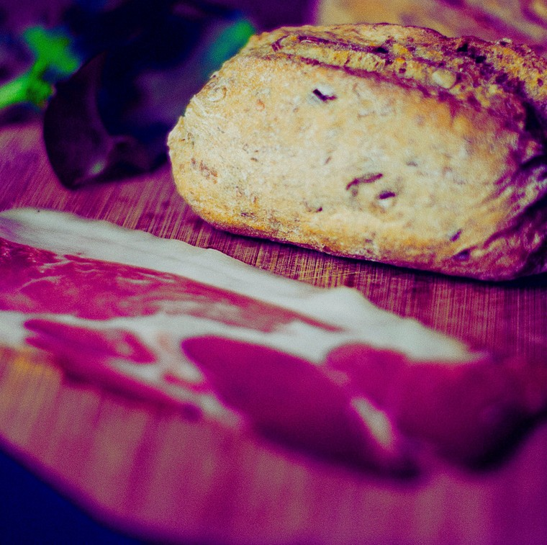

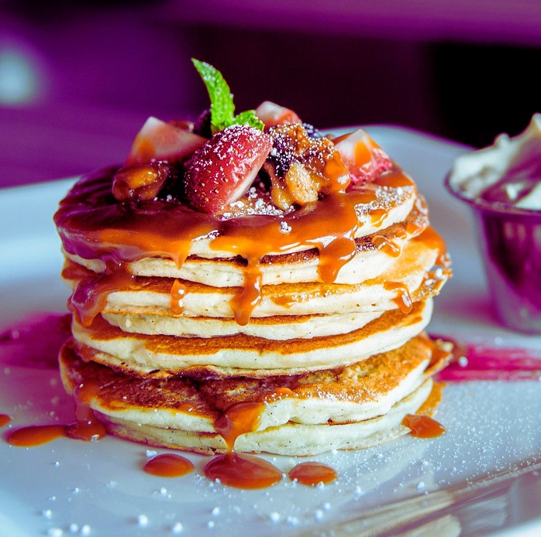
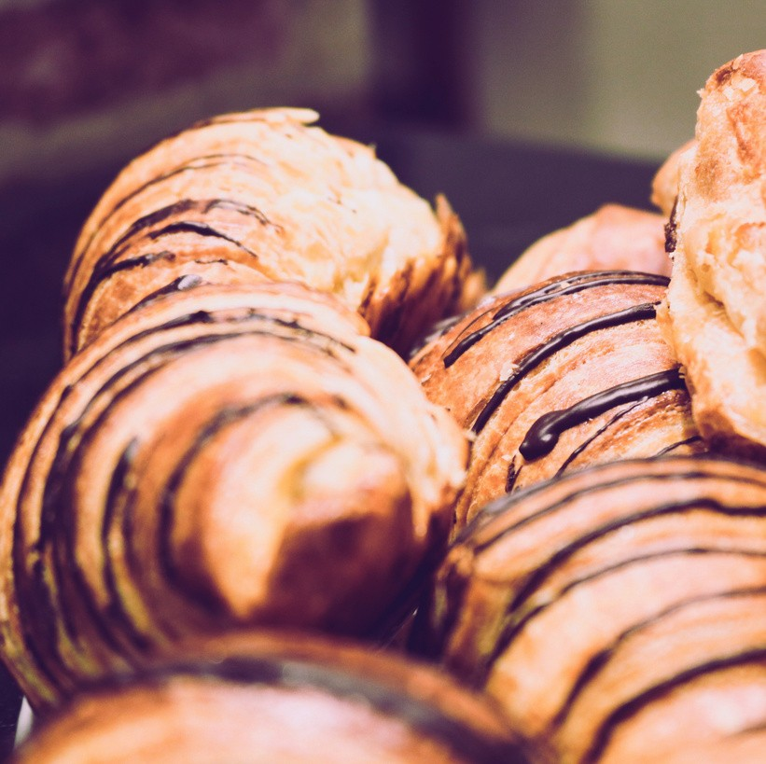
All pri ces are subj ect to 1 1 % Sales Tax and 22 % Servi ce Charge.

E X E C U T I V E B R E A K F A S T
$22.00 per person

Fresh Seasonal Fruits
Farm Fresh Scrambled Eggs with Chives Applewood Bacon or Sausage Links Breakfast Potatoes
French Toast or Pancakes

LUNCH PACKAGE
I n c l u d e d i n al l p ac k age s : Di nner Rolls | Freshly Brewed Coffee and Hot
Tea | Dessert |

S O U P , S A L A D & B A K E D
P O T A T O
$22.00 per person
Soup du Jour
Classic Caesar and Spinach Salads
Over-Sized Baked Potatoes served with Toppings of Cheddar and Monterey Jack Cheeses, Broccoli, Scallion, Peppers, Bacon, and Blackened Chicken, Hearty Chili, Butter & Sour Cream

M E X I C A N F I E S T A
$22.00 per person Chicken Tortilla Soup,
Tri-Color Tortilla Chips with Salsa

Add Beef: $26.00 per Person

Citrus Marinated Chicken Breast Strips, Tossed with Roasted Peppers, Onions, and Tomatoes Served with Flour Tortillas
Spanish Rice, Refried Beans Appropriate Condiments
Cinnamon and Sugar Covered Churros

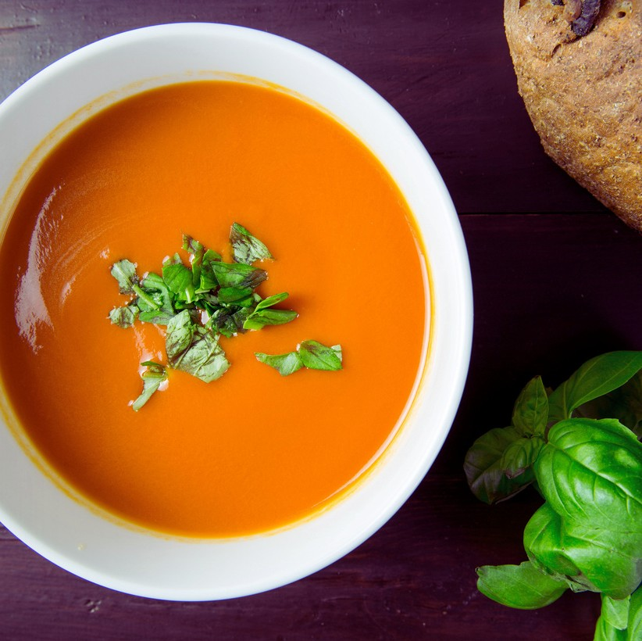
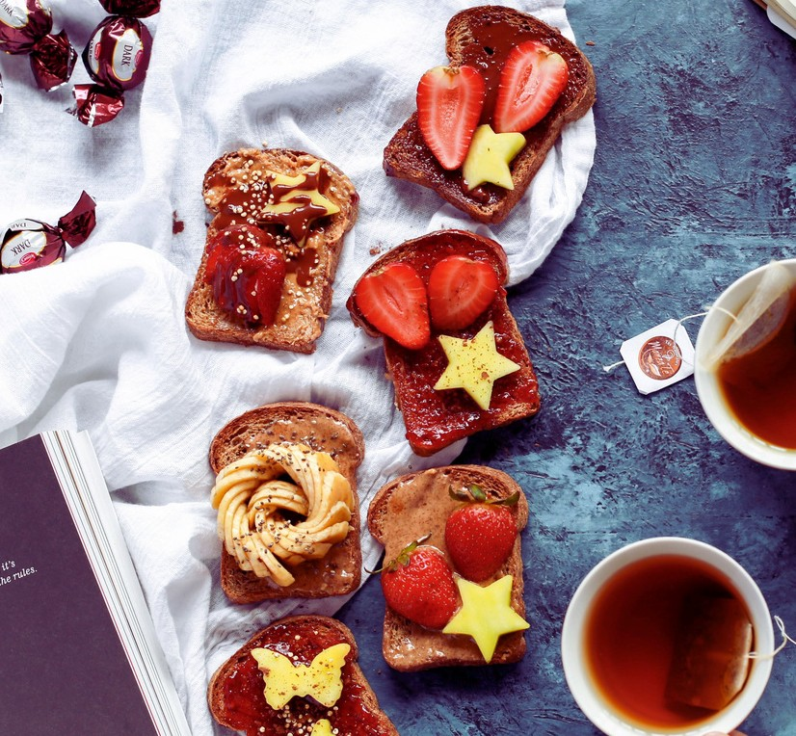

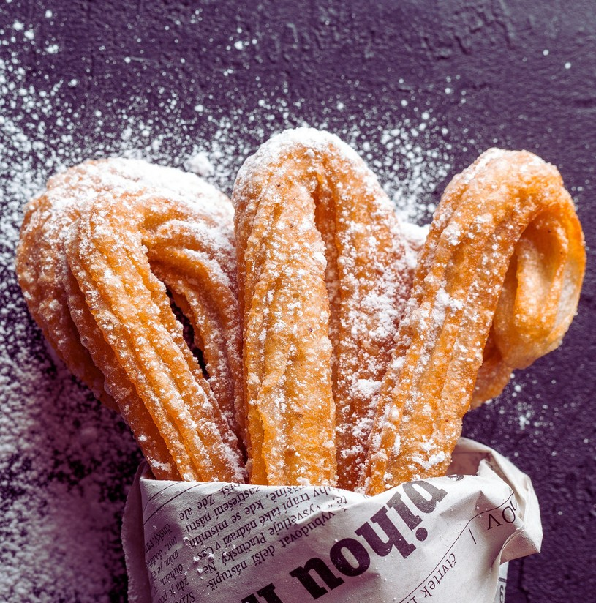
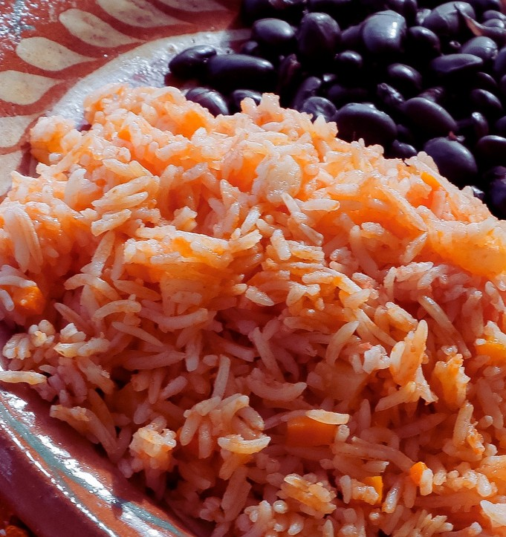
All pri ces are subj ect to 1 1 % Sales Tax and 22 % Servi ce Charge.

T H E " C L A S S I C " B U F F E T
$24.00 per person (Lunch) Choice of One (1)
$28.00 per person (Dinner) Choice of Two (2)
Soup du Jour or House Salad Meatloaf, Chicken, Pork Loin, London Broil, Broiled Tilapia
Garlic Mashed Potatoes or Wild Rice, Seasonal Vegetables

LUNCH PACKAGE
I n c l u d e d i n al l p ac k age s : Di nner Rolls | Freshly Brewed Coffee and Hot
Tea | Dessert |

P I Z Z A B U F F E T

$20.00 per person

House Salad
Assortment of Handmade Thin Crust Pizzas Baked Mostaccioli w/ Marinara
Warm Garlic Bread

T H E D E L I
$22.00 per person

House Salad
Potato Salad, Cole Slaw
Assorted Rolls and a Variety of Sliced Breads, Turkey Breast, Smoked Ham, Roast Beef with Assorted Sliced Cheeses, Crisp Lettuce and Vine-Ripe Tomatoes, Sliced Onions, Dill Pickles Homemade Chips
Assortment of Appropriate Condiments

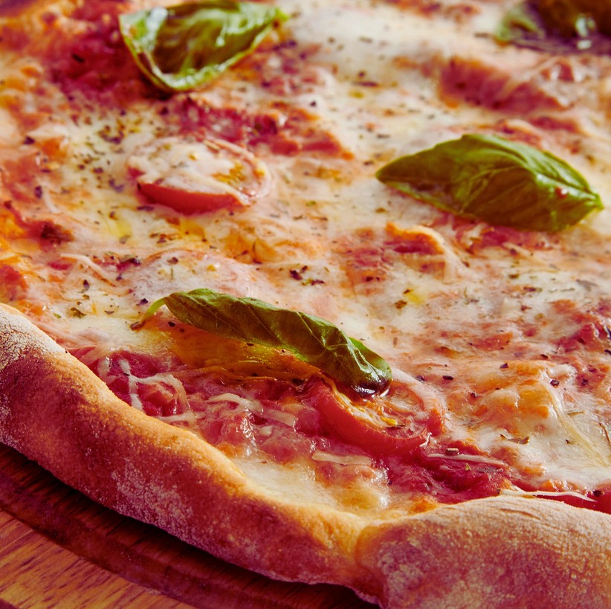
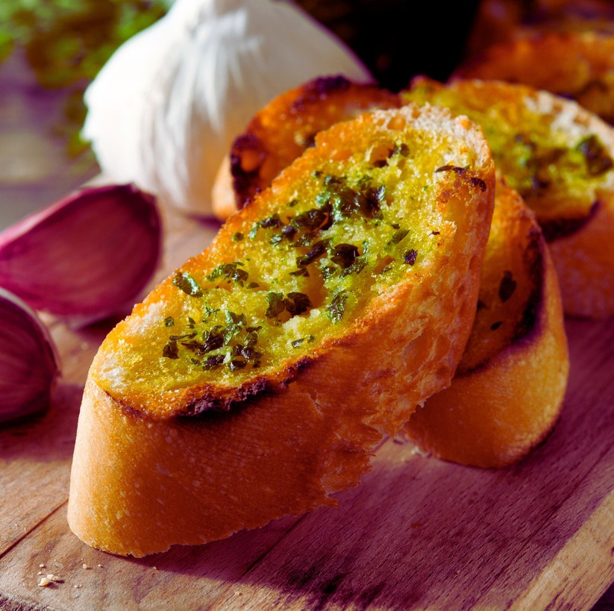

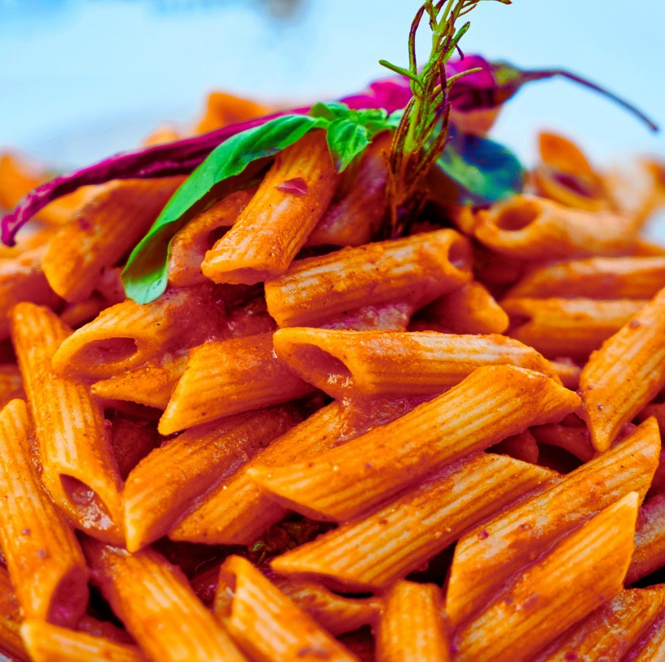
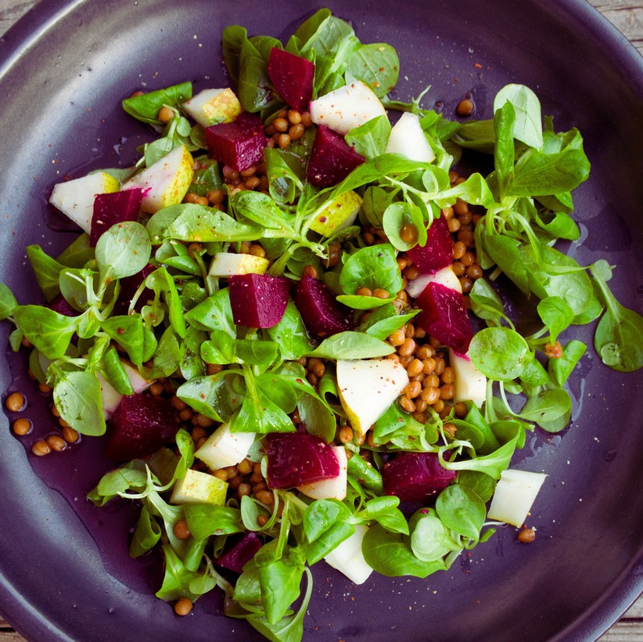
All pri ces are subj ect to 1 1 % Sales Tax and 22 % Servi ce Charge.

I T ' S A W R A P
$22.00 per person
Soup du Jour or House Salad Assorted Cold Wraps: Smoked Ham, Roasted Turkey, Roast Beef and Vegetarian,
Potato Salad, Homemade Chips, Dill Pickles
Warm It Up: Chicken, Steak and Vegetarian Wraps $ 26.00 per person

DINNER PACKAGE
I n c l u d e d i n al l p ac k age s : Di nner Rolls wi th Butter | Freshly Brewed
Coffee and Hot Tea | Chef' s Choi ce of Dessert |
B u ffe t S t yl e fo r $ 3 8 . 0 0 p e r p e r s o n
S T A R T E R S

Choice of One (1):

Soup du Jour House Salad Caesar Salad
S I D E S

Choice of Two (2):

Rice Pilaf Wild Rice Roasted Red Potatoes Garlic Mashed Potatoes Sauteed Vegetables
Steamed Broccoli with Butter

E N T R E E S
Choice of Two (2):
Citrus Tilapia with Wine & Ginger Sauce Grilled Salmon with Bourbon Sauce
Chicken Piccata with our Caper Wine Sauce Chicken Marsala with Mushrooms Herb-Roasted Chicken
Pork Medallions-Apple Chantilly Sauce London Broil with a Mushroom Sauce Penne Pasta Pesto with vegetables

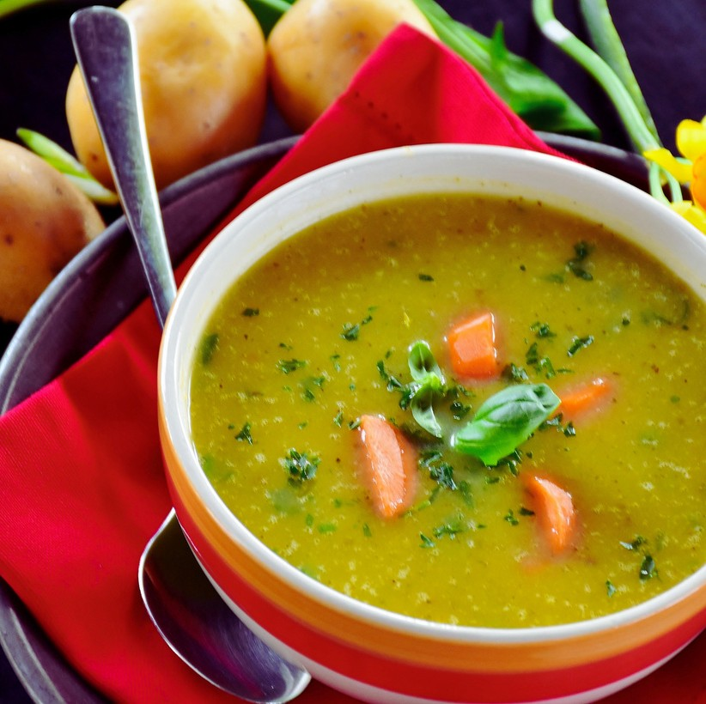
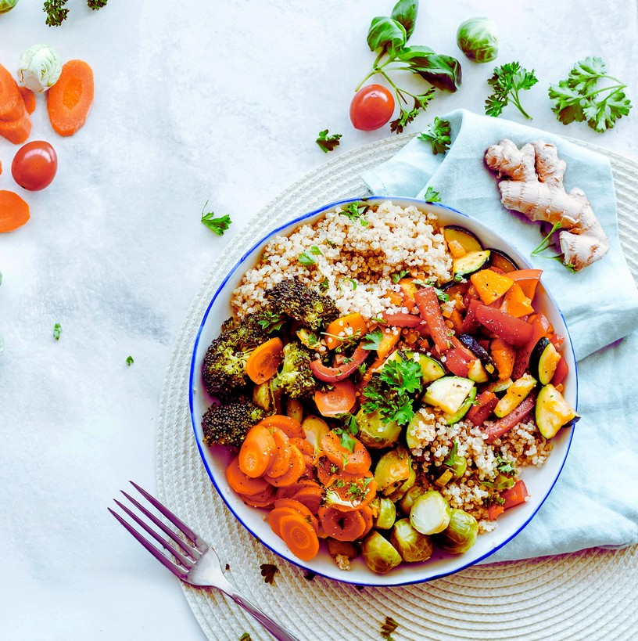

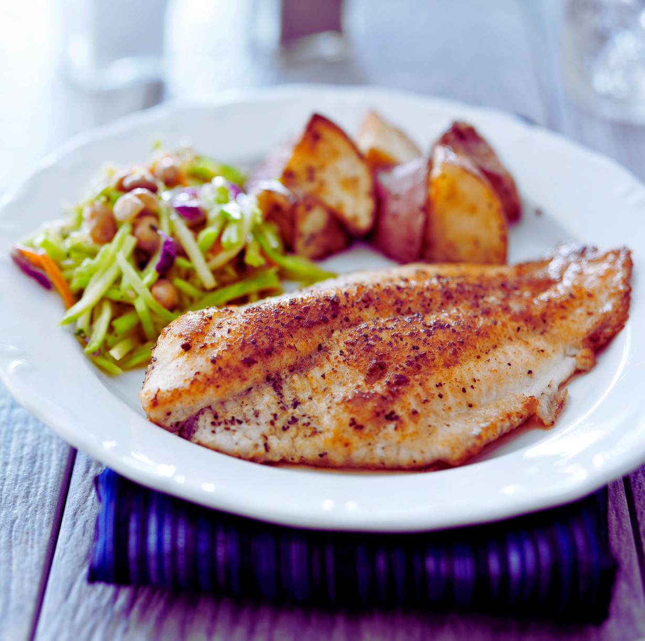
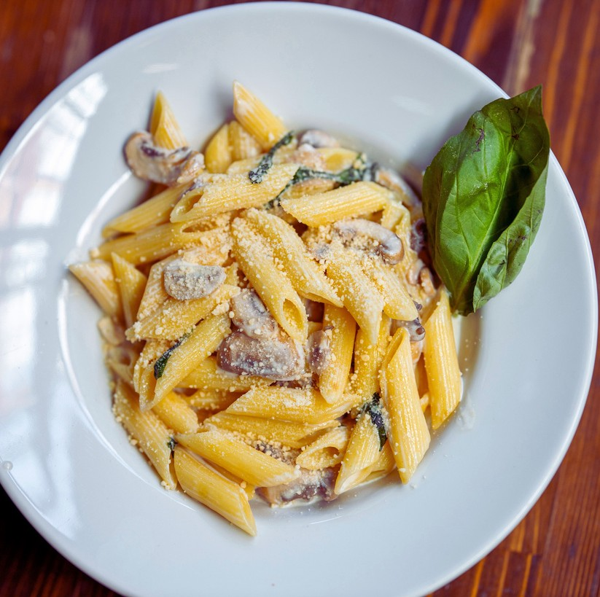
All pri ces are subj ect to 1 1 % Sales Tax and 22 % Servi ce Charge.
E N H A N C E M E N T S
Prices are per person
Carved Sirloin of Beef
Carved Roasted Turkey Breast Carved Baked Ham
$15.00
$11.00
$10.00

A LA CARTE

S N A C K S
Prices are per dozen, individual item, or per pound

Assorted Cereal or Oatmeal Assorted Jumbo Cookies Chocolate Fudge Kahlua® Brownies
Assorted Breakfast Breads & Pastries Various Bagels with Cream Cheese Seasonal Whole Fresh Fruit
Granola & PowerBars
Assorted Individual Fruit Yogurts Pretzel Sticks with Warm Cheese Sauce Premium Mixed Nuts
$4.00 each
$20.00 dozen
$20.00 dozen
$24.00 dozen
$24.00 dozen
$2.00 each
$2.00 each
$2.00 each
$4.00 each
$24.00 per lbs

Regular and De-caffeinated Coffee | $38.00 | gallon
Hot water& Assorted Individual Tea Bag Flavors | $38.00 | gallon
HotChocolate with Marshmallows | $38.00 | gallon
Iced Tea or Lemonade | $35.00 | gallon
Fruit Punch | $35.00 | gallon
Assorted Ju ice Bott les | $4.00 | each
Bottled Water | $3.00 | each
Assorted Sodas | $3.00 | each
Milk - 2%, Skim, or Chocolate | $2.00 | each
Assorted Flavor Bott led Tea | $4.00 | each

All pri ces are subj ect to 1 1 % Sales Tax and 22 % Servi ce Charge.

I T ' S A W R A P
Pricesareper carafe,pitchers, or individual item.

COLD HORS D'OEUVRES
P r i c e s ar e p e r p e r s o n

P L A T T E R S
Fresh Crudites and Dips Sliced vegetables and ranch dip
$5.00 per person

Fresh Seasonal Fruit Display
Fresh seasonal fruits with Yogurt dipping sauce
$5.00 per person

Grilled Vegetables Platter
Assorted seasonal vegetables lightly charbroiled and drizzled with balsamic glaze
$5.00 per person

Domestic and Imported Cheese
A variety of International and Domestic cheese Served with a selection of crackers
$7.00 per person

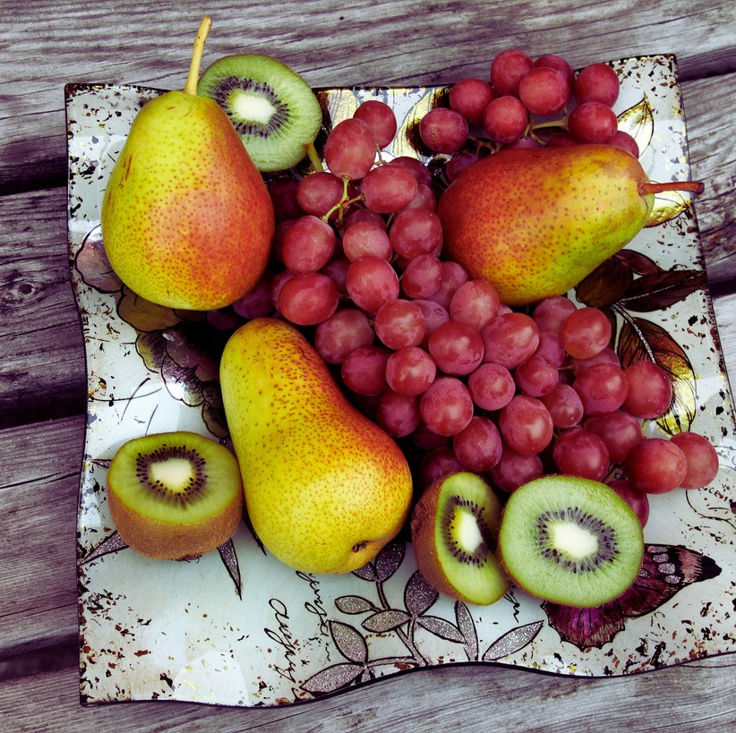
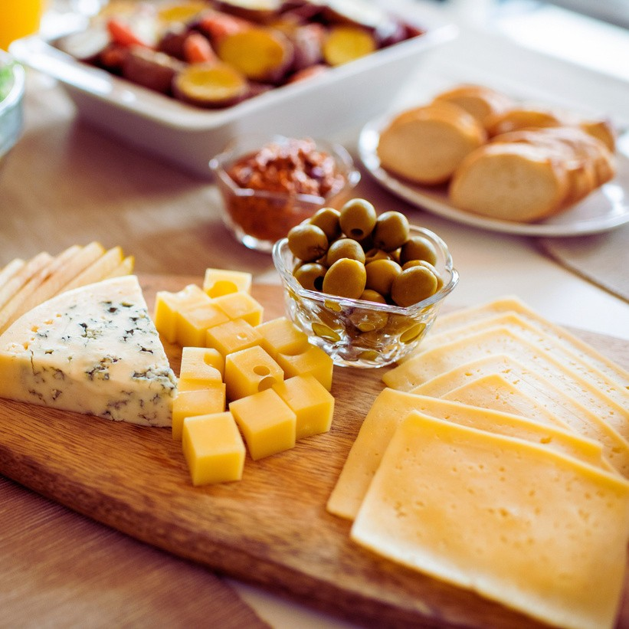

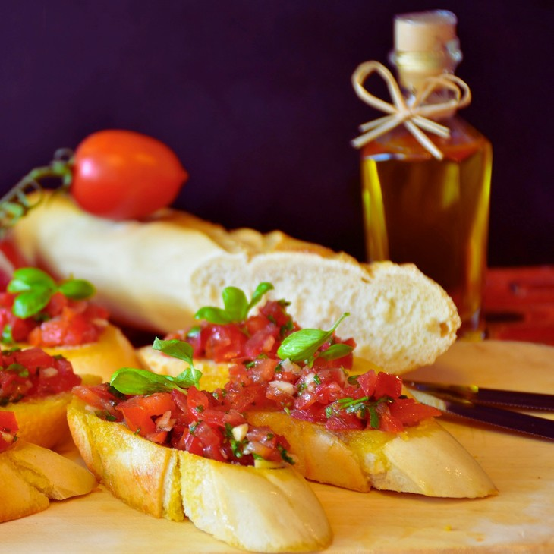
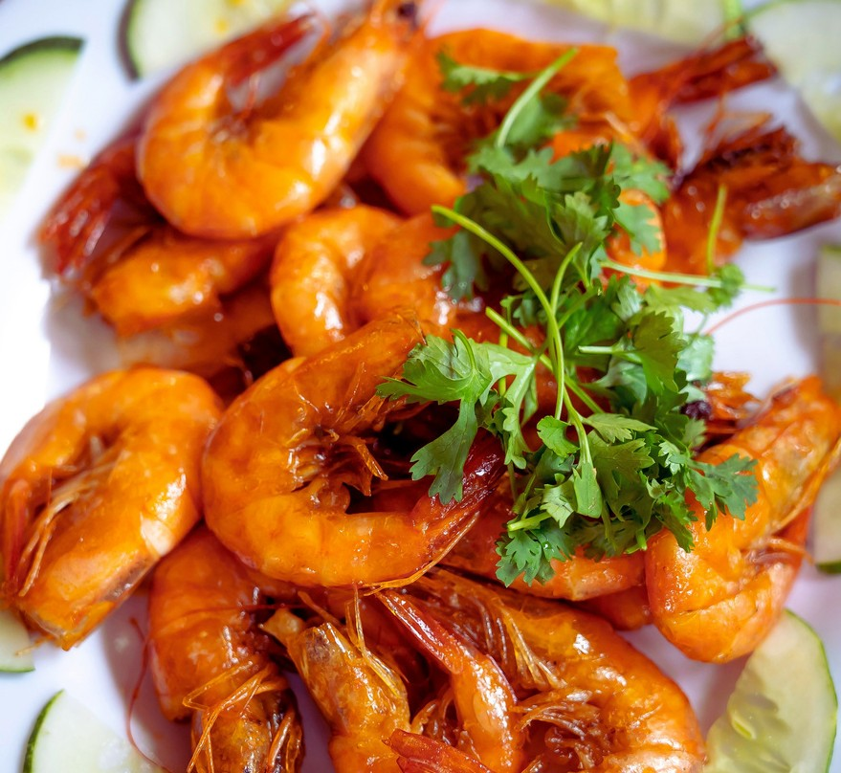
All pri ces are subj ect to 1 1 % Sales Tax and 22 % Servi ce Charge.
H A N D H E L D S
Tomato Bruschetta Chilled Jumbo shrimp Salmon rosette Antipasto Skewers Finger Sandwiches
Asparagus & Prosciutto roll
Mozzarella & tomato skewers
$3.00
$6.00
$6.00
$4.00
$4.00
$5.00
$4.00

HORS D'OEUVRES
P r i c e s ar e p e r p e r s o n

H A N D H E L D S

Salmon Bourbon Skewers $6.00 Coconut Shrimp $6.00
Mini crab cakes $6.00

Spanakopita $5.00 Vegetable pot stickers $5.00 Miniature quiche $4.00 Vegetable egg rolls $4.00 Stuffed mushrooms $5.00

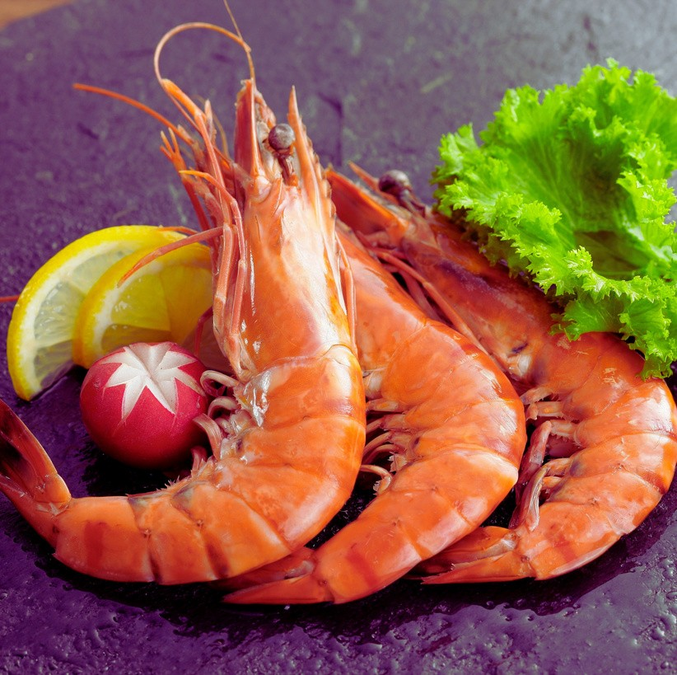
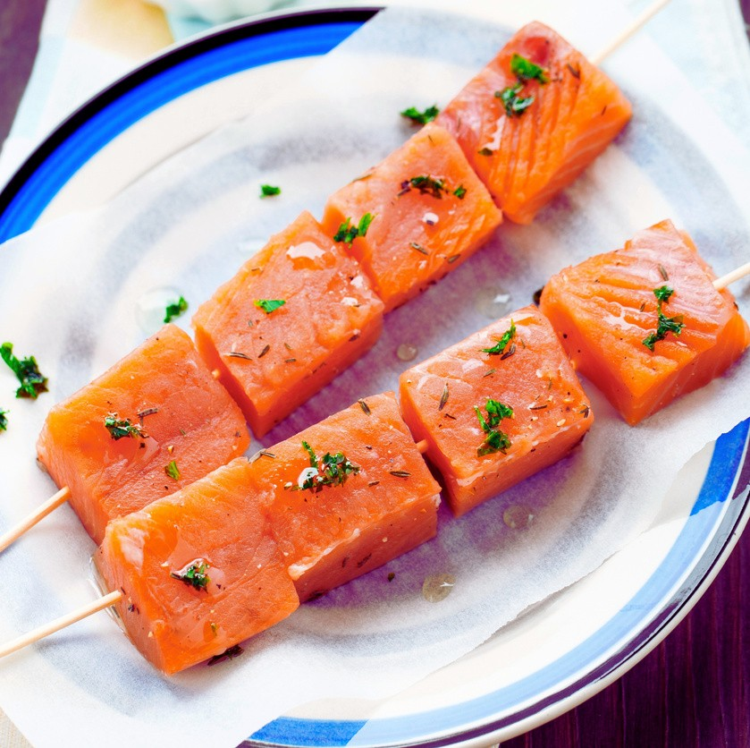

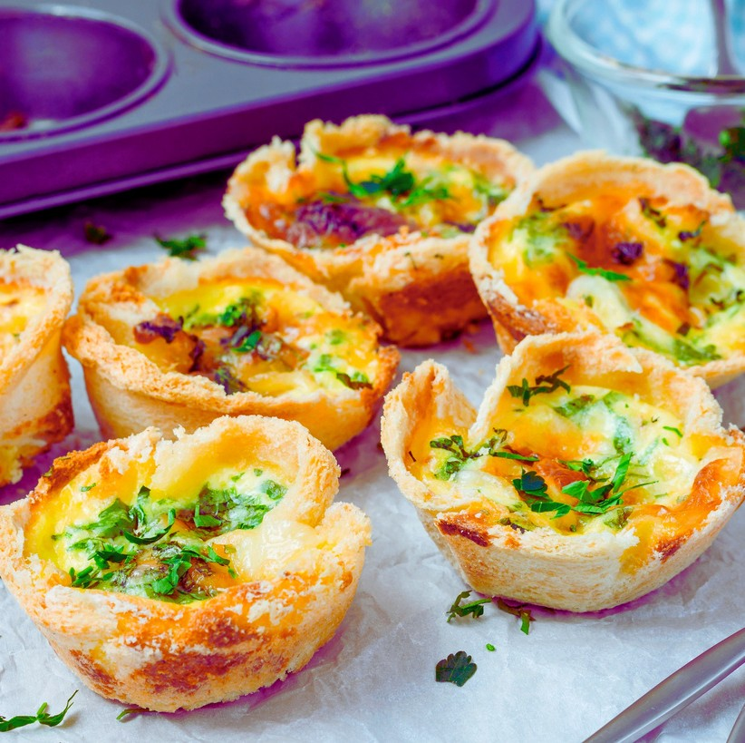
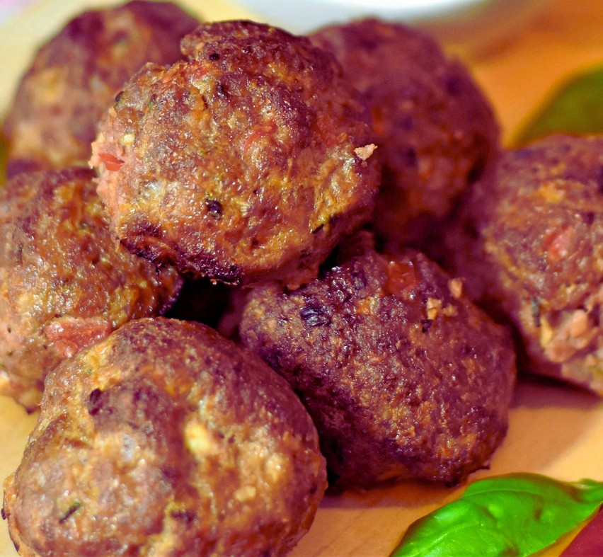
All pri ces are subj ect to 1 1 % Sales Tax and 22 % Servi ce Charge.

I N T E R N A T I O N A L I N F L U E N C E S
Pork empanadas | $5.00
Mango meatballs | $5.00
Sesame Chicken Skewers | $5.00
Teriyaki beef skewers | $5.00

ALL-DAY BREAKS
P r i c e s ar e p e r p e r s o n

R E F R E S H M E N T S
Chocolate Madness
Freshly Baked Chocolate Chip Cookies, Assorted Candy Bars, Double Fudge Kahlua ® Brownies.
$13.00 per person

A Healthy Alternative
Assorted Granola Bars, Trail Mix, Hummus with Pita Chips, and Fresh Sliced Fruit with dipping Sauce
$13.00 per person

Intermission
Homemade Potato Chips Served with Onion Dip, Colored Tortilla Chips Served with Guacamole and Salsa
$13.00 per person

The Ballpark
Pretzel Sticks served with cheese sauce, Roasted peanuts, Popcorn & Assorted Potato Chips
$13.00 per person

Afternoon Energizer
Cheese Tray with Assorted Crackers and Fresh Vegetable Platter with Ranch Dip
$12.00 per person

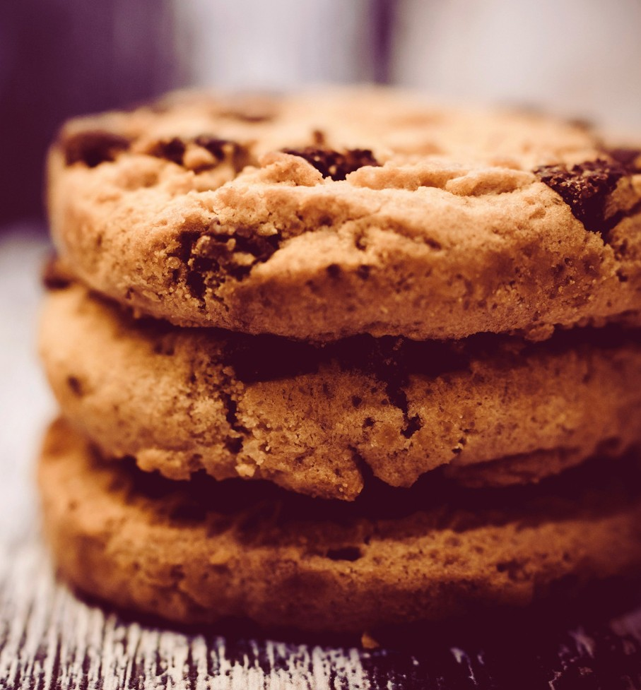
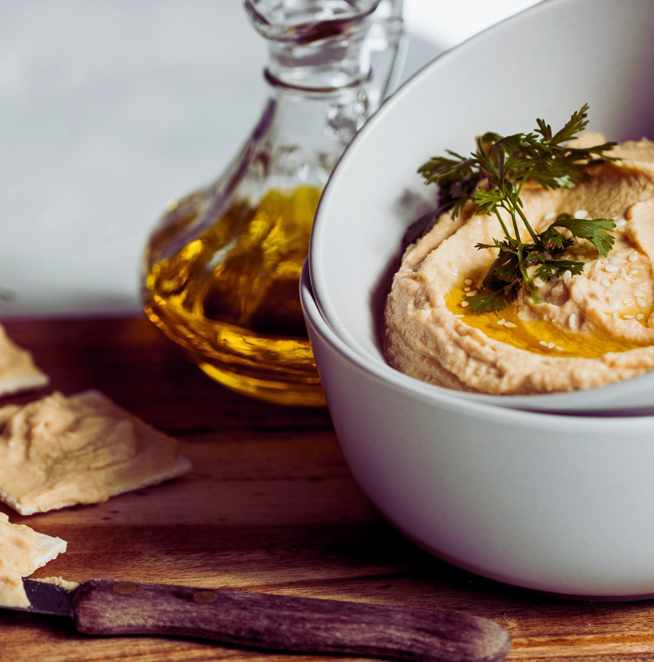
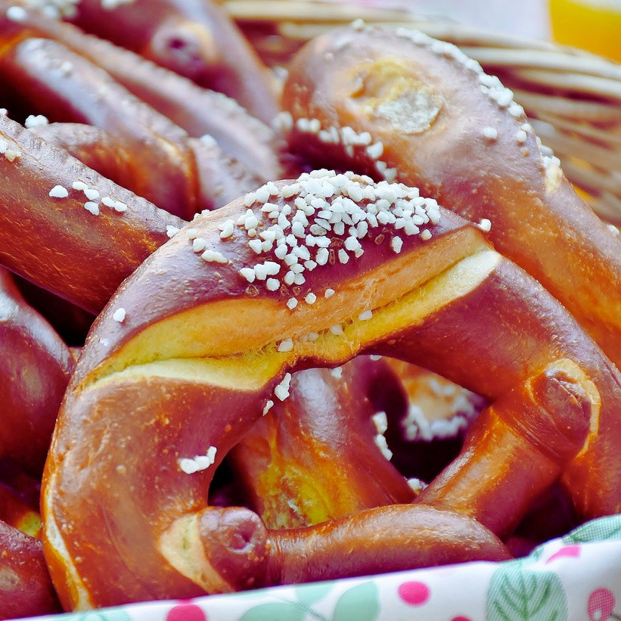

All pri ces are subj ect to 1 1 % Sales Tax and 22 % Servi ce Charge.

BEVERAGE PACKAGE
We are pleased to offer several di f ferent beverage servi ce opti ons desi gned to f i t the needs of your group and event. All Bar
Packages requi re a Bartender, wi th and addi t i onal Bartender Fee of $ 1 00 . 00 . Please note that sales and servi ce of alcoholi c beverages are regulated by the State of I l l i noi s . We I . D. al l i ndi v i duals and have the r i ght to refuse servi ce to anyone. State Law prohi bi ts guests from bri ngi ng any alcoholi c beverages i nto the hotel.
O P E N B A R
Open Bar Packages are available for a prearranged number of guests and feature an unlimited beverage service at no charge to your guests. Charges are based on a flat rate per guest for a pre- arranged number of hours.
H O S T E D B A R
Hosted Bar Packages are available for a prearranged number of guests and time frame at no charge to your guests. Charges are based on the actual number of drinks that are served.
C A S H B A R
Cash Bar Packages are available for a prearranged number of guests and time frame. All cash bars require your guests to pay for each beverage at the time of service, and are inclusive of applicable sale tax.
H O S T E D A N D C A S H B A R
All Host and Cash Bars require a minimum in sales of $300.00 and are designed for a minimum service for twenty-five (25) guests. Host and Cash Bars require a Bartender, and the Bartender Fee will be waived if a minimum of $700 .00 in sales is met.

All Packages i nclude: Call or Premi um Brand L i quors, Domesti c & I mported Beer, House Wi ne, Soft Dri nks, and Mi x ers.
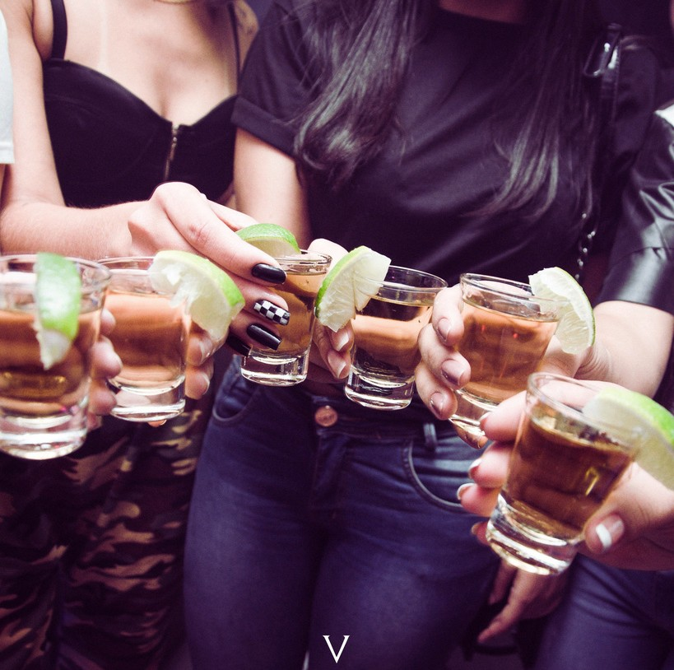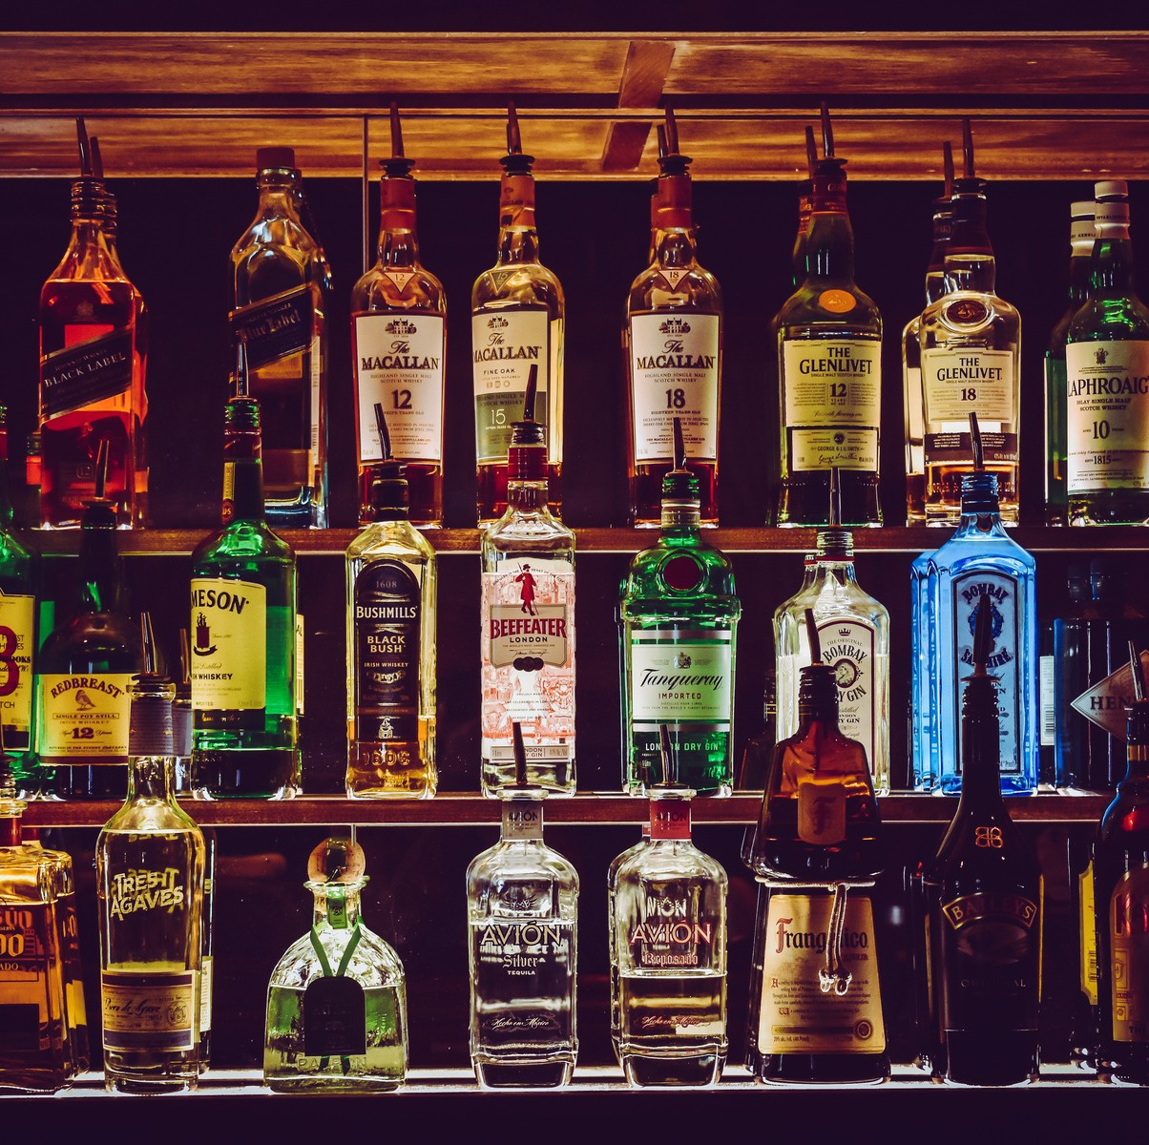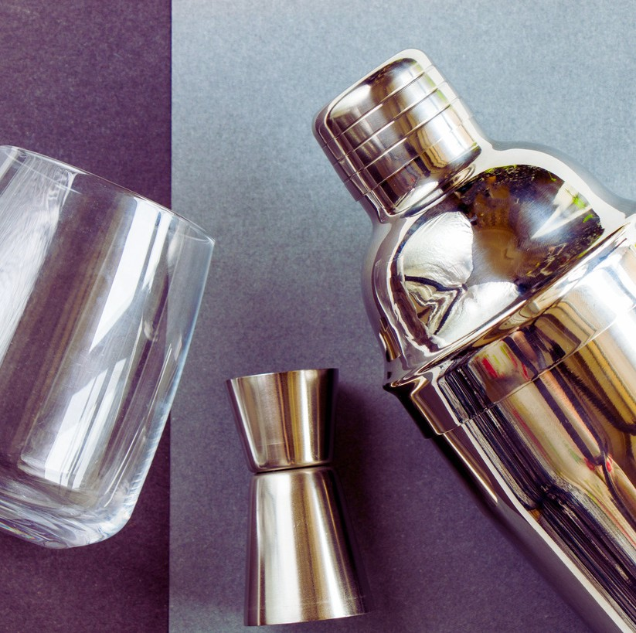

All pri ces are subj ect to 1 1 % Sales Tax and 22 % Servi ce Charge.

BEVERAGE PACKAGE
P r i c e s ar e p e r p e r s o n

O P E N B A R P R I C I N G
H O S T E D A N D C A S H B A R

 | First Hour | Second Hour | Third Hour | Fourth Hour
Call Brands | $17.00 | $22.00 | $22.00 | $32.00
Premium Brands | $21.00 | $26.00 | $26.00 | $36.00
Beer & Wine Bar | $15.00 | $20.00 | $20.00 | $30.00

 | Hosted Bar | Cash Bar
Call Brands | $6.00 | $7.00
Premium Brands | $7.00 | $8.00
Cordials | $9.50 | $10.00
Domestic Beer | $5.00 | $6.00
Imported Beer | $6.00 | $7.00
House Wine | $6.00 | $7.00
Bottled Water | $3.00 | $3.00
Soft Drinks | $3.00 | $3.00

All Packages i nclude: Call or Premi um Brand L i quors, Domesti c & I mported Beer, House Wi ne, Soft Dri nks, and Mi x ers.
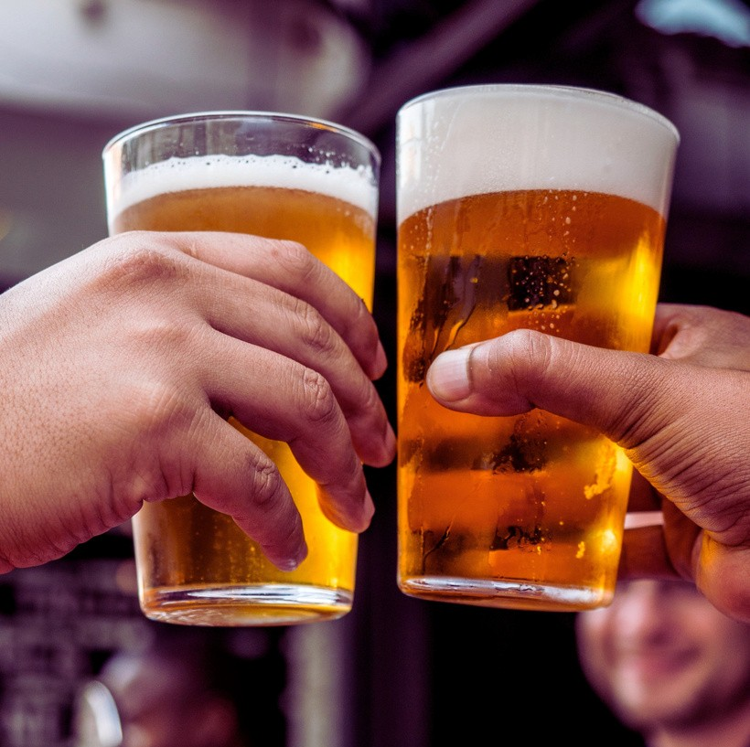
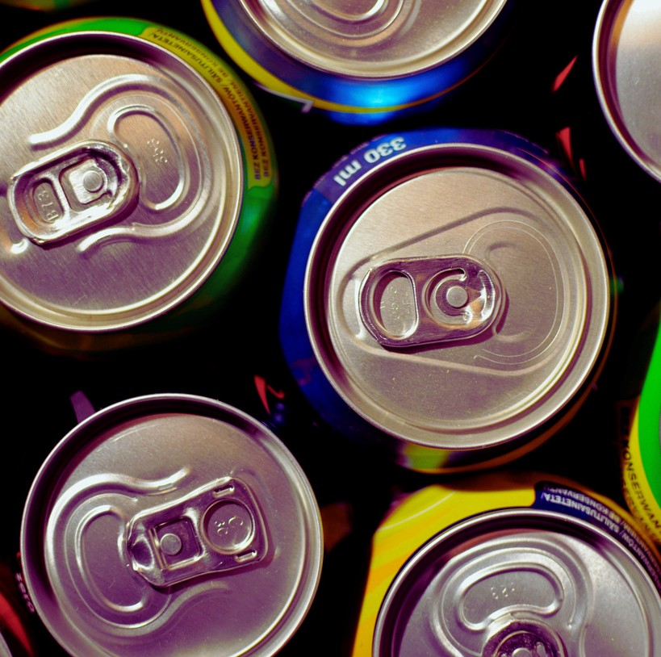
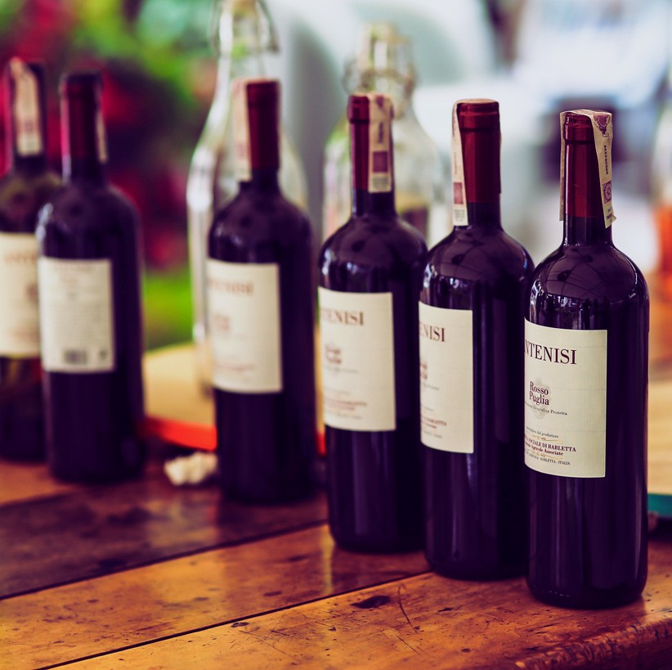

All pri ces are subj ect to 1 1 % Sales Tax and 22 % Servi ce Charge.

