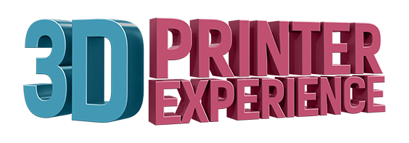

Private Event Rental Guide

Total Venue size: 3000 square feet
Maximum Capacity: 90 Guests

Rent our storefront for corporate meetings, private parties, and networking events! All rentals include support from a 3DPX event facilitator and access to our state-of-the-art integrated A/V system, which includes screens, built-in sound, and wireless microphones.

Daytime Venue Pricing
Monday-Saturday, 10:00AM - 6:00 PM

Rental Space | Max Capacity | Price (up to 3-hour rental) | Details
Cozy Corner | 10 | $250.00  *$50 per hour for additional hours | Our unique Cozy Corner is a colorful space carpeted in astroturf. Configure with comfy chairs and beanbags for an informal brainstorming session, or with a boardroom table for your next meeting. Includes a 46” presentation screen and A/V support.
Main Stage | 50 | $1000.00 | The Main Stage is ideal for your next presentation or seminar. With a 60” screen, integrated audio, wireless microphones, and seating for up to 50, this space is ideal for corporate outings, workshops, and demos. The space can also be configured cafe-style, with tables and chairs for interactive workshops and group projects.

After-Hours Venue Pricing

Weekends and after 6pm on weekdays.

Total Number of Attendees | Price (up to 3 hours) | Number of 3DPX facilitators
1 to 40 | $1,500 | 2
41 to 75 | $2,000.00 | 3
76 to 90 (MAX) | $3,000.00 | 3
$500 per hour for additional hours

Additional Notes:
The 3D Printer Experience Happy Hour gives guests the opportunity to enjoy select hors d’oeuvres and drinks while experiencing the “Intro to 3D Printing”; 3D Body Scans; and guided use of 3D design software.

Both Day and After-Hours rentals include support from event hosts who will assist with the AV system, direct guests around the space, and fulfill any venue-related requests.

The 3D Printer Experience can assist you with your catering needs! Inquire about our preferred partners, and let us do the leg-work for you!

Customize Your Event

Turn your event into an educational opportunity by adding a 3D printing Experience. Each Experience includes 3DPX facilitators, instructors, and/or design experts who can introduce guests to 3D Printing Technology.

Program Title | Max Group Size | Price / Person | Details
Introduction to 3D Printing | 50  *Minimum of 10 | $35.00 | Duration: 30-45 minutes
“Idea to Reality” | 6-24 | $50.00 | Use 3D Design muscles you didn’t even know you had by creating your own 3D item from scratch. Groups will work through the ideation of a new product within given parameters. 3DPX experts will assist you in the use of 3D design software and FDM-style 3D Printers to bring an idea to life and create a 3D prototype. Perfect for Corporate Outings or Team Building sessions  Duration: 120 minutes; optional luncheon
3D Printing Birthday | 6-12  Ages 8+ | $40.00 | Get hands-on guidance to create your very own 3D model in our design software then watch our 3D printers go to work to print your creations!
*Pricing for customized events includes venue fees

