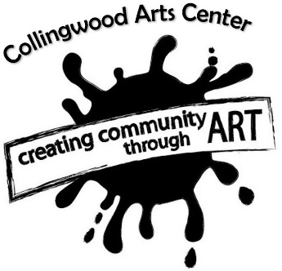

The Nelson - Formal Theater {Capacity 549}

4 Hours – (2 hour event) 2 Hours - Basic Lighting/Sound & Parking
Price: $575 or 2 consecutive days $875

5 Hours - (3 hour event) 3 Hours- Basic Lighting/Sound & Parking
Price: $650 or 2 consecutive days $950

6 Hours - (4 hour event), 4 Hours- Basic Lighting/Sound & Parking
Price: $700 or 2 consecutive days $1000

The Gerber House - Historic Mansion {Capacity 125}

3 Hours - (1 hour event), 1 Hour- 1st Floor & Parking
Price: $175
4 Hours - (2 hour event), 2 Hours- 1st Floor & Parking
Price: $250
5 Hours - (3 hour event), 3 Hours- 1st Floor & Parking
Price: $325
The Underground - Black Box Theater {Capacity 220}

5 Hours - (3 hour event), 3 Hours- Basic Lighting/Sound & Parking
Price: $350 or 2 consecutive days $450
6 Hours - (4 hour event), 4 Hours- Basic Lighting/Sound & Parking
Price: $450 or 2 consecutive days $550
The Dance Studio – Dance Studio w/ Mirrors {Capacity 40} $25 per hour (2 Hour Min.)
General Photography – Gerber 1st floor/Common Area Access $35 per hour (2 Hour Min.)
Boudoir Photography – Choice of Boudoir Suite $40 per hour or $50 for both (2 Hour Min.)
Library Photography – Historic Library $40 per hour (2 Hour Min.)

* Additional hours, amenities, staffing & tech available for events for an additional fee.

25% additional service fee for events scheduled less than 14 days in advance.

