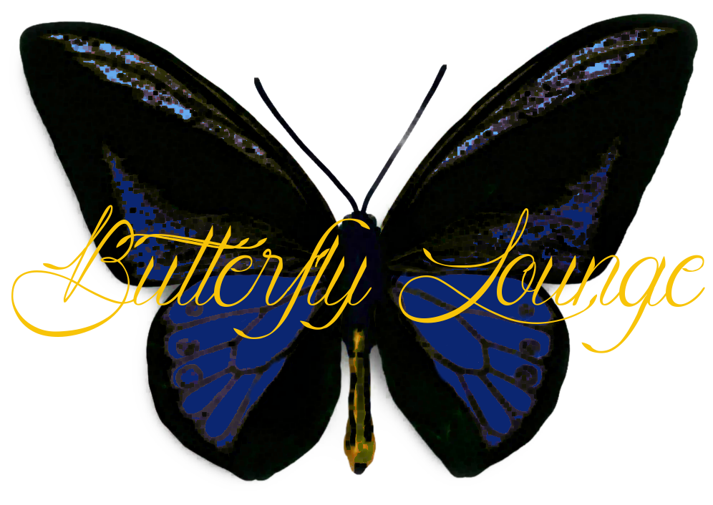

Glass Bottle
WHITE
Sparkling, Charleslafite, Brut, French 9 28
Champagne, Korbel, Sonoma County, CA, 2012 11 36
Moscato, Terra D’ Oro, CA, 2014 9 28
White Zinfandel, Montevina, Amador County CA, 2014 8 24
Riesling, Seaglass, Santa Barbara CA, 2013 8 27
Pinot Grigio, La Merika, Monterey CA, 2013 9 29
Sauvignon Blanc, Joel Gott, Napa Valley CA, 2013 9 29
Sauvignon Blanc, Bonterra, CA, Organic, 2014 10 32
Viognier, Bonterra, CA, Organic, 2014 9 30
Chardonnay, The Divining Rod, Central Coast CA, 2014 9 29
Chardonnay, Black Stallion, Napa Valley CA, 2014 10 32
Chardonnay, Hess, Monterey CA, 2014 10 30
Rose, Frisk, Lodi, CA, 2011 7 22
RED
Pinot Noir, Noble Vines, 667, Monterey, CA, 2014 9 30
Pinot Noir, La Merika, Central Coast CA, 2013 9 29
Merlot, Noble Vines 181, Lodi, CA, 2012 10 30
Malbec, Handcraft Artisan Collection, CA, 2014 9 30
Cabernet Sauvignon, Banrock Station, Australia, 2014 7 25
Cabernet Sauvignon, Menage A Trios, CA, 2013 9 28
Rioja, Ramon Bilbao, Limited Edition, Spain, 2013 13 35
Zinfandel, XYZin, CA, 2013 10 35
Zinfandel, 1000 Stories, CA, 2014 12 40

Limited Bottles
Champagne, Taittinger, France 96
Pinot Noir, Gundlach Bundschu, Sonoma Coast CA, 2013 70
Chardonnay, Raeburn, Sonoma County CA, 2014 45
Merlot, Clos Pegase, Napa Valley CA, 2013 54
Cabernet Sauvignon, Suhr Luchtel, Napa Valley, 2002 #225 68
Cabernet Sauvignon, Napa Wine Co, Napa Valley, 1999 #217 78
Cabernet Sauvignon, Hall, Napa Valley CA, 2013 80
Cabernet Sauvignon, St. Supery, Rutherford, CA, 2012 159
Tempranillo, Cruz de Alba, Spain, 2012 45
Bordeaux, Chateau Cap Leon Veyrin, Listrac-Medoc, 2003 #255 68
Bordeaux, Chateau Mongravey Margaux, France, 2013 68
Bordeaux, Chateau Simard Saint-Emilion, France, 2005 91
Red Wine, Hermitage M Chapoutier, Northern Rhone, 1994 #264 110

