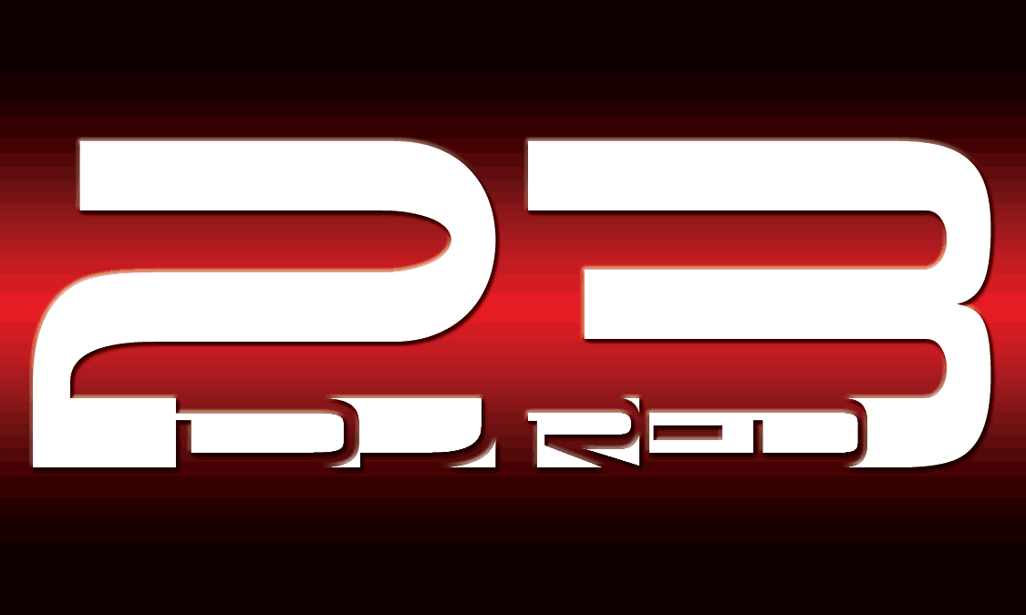

DJ RED23 SERVICE AGREEMENT (CONTRACT)

Event/Names:

Address:

City: State: Zip:

TEL #: Cell#:

Email: Referred By:

Event Date:

The Event will take place at: (site)

Address:

City: State: Zip:

Event Coordinators Name Contact #

DJ SERVICE RATES:

Birthday Party – Dance Music. Amount: $ ( hours total)

Equipment included day of event listed below: (Special Equipment might be additional)

The total amount for DJ services is $

$100.00 deposit is due at the signing of this contract (Non-Refundable)

Form of payment accepted: Cash, PayPal, Check payable to Ed Rojas

The balance of $ will be due on:

TERMS AND AGREEMENTS

Parties entering into this contract are permanently bound to fulfill the obligations by this agreement unless one or more of the following conditions apply: Both parties mutually agree to leave the agreement and its responsibilities. In the event that Ed Rojas (DJ RED23) becomes unable to provide his services due to complications beyond his control, a reputable replacement shall be provided at no more than the original price agreed on.

Any and all information or details must be communicated 5 days before preceding the event. Ed Rojas (DJ RED23) shall not be held liable for any action arising from or in connection with any individuals not directly affiliated with Ed Rojas (DJ RED23). Furthermore, the party(s) contacting Ed Rojas (DJ RED23) agrees to assume full responsibility for any and all damages caused by themselves or their guests involving any of Ed Rojas (DJ RED23) property.

The Client purchasing DJ Services of Ed Rojas (DJ RED23) agrees to allow using pictures taken the day of event for promotional purposes. I understand the terms and conditions described herein, and will abide by them.

Client Signature & Date

Ed Rojas (DJ RED23) Signature & Date

Ed Rojas Cell # 949-981-9821 or email: edrojas23@hotmail.com

NOTES:

