D&D | 2017-2018  SAMPLES MENUS
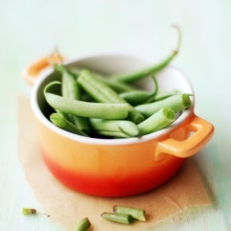  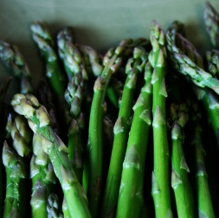  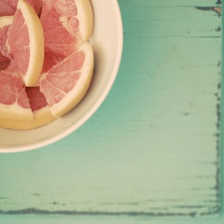  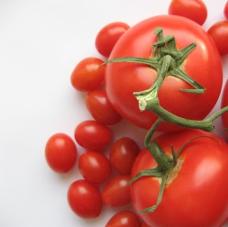 | COCKTAIL HOUR SAMPLE  Shrimp & Grit Shooters- Grilled Shrimp with onion and green peppers served over creamy grits.  Bacon Wrapped Chicken Breast Bites- Center cut bacon wrapped around tender chicken breast w/Honey mustard sauce.  Chicken & Waffle Bites- Crispy fried chicken bites served with buttermilk waffles/warm syrup.  Fresh Fruit Platter- Assorted seasonal fresh fruit selections  Mac & Cheese Tarts- Five cheese macaroni & cheese mini tarts.  Mini Hot Beef Sliders- Juicy ground beef sliders on Hawaiian rolls.  Cucumber Salad Bites- English cucumbers with roasted chicken salad  Signature Peach Tea- Handcrafted tea created by D&D  Lemonade Crush Punch- Handcrafted lemonade created by D&D  COCKTAIL HOUR SAMPLES  Spinach Spanakopita- Flaky phyllo dough filled with spinach & cheese  Crab Stuffed Mushrooms- Mushrooms filled with crabmeat  Grilled Chicken Skewers- Grilled chicken skewers w/dipping sauce  Seasonal Fresh Fruit Platter- Assorted seasonal fresh fruit  Crudites Platters- Assorted Vegetables w/dipping sauce  Seafood Salad in Martini Glasses- Martini glasses filled with delectable seafood mixture/crackers  Assorted Beverages- Handcrafted beverages created by D&D  DINNER MENU SAMPLE  Brown Sugar Glazed Ham- Baked ham with brown sugar glaze  Roasted Chicken w/Lemon Herb Butter- Roasted chicken with lemon and herb butter  5 Cheese Mac & Cheese- D&D famous five cheese macaroni & cheese  Vegetable Medley- Seasoned vegetables with butter  Mixed Field Greens w/Caesar Dressing- Assorted Salad greens/Caesar Dressing  Bread Baskets/Butter- Assorted breads/Butter  Assorted Beverages- Handcrafted beverages created by D&D  DINNER MENU SAMPLE  Roast Beef w/Au Jus- Slow cooked beef roast with light gravy  Grilled Salmon w/Citrus Glaze- Alaskan salmon with a lemon, thyme and butter glaze  Garlic Smashed Potatoes- Authentic Creamy garlicky potatoes with butter and sour cream  Braised Brussel Sprouts- Skillet braised Brussel sprouts with onion and bacon  Creamed Spinach- Creamy fresh spinach and parmesan cheese  Bread Basket/Butter- Assorted breads/Butter  Assorted Beverages- Handcrafted beverages created by D&D

