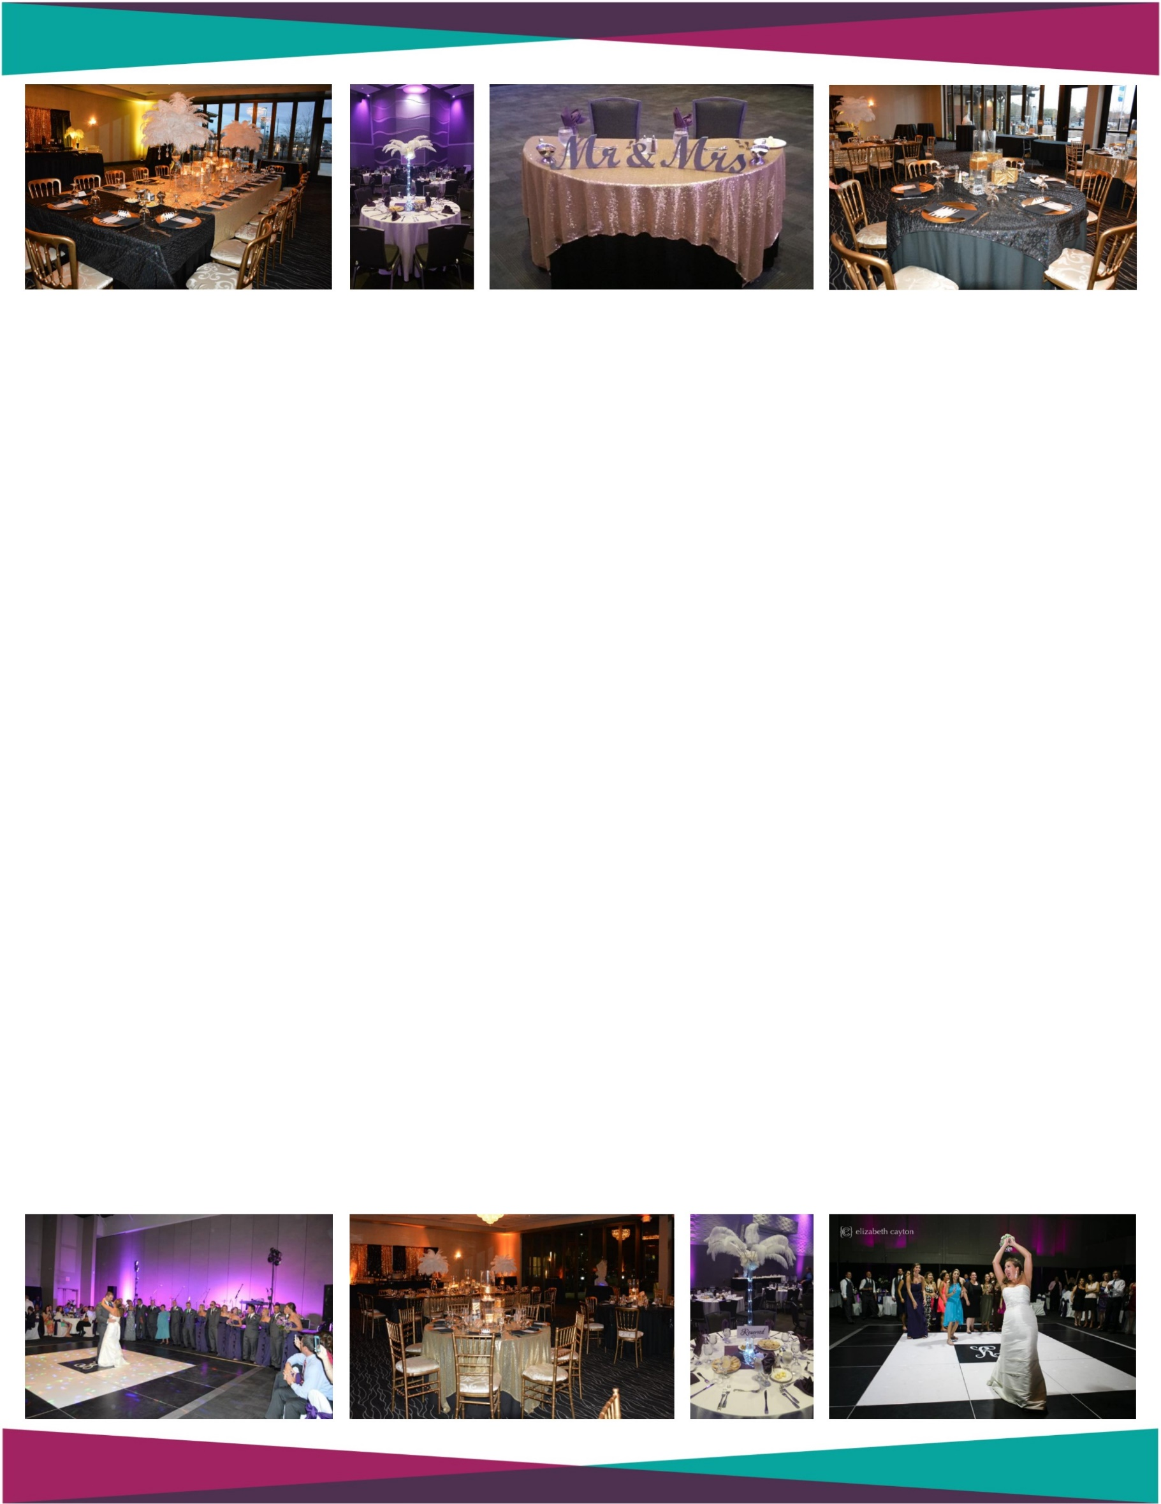
Wedding Reception
Date
Name: ____________________________
Phone Number: ____________________
Email: _____________________________
$1,500.00*
* for wedding receptions up to 150 people utilizing the Hilton Greenville as their caterer
The Hilton Greenville offers full service Catering Packages that average $25.00 - $35.00 per person plus tax and service

Package price includes the following:
Emerald Ballroom (approximately 3,000 square feet) for up to 12 hours
(to include decorating and reception time)
Black and White Dance Floor
60” round tables with (white, black, or ivory) Floor Length Linen
Black and Pewter Cushioned Chairs
LED Up-lights in color of your choice
Draped and skirted table for your DJ
Electricity for your DJ
Draped and skirted table for your Gifts and Cake
Setup Staff, Event Staff & Event Manager
Discounted Hotel Rooms / Take the Elevator Home
Congratulatory Message on Marquee day of Wedding

**Outside catering is allowed but will increase the package price to $2,300.00 (this includes the $2.00 per person outside catering surcharge for 150 guests). When utilizing outside catering, the customer is responsible for providing all of their own catering equipment and staff to include but are not limited to: kitchen, food prep staff, wait staff, dishwashers, china, silverware, glassware, food serving items, napkins, food cleanup, etc. **
***Due to NC ABC Permit laws, the Greenville Convention Center will be responsible for all alcohol sales and distribution.
All host bars require a deposit and/or credit card to guarantee payment of beverages served. ***
****To add separate space and chairs for ceremony an additional $750.00 will be charged above reception price. To add access to decorate the day before will incur an additional cost of $1,250.00 per room to cover the cost of space and labor. ****

NO FOOD AND BEVERAGE IS FACTORED INTO THIS PROPOSAL. | SPACE AVAILBILITY SUBJECT TO CHANGE. | QUOTED PRICE VALID FOR 45 DAYS.
.

