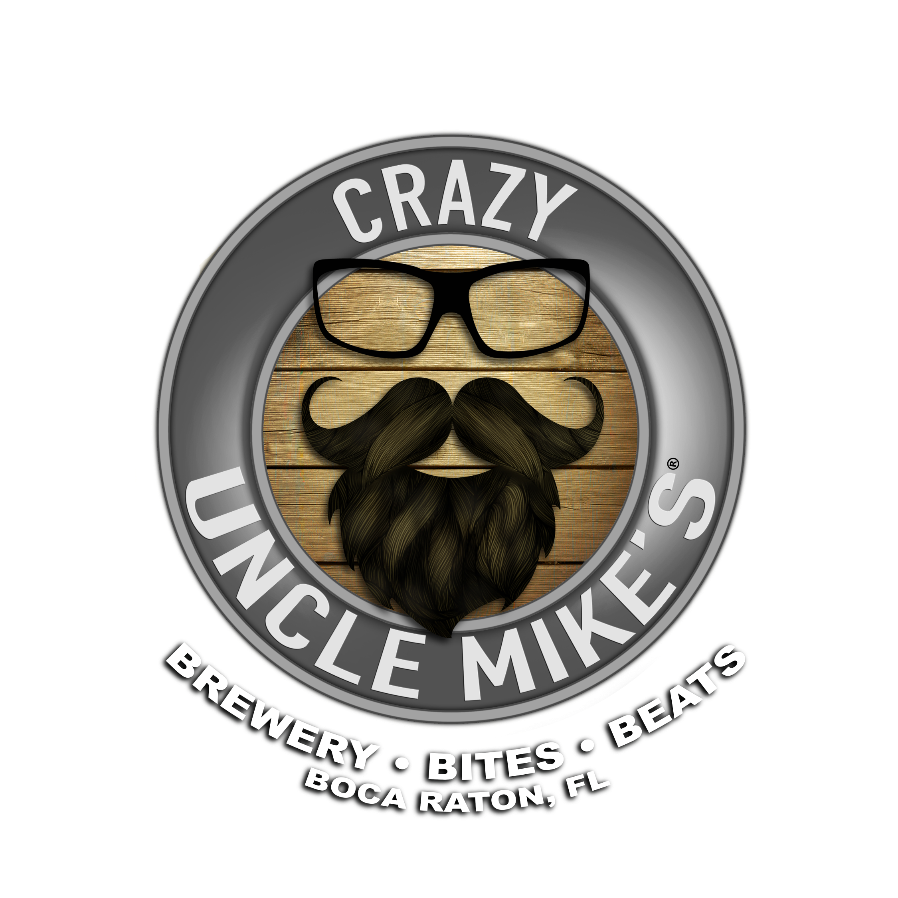

Crazy Uncle Mike’s specializes in entertaining private parties and special events of any size. We offer several options for private or semi-private functions that can be held inside our dining room or out on our spacious, fully covered patio. We can design packages for all occasions, and we will gladly do our best to accommodate any special requests your group might have. Pricing varies based on selected items and number of guests. If you have any questions give us a call at (561) 931-2889 or email us at info@crazyunclemikes.com

Drink Packages

(All drink packages are based in 1 hour of consumption)
(Please include 23% Service Charge & Gratuity & 7.1% tax)
(No shots or energy drinks)
(Product list available upon request)
*** Drinks by consumption available ***

Basic Beer & Wine Package - $25.00 per person.
Includes all you can drink house wines. House/Entry Blonde Ale, IPA, Porter, or Pilsner. Bar soda, juices and water.

Premium Beer & Wine Package - $40.00 per person.
Includes all you can drink select premium wines and premium beers. Bar soda, juices and water.

Open Well Bar Package - $35.00 per person.
Includes all-you-can- drink select wells, house beers and wines. Bar soda, juices, and water.

Premium Open Bar Package - $45.00 per person
Includes all-you-can- drink select wells, house beers and wines. Bar soda, juices, and water.

*** All Super Premium/Top shelf liquors purchase individually.

Drink Tickets/Cocktails and Brews
House Cocktails, wine and beer $5 per drink ticket
Well & Call liquor, wine and beer $9 per drink ticket

Food Packages

(All food packages are based in 1 hour of consumption or 1.5 bites per person)
(Please include 23% Service Charge & Gratuity & 7.1% tax)
(Custom menus available) (Custom sandwich spreads available)
***Food by consumption available ***

Dips
Guacamole and Chips
Baba Ghanoush with Pita

Appetizers
Chicken Wings (BBQ, Garlic & Herb, or Gochujang)
Bacon Croquettes w/ maple oil
Charcuterie
Kung Pao Chicken Skewers
Grilled Broccoli

Salads
Lil’ Gem Caesar Salad
Gorgonzola Spring Mix Salad

Flatbreads
Margherita Flatbread
Harissa Shrimp Flatbread

Tacos
Cobia tacos
Mole roasted broccoli & cauliflower tacos
Braised Chicken tacos

Sandwiches and Entrée’s
Tequila Steamed Mussels
Nashville hot chicken sandwich
Cobia Bahn Mi
Grilled Chicken & Cranberry sandwich
Burger or Beyond Burger
Grilled Chicken Wraps
Cheese Steaks
Skirt Steak
Chicken & Pancakes
Summer Vegetable Lasagna

Food Packages

Appetizer / Chips & Dip Package - $15.00 person
Your choice of 2 Chips & Dips options along with 2 Appetizers.

Full Appetizers Package - $25.00 per person
Your choice of 1 Chips and Dip option. Includes 3 appetizers.

The Flatbread Spread - $35.00 per person
Your choice of 1 Chips & Dip, 1 appetizer and a taco or flatbread. (taco bar available)

The Full Meal Deal - $45.00 per person
Your choice of 1 Chips and dip, 1 appetizer, 1 salad, and 1 sandwich or entrée.

