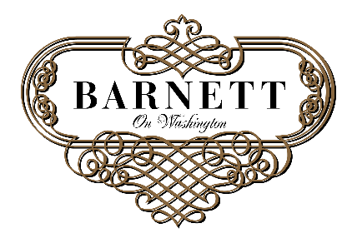
Barnett Grand Hall
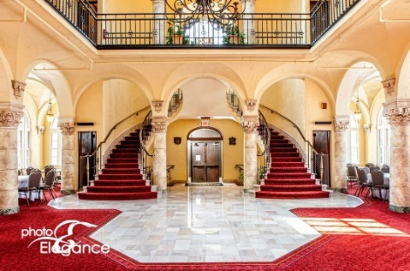
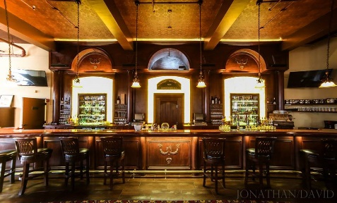
Corporate Meeting Rates
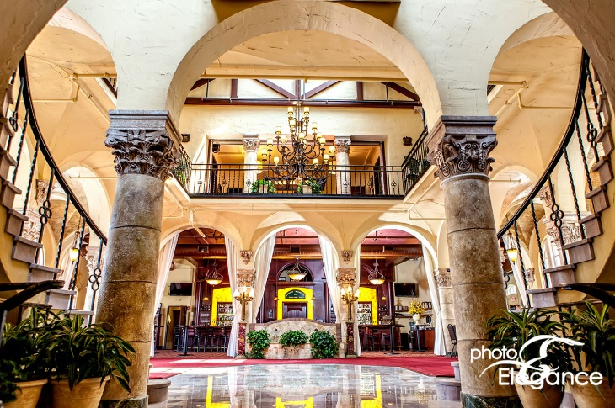

Monday – Friday: Up to 60 guests {Banquet Seating} $750
Up to 180 guests {Theater Seating}
Up to 54 guests {Classroom Seating}

Custom Packaged Lunch: Provided by Russo’s $15/per person

Includes: Private Room for 3 Hours
Complimentary Soft Beverage Service
Event Coordinator
All Tables and Chairs
In-House Sound System Including A/V Equipment
Complimentary Wi-Fi
On-Site Security

Corporate Meeting Rates
Additional Price
Open Beer & Wine Bar $18/per person
{3 hour service}

Premium Bar Package $30/per person
{3 hour service}

Cash/Consumption Bar $500 minimum

Valet Parking $125/per hour

Barnett Lounge Rental Extension $125/per hour

Barnett Grand Hall Rental Extension $250/per hour

