Tracer Celebration Dj Entertainment Pkgs.

“Plan your Entire Wedding Event online with exclusive free access to Gigbuilder
Simply go to our website and login!

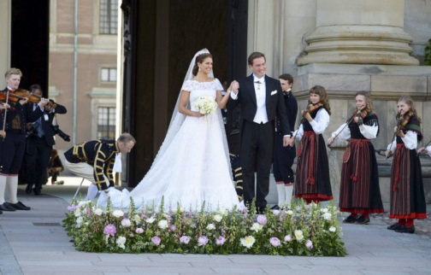

Budget pkg 650.00
It includes the following items.
- Professional Dj booth
- (2) Stand mounted 15” Powered Speakers
- Music through dinner / Wireless microphone
- (4) hours of high energy wedding dance music
- (3) Trussed Special Effect club lights (of your choice)
- Exclusive access to the best event planning and dj music database in the industry (GigBuilder)
- When we do take requests and we do play them! ( unlike numerous other dj services)

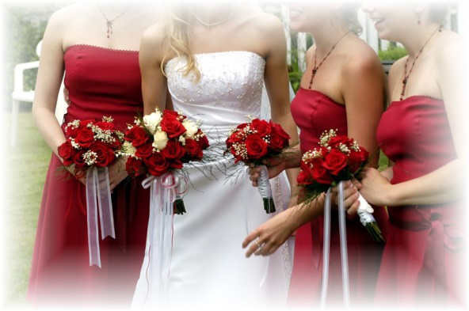

Value wedding reception pkg. $750
*This Value package includes:
- (2) Hours of cocktail and dinner music (in reception hall only)
- (4) Hours of Dj musical entertainment
- (1) Interactive Dj'.
- Plan your entire event with your unique professional (password protected) GigBuilder account. Thousands of songs to view and listen to.
- Professional Odyssey facade
- (2) Stand mounted powered 15" Dj speakers.
- Complimentary Wireless microphone for the head table
- A special effect lighting truss with (3) special effect led club lights
- Free commemorative mp3 music cd is our gift to you.
**Upgrade the sound system with (2) Bass Boosting 18" Sub woofers 'and high end sound system components for an additional $150.00
"This Must Have accessory" adds more power and punch to your event"

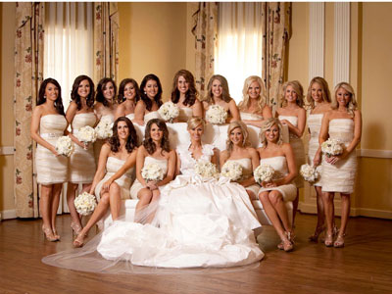

"Touch of class pkg" $875.00 (*couple’s choice for 2015)
"Add Exceptional Class and Elegance to your very special day"
- (2) Interactive professional Dj's (with emcee’ skills)
- (2) Hours of mood enhancing cocktail and dinner music.
- (4) Hours of the Very Best dance and interactive music available
- A High end wireless microphone for the Wedding party table,
- (5) Mesmerizing Special Effect Dance Club light fixtures of your choice
- A club style lighted spandex façade that changes colors with the music.
- A projected gobo template that can accent your wedding cake table or can be projected to the floor or ceiling. (You have (4) colors to choose from).
- (6) led soft colored pin spot lights for the wedding cake table
- The speaker stands have classy black scrims with led strip lighting.
- A free commemorative printed mp3 cd with your entire playlist.
***This unbeatable special price includes free sound system upgrade with (2) 18’ Subwoofers’’

The "Afternoon Delight" pkg. $1250.00. (Incredible value)
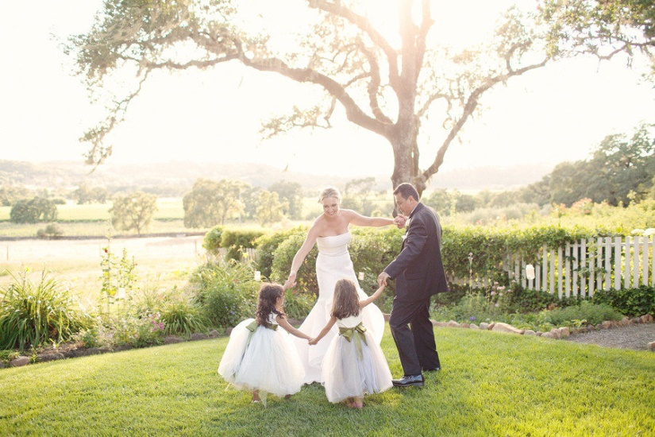

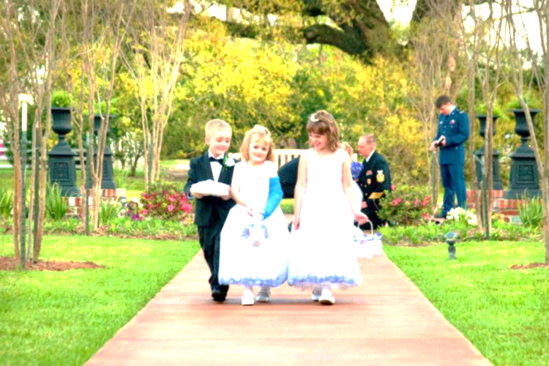
*This premier all-inclusive Wedding Entertainment package is perfect for your upcoming Summer Wedding event that includes an outdoor ceremony. We exclusively provide Up to 2 hours of select Outdoor Entertainment after the ceremony which leads up to the dinner and cocktail music. ‘We provide elegant accommodations for the ceremony as well as the Reception Banquet”. This pkg. includes the following provisions.
- Complete Outdoor Ceremony P.A. system Setup. (includes music for the entire ceremony)
- (2) Wireless microphones for the ceremony. (the officiant will be given a lapel microphone)
- up to (2) hours of post ceremony outdoor music
- Premium Mood enhancing Music through dinner
- (4) hours of requested and premium wedding dance music
- (5) Trussed Special Effect club lights which includes an amazing character and script writing multi colored laser
- Led lighted Façade/ lighted scrims for speaker and truss stands.
- Significant Upgraded sound system which includes the “18 subwoofers’ and additional High End sound conditioning components.
- New for 2016! (2)Towering 5 ft. dual 15" professional speakers.
- HD video projector and a large 5'- 8' Trussed Spandex Screen.
- No mileage fees or any other fees.
***Plan your Wedding Celebration event for those "Hot Summer Days" and "Warm Summer Nights" with this All Inclusive Premium Summertime pkg. It includes everything you need to make your Wedding day a truly Remarkable, Elegant and Unforgettable Experience. “You won’t find a better price anywhere. “Are you having your Wedding ceremony @ a home residence? We provide Elegant, complete Wedding Ceremony provisions.
- Add an additional 10”-10” tented gazebo (with side walls) for just $79.00

