+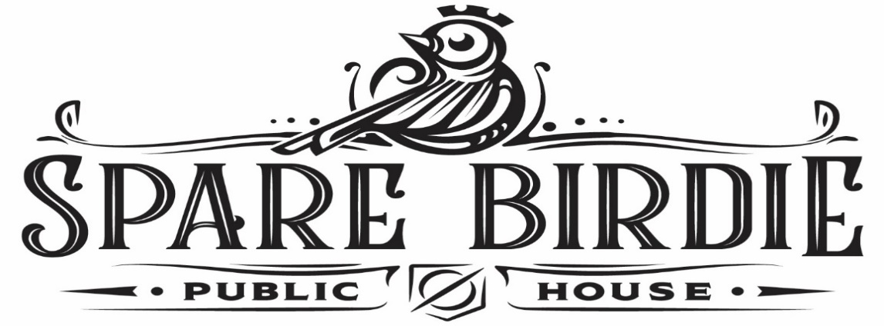

Thank you for choosing Spare Birdie Public House, we are excited to have the opportunity to book your next event. We have the following structure to give you the flexibility to choose the options that best suit you and your event. These options are for events with a headcount of under 60 guests. The pricing and details are as follows:
- These group packages can be booked Wednesday and Thursday from 4pm to close and Friday, Saturday, & Sunday 11am to close.
- We do not have a private room for events. Events can be planned in the bowling area or in the virtual bay area food will be provided in their specific areas. Events also have the option to split and do both, for this the food will be placed in the dining area buffet style for your guests to choose what they would like to eat and be able to float the building. Additional games (pool tables, darts, bocce ball, and virtual putting green) can be added on for additional fees.
- Groups under 20 guests are required to meet a $1,000 minimum before fees.
- Gaming prices are by the hour 6 people per Virtual Bay or Bowling Lane.
- You can choose from among the food and beverage packages attached here. All packages have a cost per person so you can mix and match packages to meet your needs. The only real qualification is that you must order the quantity of each package that matches the number of people in your group.
- The food packages are priced for one hour but can be increased if you desire. The beverage packages are priced for two hours (within limits of consumption).
- You will have a dedicated server(s) for just your party to ensure that all your guest needs are attended to.
- There will be game attraction attendants present to ensure that all attraction functions are working properly and can assist you and your guests as needed.
All group packages are subject to 7% service fee, 8.25% tax and a 20% gratuity on the total bill. All group packages are subject to the cancellation policy. All group packages require a credit card on file and a signed contract with all group function details.

Thank you,

Staci McRae
Corporate Event Director
Email: Staci@sparebirdie.com
Cell:512-569-0181

