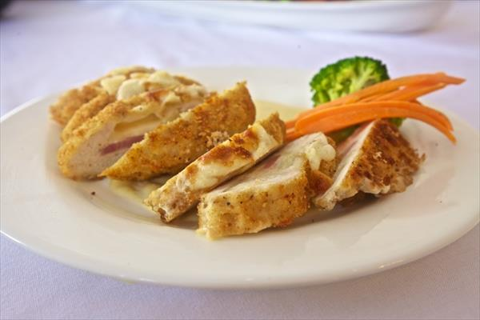
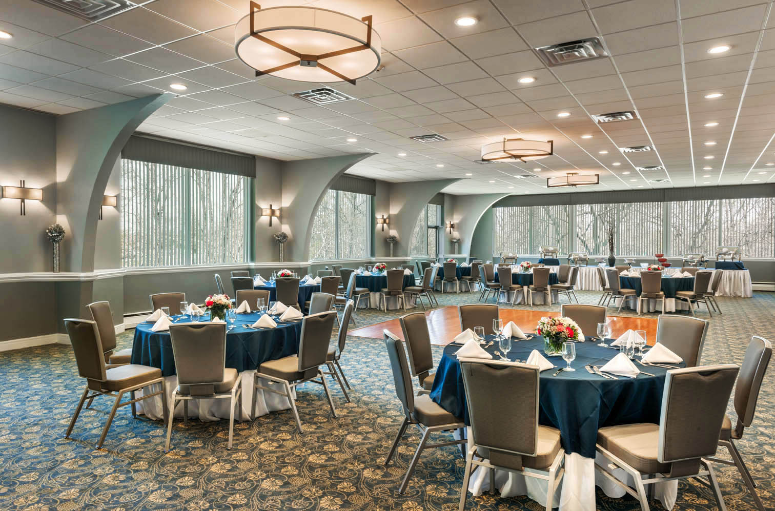
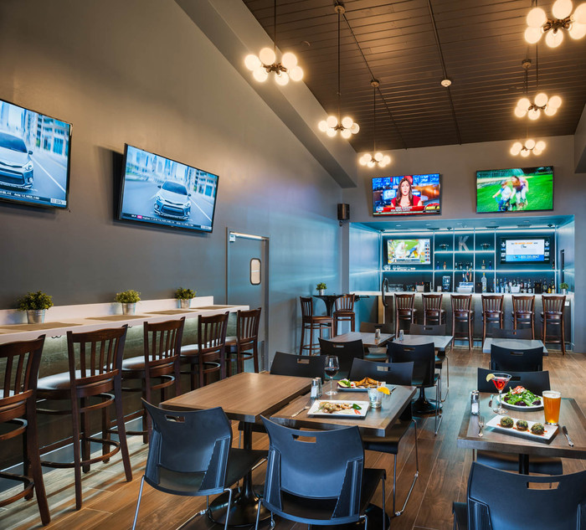

Offering Memorable Moments
With Delicious Cuisine
Menu Packages
WHERE YOU WANT TO CELEBRATE

BREAKFASTS

The Deluxe Continental Breakfast Buffet
Homemade Breakfast Breads
Muffins and Bagels
Served with Butter, Preserves &
Cream Cheese
Yogurt & Granola
Whole Fruit
Orange Juice & Cranberry Juice
Coffee, Decaffeinated Coffee, and
Herbal Teas
$16.95 Per Guest ++

The Union Hot Breakfast Buffet
Fluffy Scrambled Eggs
Bacon and Sausage
French Toast with Powdered Sugar
Maple Syrup
Seasoned Breakfast Potatoes
Homemade Breakfast Breads
Muffins and Bagels
Served with Butter, Preserves &
Cream Cheese
Yogurt & Granola
Fresh Sliced Fruit
Assorted Cold Cereal & Milk
Orange Juice & Cranberry Juice
Coffee, Decaffeinated Coffee, and
Herbal Teas
$21.95 Per Guest ++

Additional Enhancements
$75.00 Attendant Fee per station

Omelet Station
Chef Prepared Omelets with Choice of:
Peppers, Ham, Bacon, Onions, Mushrooms,
Cheeses and Salsa
$10.95 Per Guest ++

Minimum 25 Guests

MORNING / AFTERNOON BREAKS

AM or PM Coffee Break
Regular Coffee, Decaffeinated Coffee,
Assorted Herbal Teas
Service is for 45 minutes per break
$6.95 per person ++

All-Day Beverage Break
Regular and Decaf Coffee
Assorted Herbal Tea Station
Bottled Waters
Assorted Sodas
$14.95 per person++

Jersey Shore Break
Pizza Bagels
Buttered Popcorn
Mini Hot Dogs Wrapped in Puff Pastry
Hot Soft Pretzels Served with Mustard
Apple Wedges dipped in Caramel
Coffee & Decaffeinated Coffee & Herbal Teas
$14.95 per person ++

The Cookie Jar Break
An Assortment of Cookies to Include:
Chocolate Chip, Oatmeal Raisin
Sugar Cookie
Brownies
Chilled Milk
Coffee & Decaffeinated Coffee & Herbal Teas
$14.95 per person ++
Minimum 25 Guests
The Healthy Choice Break
Individual Fruit Yogurts
Nutri-Grain Bars
Trail Mix
Whole Fruit
Orange & Cranberry Juice
Coffee & Decaffeinated Coffee & Herbal Teas
$14.95 per person ++

A La Carte Items

Assorted Sodas-
Regular, Diet, and Lemon/Lime
$3.50++ Per Can

Coffee/Tea by the Gallon
Regular Coffee, Decaffeinated Coffee,
Herbal Teas
Priced per gallon/per item
(Each gallon yields about 16 cups)
$58.00 per gallon++

Assorted Cookies by the Dozen
$18.00 per dozen ++

Assorted Brownies and Scones
$20.00 per Dozen

Bags of Chips
$1.25 each ++

Protein Bars
$42.00 per dozen ++

LUNCH OPTIONS

Kenilworth Lavish Lunch Buffet Includes:

(Please Select One Fresh Salad)
Garden Salad with Assorted Dressings
Fresh Field Green Salad
Served with Rolls & Butter

Grilled Breast of Chicken
Sliced Sirloin
Penne Ala Vodka
Roasted Vegetable Medley
Rice Pilaf

Cookies and Brownies
Iced Tea and Water
Coffee, Decaffeinated Coffee, Teas
$30.95 per person ++

A Piece of Italy Lunch Buffet Includes:

Garden Salad with Assorted Dressings
or
Caesar Salad
Served with Rolls & Butter

(Please Select Two Entrees)
Penne Ala Vodka
Stuffed Shells
Eggplant Parmesan
Sausage & Peppers
Assorted Homemade Pizzas
Chicken Marsala, Piccata, Francese or Parmesan
Chef's Choice of Starch & Seasonal Vegetable
Italian Cookies
Iced Tea and Water
Coffee, Decaffeinated Coffee, Teas
$28.95 per person ++

Picnic in the Park Lunch Buffet Includes:
‘SUMMER MENU ONLY”

Cole Slaw and Potato Salad

Full Barbecue with all the Fixings:
Hamburgers
Hot Dogs
Grilled Chicken
Baked Beans
Corn on the Cob

Watermelon Wedges
Cookies & Brownies

Iced Tea and Water
Coffee, Decaffeinated Coffee, Teas
$27.95 per person ++

Wall Street Lunch Deli Buffet Includes:
(Please Select Two Salads)
Tri Colored Tortellini Salad
Traditional Tuna or Chicken Salad
3-Bean Salad
Garden Salad or Caesar Salad

Assorted Deli Tray:
Turkey Breast, Roast Beef, Baked Virginia Ham, Sliced Swiss, Cheddar, Provolone and American Cheese
Potato Chips
Sliced Beefsteak Tomatoes and Lettuce
Condiments and Relish Tray
Kaiser Rolls, Assorted Sandwich Breads

Cookies and Brownies
Iced Tea and Water
Coffee, Decaffeinated Coffee, Teas
$27.95 per person ++

LUNCH OPTIONS

Wrap Up Lunch Buffet Includes:

Choose 2 Salads:
Garden Salad with Assorted Dressings
Macaroni Salad
Potato Salad

A Variety of:
Vegetable Wraps, Roast Beef Wraps, Turkey Wraps, and Tuna Wraps

Cookies & Brownies
Whole Fresh Fruit

Iced Tea and Water
Coffee, Decaffeinated Coffee, Teas
$19.95 per person ++

Traveling Boxed Lunches Include:

Pre-Selected Sandwich
Bag of Chips
Whole Fruit
Cookie
Can of Soda or Bottled Water

Please choose from the following sandwiches:
Roast Beef
Turkey
Tuna
Veggie Wrap

Selections must be received 14 days prior to
your event
$18.95 per boxed lunch++

Minimum 25 guests

Kenilworth Lunch

(Please select one salad)
Field Green Salad with Our Creamy Balsamic Vinaigrette
Caesar Salad
Baby Spinach Salad with Goat Cheese, Beets & Caramelized Walnuts (add $2)

Entrée:
(Please select two entrees)
Herb Roasted Chicken on the Bone
Chicken Marsala, Piccata, or Francese
*Broiled Salmon with Lemon Butter Sauce
(add $3.00 per person)
Eggplant Rollatini
Cheese Tortellini with Sautéed Vegetables
Sliced Steak

Chef's Choice of Starch and Vegetable Accompaniment
Rolls and Butter

Dessert:
(Please select one dessert)
New York Cheesecake
Double Chocolate Cake
Carrot Cake
Cookies and Brownies

Coffee, Decaffeinated Coffee, & Teas
Iced Tea
Please select two entree choices for your guests
(Entrée counts required at least 14 days prior to event)

$30.95 per person ++
BRUNCH OPTIONS

Kenilworth Brunch Buffet includes:

Assorted Breakfast Breads
Butter, Cream Cheese & Fruit Preserves
Fresh Seasonal Fruit Platter
Orange & Cranberry Juice
Coffee, Decaffeinated Coffee & Herbal Teas

Hot Breakfast
Fluffy Scrambled Eggs
Bacon, Taylor Ham or Sausage
(please choose one)
French Toast
Maple Syrup
Seasoned Breakfast Potatoes
Seasonal Vegetable
Salad (Select One)
Fresh Field Green Salad
Classic Caesar Salad with Garlic Croutons

Entrée Selection: (Choose 2 or 3)
Penne A La Vodka
Penne with Basil & Prosciutto
Stuffed Shells Vegetable Lasagna
Eggplant Rollatini
Chicken Marsala
Chicken Piccata
Chicken Francese
Chicken Parmesan
Poached Salmon with Dill Sauce (add $4)
Cookies and Brownies
Coffee, Decaffeinated Coffee, Teas
Iced Tea and Water

Two Entrees $34.95 per person
Three Entrees $36.95 per person
Children under 10 - $18.95

BRUNCH OPTIONS

Brunch Menu Enhancements* (additional charge)
Top Sirloin Carving Station* (add $11.95 per person++)
Virginia Ham Carving Station* (add $9.50 per person++)
Oven Roasted Turkey Carving Station* (add $11.95 per person++)

Omelet Station* (add $9.95 per person++)

Beverages* (additional charge)
Mimosa ($4.00/glass++)
Sparkling Cider ($3.00/glass++)
Sangria ($65/gallon++)

Butler Passed Hors d’oeuvres*(add $16.95 Per Guest ++ for Choice of Six)
See Hors d’oeuvres Menu

All Buffet Prices above are Per Guest ++

$75.00++ attendant fee applies to each station selected

Minimum 30 Guests

DINNER

Kenilworth Dinner Buffet
Salads

(Please Select One Composed Salad)
Pasta Salad
Couscous Salad
Spinach Salad
(Please choose one fresh Salad)
Caesar Salad or Fresh Field Green Salad
Served with Rolls and Butter

Entree Selections (Select 2,3, or 4 Entrees)

Sliced Roast Strip Sirloin Bordelaise
Sliced Steak
Salmon with a Dill Sauce
Tilapia Francese
Chicken Parmesan
Chicken Marsala
Chicken Piccata
Southern Fried Chicken
Roast Pork Loin
Tortellini Alfredo
Penne Ala Vodka
Rigatoni Bolognese
(Please Select One Starch and One Vegetable Accompaniments)
STARCHES
Mashed Potato
Oven Roasted Potato
Sweet Potato Wedges
Wild Rice Pilaf
VEGETABLES
Green Beans
Vegetable Medley
Broccoli & Carrots
Chef's Selection of Desserts
Iced Tea and Water
Coffee, Decaffeinated Coffee, Teas

Two Entrees $36.95 per person (Under 10 yrs. old $18.95)
Three Entrees $39.95 per person (Under 10 yrs. old $19.95)
Four Entrees $42.95 per person
(under 10 yrs. old $20.95)
Minimum 30 Guests

DINNER

A Piece of Italy Dinner Buffet Includes:

Caesar Salad
Garden Salad with Assorted Dressings

Served with Rolls & Butter

Seasonal Vegetables

Entree Selections (please select 2,3, or 4 Entrees)
Farfalle Pesto Pasta
Penne Ala Vodka
Tomato, Basil Tortellini
Manicotti
Eggplant Parmesan
Sausage & Peppers
Chicken Parmesan
Chicken Marsala, Piccata, or Francese
Assorted Homemade Pizzas

Tiramisu

Iced Tea and Water
Coffee, Decaffeinated Coffee, Teas

Two Entrees $31.95 per person
Three Entrees $34.95 per person
Four Entrees $36.95 per person

Children Under 10
Two Entrees: $15.95
Three Entrees: $17.95
Four Entrees: $19.95

Minimum 30 Guests

CHILDREN’S OPTIONS

Children's Options
(For Children 10 Years Old and Under)

Minimum of 20 Guests for Buffets to be set up
Buffets will remain out for a maximum
of one and a half hours

Children's Paradise Buffet

Mini Hamburgers and Cheeseburgers
Mini Hot Dogs w/bun
Mini Pepperoni & Cheese Pizzas
Mac 'n Cheese
Chicken Tenders with Dipping Sauce
Fried Mozzarella Sticks with Marinara Sauce

3 Choices - $13.95 per child ++
4 Choices - $16.95 per child ++
5 Choices - $19.95 per child ++

Plated Chicken Fingers & Fries

Chicken Tenders Served with Honey Mustard
and Ketchup Dipping Sauces
$13.95 per child++
(10 years old or younger)

Minimum 30 Guests

RECEPTIONS

Displays

Display of Italian Antipasto

Prosciutto, Pepperoni, Genoa Salami, Capicola, Kalamata Olives, Artichoke Hearts, Pepperoncini and Crusty Italian Bread

(Price per Display - Served 50 guests)

$325.00 per display++

Display of Fresh Fruit

Fresh Cut & Whole Seasonal Fruit

(Price per Display - Serves 50 guests)

$275.00 per display++

Display of Vegetables Crudités

Display of Seasonal Cut Fresh Vegetables Served with Chef's Selection of Dips

(Price per Display - Serves 50 guests)

$225.00 per display++

Display of Domestic & International Cheeses
Assorted Cheeses Garnished with Fresh Fruit & Grapes, Assorted Crackers and French Baguettes
$275 .00 Per Display ++(serves 50)

Grilled Vegetable Antipasto Display
Fresh Mozzarella and Roasted Tomato with Basil and Grilled Vegetables Antipasto
(Display serves 50 guests)
$325.00 per display++

Carving Stations with Attendant

Whole Top Round of Beef
$15.95 Per Guest ++ Plus Attendant Fee $75

Baked Sugar-Cured Virginia Ham
$9.95 Per Guest ++ Plus Attendant Fee $75

Whole Roast Turkey
$10.95 Per Guest ++ Plus Attendant Fee $75

A Taste of Rome Action Station with Attendant (Please Select Two)
Penne a la Vodka
Linguini Primavera
Fettuccini Carbonara
Tortellini Primavera
Penne Sweet Basil & Prosciutto
Lemon Pepper Fettuccini
Rigatoni Bolognese
Rolls & Butter
$15.95 Per Guest Plus Attendant Fee $75

Santa Fe Fajita Station
Chicken & Beef Fajitas
Chicken Quesadillas
Accompanied with Pico De Gallo
Guacamole, Sour Cream
Monterey Jack & Cheddar Cheeses
$13.95 Per Guest ++

Indian Station
Chicken & Beef Kababs
Dal, Naan, Chaat and Chutneys
$12.95 Per Guest ++
All Stations are a minimum of 40 guests and
must be accompanied with a Meal Plan

All Station prices are per hour Plus Per Attendant Fee $75

RECEPTIONS

Pasta Station
(Please Select Two)
Penne Ala Vodka
Tortellini Primavera
Cavatelli with Broccoli & Sundried Tomatoes
Penne Sweet Basil & Prosciutto
Rigatoni Bolognaise

Rolls & Butter Included

$10.95 Per Guest ++
Mashed Potato Bar with Toppings
Butter, Gravy, Cheddar Cheese, Chives,
Bacon Bits, Sour Cream
$9.95 per person plus $75 attendant fee

Slider Station
Pulled Pork, Chicken Parmesan, and Mini Burgers
$12.95 Per Guest ++
Caprese Salad Display
$6.95 per person ++
Tossed Salad with Chef's choice of Dressing
Rolls and Butter
$5.95 per person ++

Display of Corn Chips Salsa & Fresh Guacamole
$9.95 per person ++

Ice Cream Sundae Bar with Toppings
Vanilla, Chocolate and Strawberry Ice Cream

Chef's Choice of Assorted Toppings, Syrups, and Sauces
$12.95 per person ++

Additional Dessert Enhancements

Seasonal Fresh Fruit Skewers (add $5.95 per person)

Assorted Cookie & Brownie Platters on each Table (add $6.95 per person)

Candy Bar Buffet (add $10.95 per person)

All Stations are a minimum of 40 Guests and
must be accompanied with a Meal Plan
All Station prices are per hour Plus Per Attendant Fee $75

RECEPTIONS

Hors d’oeuvres Package

Chef’s Hot Hors d’oeuvres
(Choice of Three passed for 1 hour)

Mini Crab Cakes

Beef and Chicken Empanada

Mini Hot Dogs Wrapped in Puff Pastry Served
with Dijon Mustard

Vegetable Spring Rolls Served with Sweet Chili

Black Bean, Jack Cheese & Chicken Quesadilla

Cocktail Meatballs

Mini Quiche

Grilled Portobello Fries

Eggplant Pizzette with Fresh Mozzarella & Pesto

Wellington Cap

Bacon Wrapped Scallops

Sliced Sirloin Canapé with Horseradish Cream

Pecan Encrusted Chicken Fingers with Orange Bourbon Sauce

Spanakopita

Chef’s Cold Hors d’oeuvres
(Choice of Three passed for 1 hour)

Shrimp Cocktail (add $2)
Caprese Skewers

Smoked Salmon Canapés

Cheese and Crackers

Melon and Mozzarella

Prosciutto and Asparagus Roll-Up

Chicken Salas Sliders

Southwest Chicken on Date Bread with Mango Salsa

Hummus Crustini

Tomato Bruschetta with Crostini

$23.95 Per Guest ++
(Must be Accompanied with a Meal Plan)
(Minimum 40 Guests)

RECEPTIONS
Cocktail Reception Package
Three-Hour Reception
Cold Platters Displayed upon arrival (please choose 2)

Display of Italian Antipasto and Crusty Italian Bread

(Prosciutto, Pepperoni, Genoa Salami, Capicola, Kalamata Olives, Artichoke Hearts, Anchovies, Pepperoncini)

Display of Fresh Cut Fruit

Display of Seasonal Cut Fresh Vegetables

(Served with Chef’s Selection of Dips)

Display of Domestic & International Cheeses
(Assorted Cheeses Garnished with Fresh Fruit & Grapes, Assorted Crackers and French Baguettes)

PASSED HORS D’OEUVRES (for 1 hour)
Choose four (add an additional selection for $3 per Guest ++)

Tomato Bruschetta with Crostini
Vegetable Spring Rolls Served with Sweet Chili
Eggplant Pizzette with Fresh Mozzarella & Pesto
Crab Cakes w/Remoulade
Stuffed Mushrooms
Mozzarella Crustini
Sliced Sirloin Canapé with Horseradish Cream
Pecan Encrusted Chicken Fingers with Orange Bourbon Sauce
Deviled Eggs
Crab Cakes
Shrimp Cocktail (add $2)

BUFFET SELECTIONS
Choose any combination of three Entrees (add an additional selection for $6 per Guest ++)
Hot Entrees

Sausage & Peppers
Penne Ala Vodka
Tortellini Primavera
Penne Sweet Basil & Prosciutto
Ravioli
Rigatoni Bolognaise
Chicken Piccata
Sliced Sirloin w/mushroom demi
Chicken Milanese

Tossed Salad, Rolls & Butter

DESSERT
Cookies and Brownies
Coffee, Decaffeinated Coffee, and Herbal Teas
$36.95 Per Guest ++ for 3-hour reception
for Additional Hours please add $10.95 Per Guest ++, Per Hour
(Minimum 40 Guests)

BEVERAGE OPTIONS

Well Open Bar
Well Vodka
Well Rum
Well Tequila
Well Gin
Well Scotch
Well Cordials
House Cabernet
House Chardonnay
Domestic Beers
Sodas & Juices

$18.00 Per Guest 1st Hour++
$5.00 Per Guest Each Additional Hour++

House Open Bar
Titos Vodka
Bacardi Rum
Beefeater Gin
Dewars Scotch
Sauza Tequila
Jack Daniels
Captain Morgan
Canadian Club
Southern Comfort
Seagrams VO
Kahlua
Cordials
House Cabernet
House Chardonnay
Domestic Beers
Sodas & Juices

$20.00 Per Guest 1st Hour++
$10.00 Per Guest Each Additional Hour++

Beer & Wine Bar
Imported & Domestic Beer
Cabernet
Chardonnay
$18.00 Per Guest ++ 1st Hour++
$9.00 Per Guest ++ Each Additional Hour++

BEVERAGE OPTIONS
Premium Open Bar
House Bar Plus
Absolute or Smirnoff Vodka
Malibu Rum
Cuervo 1800 Tequila
Johnnie Walker Red
Cordials
House Cabernet
House Chardonnay
Imported Beer
Sodas & Juices
$25.00 Per Guest 1st Hour++
$15.00 Per Guest Each Additional Hour++

Martini Bar Includes:
with Complete Garnishes

Apple Martinis, Cosmos, Chocolate, Classic, Dirty

$19.95 Per Guest 1st Hour++

$10.00 Each Additional Hour++

Additional Beverages

- Spiked Punch $65 Per Gallon
- Fruit Punch $25 Per Gallon
- Sangria with Fresh Fruit per 32 oz. Pitcher $22.00++ per pitcher
(Each pitcher serves 4-6 glasses)
- Mimosas or Bellini’s $4.00 per glass
- Cider/Sparkling Cider $3.00 Per Glass
- Champagne Toast $4.50 per glass
- Regular Apple Cider $2.50 ++ Per Glass
- Assorted Sodas- Regular, Diet, and Lemon/Lime
$3.50 Per Can

Host Bar or Cash Bar
$100 per Bartender

Soda Bar:
Unlimited Soda Bar Includes:
Assorted Regular, Diet and Lemon/Lime Soft Drinks
$7.95 Per Guest ++

Wines / Sparkling by the Bottle
House Wines $28 Per Bottle
Premium Wines $35 Per Bottle
Korbel Champagne $35 Per Bottle
Prosecco $35 per Bottle
Moet Chandon $95 Per Bottle

It's Tea Time

Display of Assorted Herbal Teas
Coffee & Decaffeinated Coffee
Sparkling Cider
Flavored Lemonade
Honey & Lemon Wedges

Hot Scones

Assorted Mini Tartlets

Petit Fours

Shortbread Cookies

Mixed Fresh Fruit

Choice of 3 Tea Sandwiches:

Smoked Salmon & Dill Cream Cheese
Chicken Salad with Granny Smith Apples
Spinach & Feta on Sourdough Bread
Baked Brie Bites with Raspberry Compote
Cucumber Watercress on Wholegrain Bread
Black Forest Ham on Pumpernickel

$26.95 per person ++
(Minimum 25 Guests)

Young Adult Buffet Celebration

Display Upon Arrival
Corn Chips with Cheddar Cheese Sauce, Doritos and Pretzels

Salad- Select One
Caesar Salad with Garlic Croutons
Tossed Salad

Entree - Select Three

Penne A La Vodka
Meatballs Italian Style with Zesty Marinara Sauce
Crispy Chicken Tenders
Mozzarella Sticks with Marinara Sauce
Chicken Francaise
Roasted Pork Loin or BBQ Pulled Pork
Cheese Tortellini with Alfredo Sauce
Ravioli
Baked Macaroni with 3 Cheeses

Starch - Select One
Oven Roasted Potatoes
French Fries
Mashed Potatoes
Rice
Vegetables- Select One
String Beans and Carrots
Mixed Seasonal Vegetables
Glazed Baby Carrots

Tex-Mex Station (Included with Entrees)
Hard and Soft Tacos, Ground Beef, Grilled Chicken
Lettuce, Cheese, Salsa, Sour Cream, and Guacamole

Dessert
Ice Cream Bar with Toppings

Lemonade and Sweet Iced Tea
Coffee, Decaffeinated Coffee, and Herbal Teas

$35.95 per person ++
(Minimum 25 Guests)

Quinceanera Buffet Celebration

Display Upon Arrival:
Corn Chips with Cheddar Cheese Sauce, Doritos and Pretzels

Butler Passed Hors d'oeuvres: (select 3)

Beef Empanada
Buffalo Chicken Tenders
Pigs in a Blanket
Vegetable Spring Rolls Served with Sweet Chili
Sweet Plantains

Salad (Select One)
Caesar Salad with Garlic Croutons
Tossed Salad

Entree (Select Three)

Penne A La Vodka
Meatballs Italian Style with Zesty Marinara Sauce
Crispy Chicken Tenders
Mozzarella Sticks with Marinara Sauce
Chicken Francese
Roasted Pork Loin or BBQ Pulled Pork
Cheese Tortellini with Alfredo Sauce
Filet of Sole in garlic Sauce
Baked Macaroni with 3 Cheeses

Starch (Select One)
Oven Roasted Potatoes
French Fries
Mashed Potatoes
Yellow Rice and Beans
Vegetables (Select One)
Carrots
Roasted Corn
Mixed Seasonal Vegetables
Black Beans w/Cilantro Sauce

Tex-Mex Station (Included with Entrees)
Hard and Soft Tacos, Ground Beef, Grilled Chicken
Lettuce, Cheese, Salsa, Sour Cream, and Guacamole

Dessert:
Ice Cream Bar with Toppings

Lemonade & Sweet Iced Tea
Coffee, Decaffeinated Coffee, and Herbal Teas

$34.95 per person ++
(Minimum 40 People)

Wedding Package- Elegant Buffet Dinner

Champagne Toast

Salads
Classic Caesar Salad with Garlic Croutons and
Baby Spinach with Seasonal Accompaniments & Dressing

Pasta - Select One
Penne with Roasted Vegetables
Cheese Tortellini with Lemon & Fine Herbs
Rigatoni Bolognese
Penne a la Vodka

Entree - Select Two
Sautéed Chicken over Baby Spinach in Lemon Butter Sauce
Chicken Piccata
Seared Salmon with Fresh Dill Butter Sauce
Flounder Francese
Roasted Pork Loin with Pork Jus
Sliced Roast Strip Sirloin Bordelaise
Gorgonzola Cheese tortellini

Starch - Select One
Oven Roasted Potatoes
Mashed Potatoes
Rice Pilaf
Risotto Parmesan

Vegetables - Select One
Green beans Oreganata
Mixed Seasonal Vegetables
Baby Glazed Carrots
Dessert
Chef’s Choice
Sodas, Coffee, Decaffeinated Coffee and Tea included
$75.00 per person ++

Wedding Cake Available (Pricing Upon Request)
(Minimum 50 Guests)

Repast Buffet

Buffet Luncheon includes:

Select one Salad:
Garden Salad
Caesar Salad

Entrée: (choose 2 or 3 Entrees)
Herb Roasted Chicken
Chicken Marsala, Piccata or Francese
Broiled Filet with Lemon Butter Sauce
Sausage & Peppers
Eggplant Rollatini
Rigatoni Bolognese
Tortellini Alfredo
Penne A La Vodka

Includes:
Chef’s Choice Vegetable
Chef’s Choice Starch

Rolls and Butter

Cookies and Brownies

Regular and Decaf Coffee and Teas
Iced Tea

Two Entrées $25.95 Per Guest
Three Entrees $28.95 Per Guest
(Minimum 30 Guests)

