Catering Package

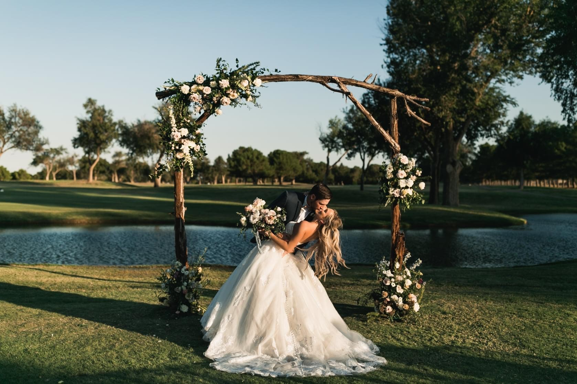

Function Rooms

Vista Room | Up to 150 Guests

The Main Dining Room provides a commanding view of the Golf Course.
Room Rental
Friday and Saturday: $1,000
Sunday-Thursday: $500

Concho Room | Up to 55 Guests

Room Rental
Friday and Saturday: $400
Sunday-Thursday: $200

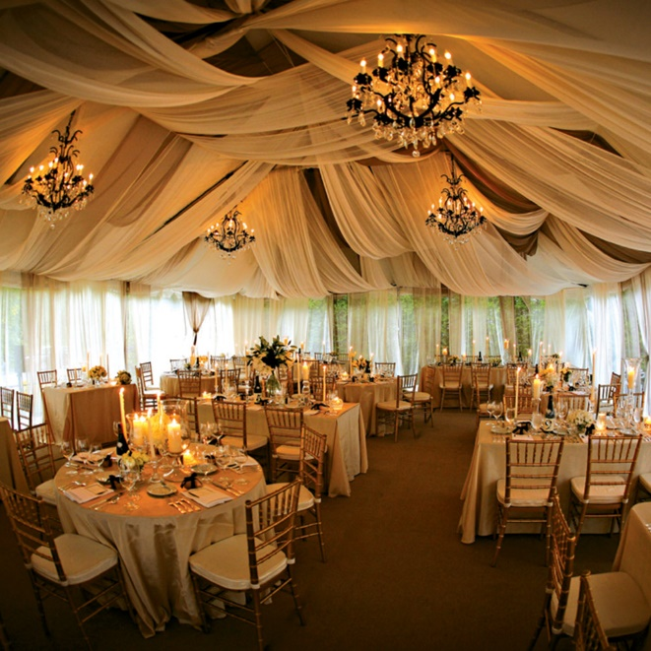

Pinion Room | Up to 225 Guests

Room Rental
Friday and Saturday: $2,000
Sunday-Thursday: $1,000

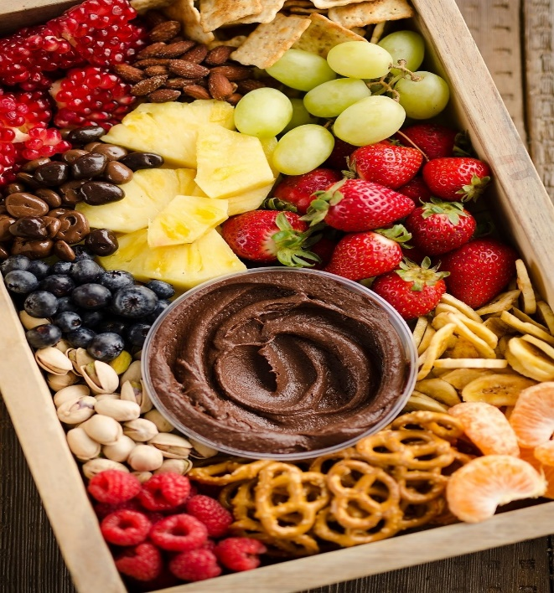

South of the Border |$7.50
Corn chips | salsa| creamy guacamole |Hatch green chile queso
Shrimp Cocktail| $9.75
Chilled gulf shrimp | cocktail sauce | fresh lemons
Fresh Vegetable Crudites |$5.50
Garden fresh cut vegetables | ranch dip
Fresh Seasonal Fruit|$8.75
Sliced fresh fruit | seasonal berries | cream cheese dip
Charcuterie Board | $12
Domestic cheeses | meats | chipotle ranch | assorted nuts | assorted crackers

Displays and Stations
Priced per person

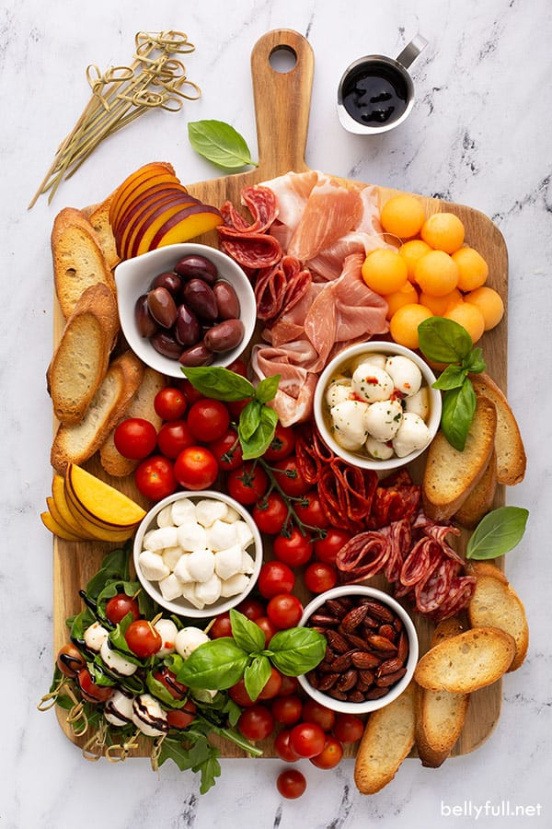

Ranchland Hills Buffets
includes warm rolls and butter, priced per person.

Lone Star BBQ

Select Two (2) Meats:
Brisket
Chicken
Pulled Pork
Pork Ribs
Roasted Corn
Ranch Style Beans
Potato Salad
Coleslaw
Sliced Red Onions and Dill Pickles
Jalapeño Cornbread Muffins
Seasonal Cobbler and Pecan Pie
$29.95 PP

Tuscan

Classic Caesar Salad
Caprese Salad

Select Two (2) Entrées:
Baked Penne with Marinara
Chicken Marsala
Chicken Fettuccine Alfredo
Three Cheese Tortellini with
Parmesan Crusted Chicken
Beef Lasagna or
Vegetable Lasagna
Roasted Vegetable Medley
Garlic Bread
Cannoli
$26.95 PP
La Hacienda

Tortilla Chips and Queso
Cheese Enchiladas
Grilled Chicken and Beef Fajitas
with Grilled Peppers and Onions
Flour Tortillas, Fresh Salsa,
Sour Cream, Shredded Cheese,
Crisp Lettuce
Cowboy Beans
Spanish Rice
Tres Leches Cake
$28.95 PP

Other Buffet Options
includes warm rolls and butter, priced per person.

Salads
Please Choose Two (2):
Ranchland House Salad - Fresh Greens, Julienne Vegetables, two dressing selections GF, VEG.
Caesar Salad - Romaine, Parmesan, Herb Croutons, Caesar Dressing VEG
Penne Pasta Salad - with Fresh Vegetables, Red Wine Vinaigrette VEG

Entrées
Please Choose Two (2):

Chicken Breast Florentine with Artichoke Cream Sauce GF
Chicken Cordon Bleu
Rosemary Pork Loin with Strawberry Demi GF

Curried Pork Loin with Apricot, Raisin, and Apple Chutney
Pecan Crusted Salmon with Honey Glaze GF
6 oz filet with Peppercorn Demi-glaze GF
Three Cheese Tortellini VEG
Vegetable Lasagna VEG

Accompaniment

Please Choose Two (2):
Gouda Mac and Cheese
Herb Roasted New Potatoes
Garlic Mashed Potatoes
Potatoes au Gratin
Sweet Potato Mash
Vegetable Rice Pilaf
Roasted Asparagus
Green Beans with bacon and onions
Yellow Squash and Baby Zucchini Medley

Dessert
Chef's Selection of Two Decadent Desserts
$32.95

. All prices are subject to change without notice. Prices do not include 20% service charge or current sales tax.

Plated Dinners
Includes starter, accompaniment, entrée, dessert, rolls and butter, coffee, or iced tea, priced per person.

Starters
Choice of one
Ranchland Hills Garden Salad GF, VEG
Mixed greens, tomatoes, carrots, cucumbers, croutons, ranch dressing
French Onion Soup
Served with swiss cheese & crostini.

Accompaniments
Choice of one
Roasted Garlic Mashed Potatoes
Vegetable Rice Pilaf
Green Beans with bacon & onion
Seasonal Mixed Vegetables
Gouda Mac & Cheese

Desserts
Choice of one
Ny Cheesecake with Fruit Coulis
Caramel Pecan Cheesecake
Tiramisu
German Chocolate Cake
Red Velvet Cake

GF| Gluten Friendly VEG| Vegetarian
Entrees
If multiple entrees are selected, higher priced entrée prevails.
Chicken Breast Florentine with Artichoke Cream |$36

Panko Crusted Chicken with Bechamel Sauce | $36

Chicken Cordon Bleu | $38

8 oz. Grilled Filet Mignon with Red Wine Demi Glaze GF | $45

Rosemary Pork Loin with Caramelized Onions GF | $39

Pecan Crusted Salmon with Honey Glaze GF |$36

Chilean Sea Bass with Champagne Cream GF | $43

Eggplant Parmesan VEG | $35

6 oz. Petite Filet and 4 Skewer Herb Shrimp Duet GF | $45

Chicken Breast Florentine and 6 oz. Petite Filet Duet | $48

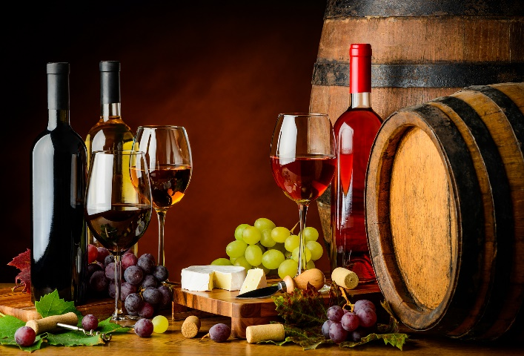

Ranchland Hills Bar Packages

Host Hourly
Beer & Wine
2 Hours | $18
3 Hours | $24
4 Hours | $28

Call
2 Hours | $22
3 Hours | $27
4 Hours | $32

Premium
2 Hours | $32
3 Hours | $37
4 Hours | $42

Super
2 Hours | $40
3 Hours | $45
4 Hours | $50

Domestic and Premium Beer*
Bud Lite, Miller Lite, Michelob Ultra, Coors Light
Dos XX, Shiner Bock, Corona, Corona Premier, White Claw

Call Brands* |
Enchanted Rock, Tanqueray Gin, Jack Daniel's Whiskey, Jose Cuervo Gold Tequila, Dewar's Scotch, Bacardi Silver Rum

Premium Brands* |
Ketel One Vodka, Beefeater Gin, Maker's Mark Whiskey, Patron Silver Tequila,
Johnny Walker Red Scotch, Captain Morgan Spiced Rum

Super Premium Brands* |
Grey Goose Vodka, Bombay Sapphire Gin, Crown Royal Canadian Whiskey, Flecha Azul Blanco Tequila,
Chivas Regal Scotch, Flor de Cana 7yr Rum, Grand Marnier

Host Bar prices subject to service charge and tax. Cash Bar prices include tax.

*brands subject to change without notice
All prices are subject to change without notice. Prices do not include 20% service charge or current sales tax.

Alcohol and Beverages
Beverage Add-Ons
Sparkling Champagne Greeting | $7 pp
Tray passed club champagne
Hand Poured Wine Service with Dinner | $25 bottle
Choice of club red or white
1 Hour Mimosa Bar | $14 pp
Choice of three (3) juices: orange, cranberry, & pineapple
Bloody Mary Bar | $14 pp
Vodka, bloody Mary mix, celery, and assorted garnishes
Keg of Beer
Domestic $300 | Imported $375
By the Gallon
Margaritas $75 | mimosas $65 | sangria $65 | fruit juices $25
Sodas and Bottled Water | $2.50 each

The Happy Hour
Priced per person.
Mini Grilled Cheese and Mini Tomato Soup | $3.25
Mini Pork Tenderloin Sliders | $4.50
Mini Beef and Cheddar Sliders |$4.50
Breakfast Tacos | $4
Select Two (2): Bacon, Egg, and Cheese; Sausage, Egg and Cheese; Potato, Egg and Cheese served with
Fresh garden salsa
Fresh Baked Cookies | $3
Build your own Smores | $5.50
Graham crackers, Hershey’s Chocolate bars, marshmallows
Assorted Mini Dessert Display |$7

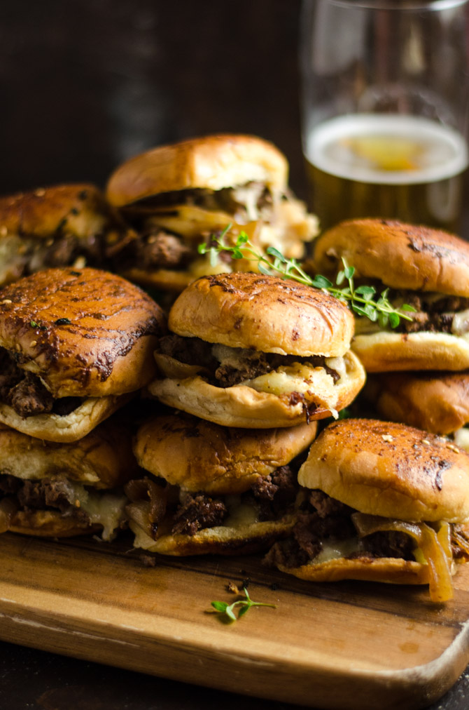

Hors d’oeuvres
Priced per piece, minimum order of 25 of any items

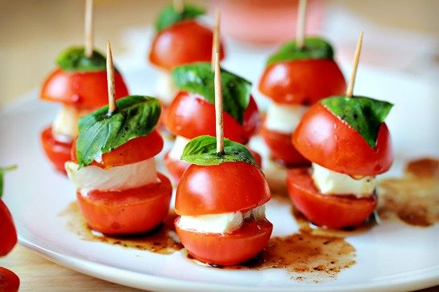
Chilled
Seared Ahi Tuna on Wonton Crisp | $5
Goat Cheese Toast with Strawberry Habanero Jam | $3.25
Cajun Shrimp and Avocado Crostini | $4.50
Caprese Salad Skewer | $3 GF, VEG
Mozzarella, Tomato and Basil Oil Bruschetta | $3.50 VEG

Hot
Mini Beef Wellington | $4.50
Casino Stuffed Mushroom | $4.25 VEG
Brisket Egg Rolls
with Garlic Chile Au jus | $4.50
Seared Beef Tenderloin and Vegetable Skewer | $4.50 GF
Pesto Chicken Skewer with
Tomato | $3.25 GF
Mini Jalapeno Biscuit topped with Smoked Brisket | $4
Coconut Shrimp with Mango Chutney | $4.25
Bacon Wrapped Scallop or Shrimp | $4.50 GF
Crispy Parmesan Artichoke Heart | $3.50 VEG
Gouda Mac n Cheese Bite | $3
Mini Crab Cake with Roasted Red Pepper | $4.75

GF | Gluten Friendly VEG | Vegetarian

Chef Attended Stations
Priced per person unless otherwise noted

Pasta | $15
Select 2: Penne, Farfalle, Cheese Tortellini, Tri-Colored Fusilli, or Linguine
Select 2: Marinara, Alfredo, Carbonara, Olive Oil with Garlic White Wine, or Pesto
Select 1: Chicken Breast, Shrimp, Sun-dried Tomatoes, Artichoke Hearts, Garlic, Applewood Bacon, Mushrooms or Parmesan Cheese
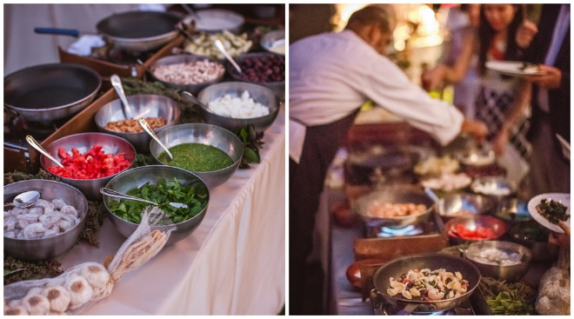
Street Tacos | $15
Select 2: Carne Asada, Sriracha Honey Pork, Fiesta Chicken, Diablo Shrimp.
Pico de Gallo, Salsa, Hatch Green Chile Queso, Grilled Onions, Yellow Corn and Flour Tortillas, Tortilla Chips, Cilantro, Tomatoes, Shredded Cabbage, Sour Cream or Lettuce

Seafood Tower $160
(serves 15-20 people)
Oysters, King Crab, Colossal Shrimp, Tuna Tar Tar, Caviar and Dipping Sauces

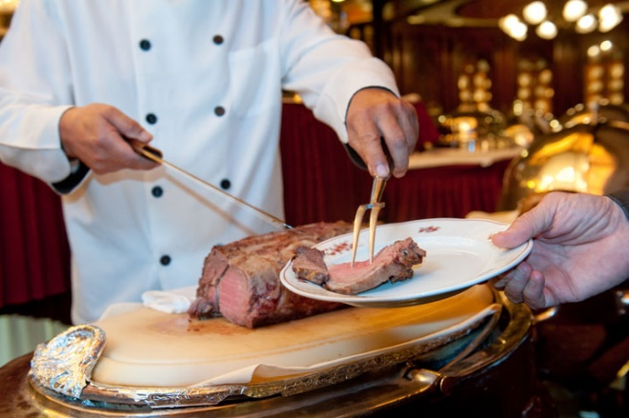

Carving Stations
Served with Rolls and Condiments
Rosemary Turkey Breast | $195 each
(Serves approximately 30 guests)
Beef Tenderloin | $380 each
(serves approximately 25 guests)
Roasted Prime Rib | $375 each
(serves approximately 25 guests)
Honey Glazed Ham | $225 each
(serves approximately 40 guests)

Attendant fee of $75 will be assessed for each Attended Station.
Wines by the Bottle
Chardonnay
Canyon Road | $25
Avarean | $48

Sauvignon Blanc
Canyon Road | $25
Astrolabe | $38

Pinot Grigio
Canyon Road | $25

Limited Time Offerings
Ask about our current specials
Cabernet Sauvignon
Canyon Road | $25
True Myth | $36

Merlot
Canyon Road | $25

Pinot Noir
Canyon Road | $25
Cannonball | $42

Interesting Reds
Corazon Del Sol Malbec | $18
Skeleton Key | $58

Vendors to consider
Florists
A Flower by Design
www.flowersbydesigntx.com
432-520-5290
Becky’s Flowers
www.beckysflowersmidland.com
432-699-0011
Blooming Rose
www.flowershopmidland.com/flower-bouquets
432-570-5459
Flowerama
www.floweramamidland.com
432-697-0255

Photo Booth
Boyd’s Events
www.boydsevents.com
432-262-1951
24K Photo Booths
www.24kphotobooths.com
432-664-9304

Draping
Boyd’s Events
www.boydsevents.com
432-262-1951

Photographer
Eternal Bliss Photography
www.facebook.com/eternalblissphoto
806-470-1276
Studio 1401
http:/studio1401.com
432-695-4666
Jordan Nicole Photography
http:/jordannicolephotography.com
832-627-2347
More Vendors to Consider

Entertainment
Boyd’s Events
www.Boydsevents.com
432-262-1951

DJ Music Connection
432-699-8888

Wedding/Event Planners

Reed Boyd Enterprise
www.boydsevents.com
432-262-1951

Bubbles Event Planning & Rentals
432-254-4704
Bubblesrentals.com

Bakery
The Cake Company
https://thecakecompanyofodessa.com
432-339-2253

Cake N Cakes
Cakencakes.com
432-299-9905

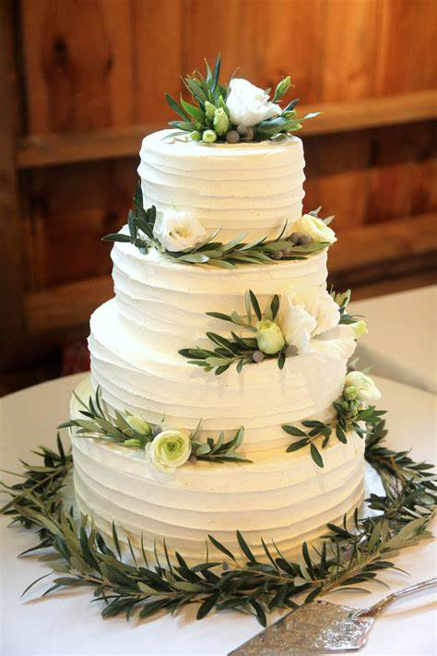

Club Policies and Procedures
All events have a time limit of five (5) hours. If additional time is needed, please make arrangements with the Private Events Director. Additional charges may apply. All events must end no later than 12:00 am. If a client goes over the agreed rental time, a $500 minimum charge will be applied.
Final menu selections, room arrangements, and other details are due 45 days prior to the event. Menu pricing is guaranteed up to 90 days prior to the event.
Final guaranteed attendance count is due seven (7) days prior to the event.
All food and beverage must be provided bu the Club, unless otherwise approved with the Private Events Director. We offer a variety of menu selections and packages designed to accommodate any event. Custom menus can be created for an event.
All food and beverage is subject to the current tax of 8.25% and service charge of 20%.
A signed contract and non-refundable deposit is required to confirm a date. Payments may be made by check, Visa, or Mastercard. Payment schedule is as follows:
- At contract signing – 25% of the estimated event total.
- 90 days prior to the event- 50% of the remaining event charges.
- 7 days prior to the event-remaining balance is due
A valid credit card may be required to be on file for payment of any additiional charges incurred at the event and for cancellation purposes.
In the event a Member?Client cancels a function for any reason, the Club will be entitled to a cancellation fee as liquidated damages (plus service charges and applicable taxes) at the time of cancellation as follows:
- 14 days prior to the event- 50% of the Estimated Cost
- 72 hours prior to the event- 75% of the Estimated Cost
- Less than 48 hrs will incur 100% of the Estimated Cost
Given the Club’s capacity to prepare and serve food and beverages, the parties acknowledge that it is highly unlikely that the Club would be able to mitigate any losses caused by cancellation of the function. The parties agree that prospectively calculating the damages that the Club would suffer as a result of the cancellation of the would be exceptionally difficult or impossible. For this reason, the parties have agreed that the cancellations set forth above are a reasonable forecast of just compensation in the event of the cancellation of the function. The amounts due for cancellation set forth herein are intended as liquidated damages and not as a penalty.
Club Usage Fee: A benefit of Membership is that Members are allowed usage of our facilities without a rental fee. Non-member Club rental fees range from about $200-$2,000. If interested in becoming a Member, speak with the Private Events Director.

1600 E. Wadley; Midland, Tx 79705
Clubhouse (432) 683-2041
www.ranchlandhills.com

Christa Brown
Director of Events and Catering
events@ranchlandhills.com

