 |  |  | PREFERRED CATERERS  CHRISTIAN ATHLETIC COMPLEX  3540 36TH ST SE  GRAND RAPIDS, MI 49512 |  |  | 2017 FACILITY RENTAL RATES AND INFORMATION  CHRISTIAN ATHELTIC COMPLEX

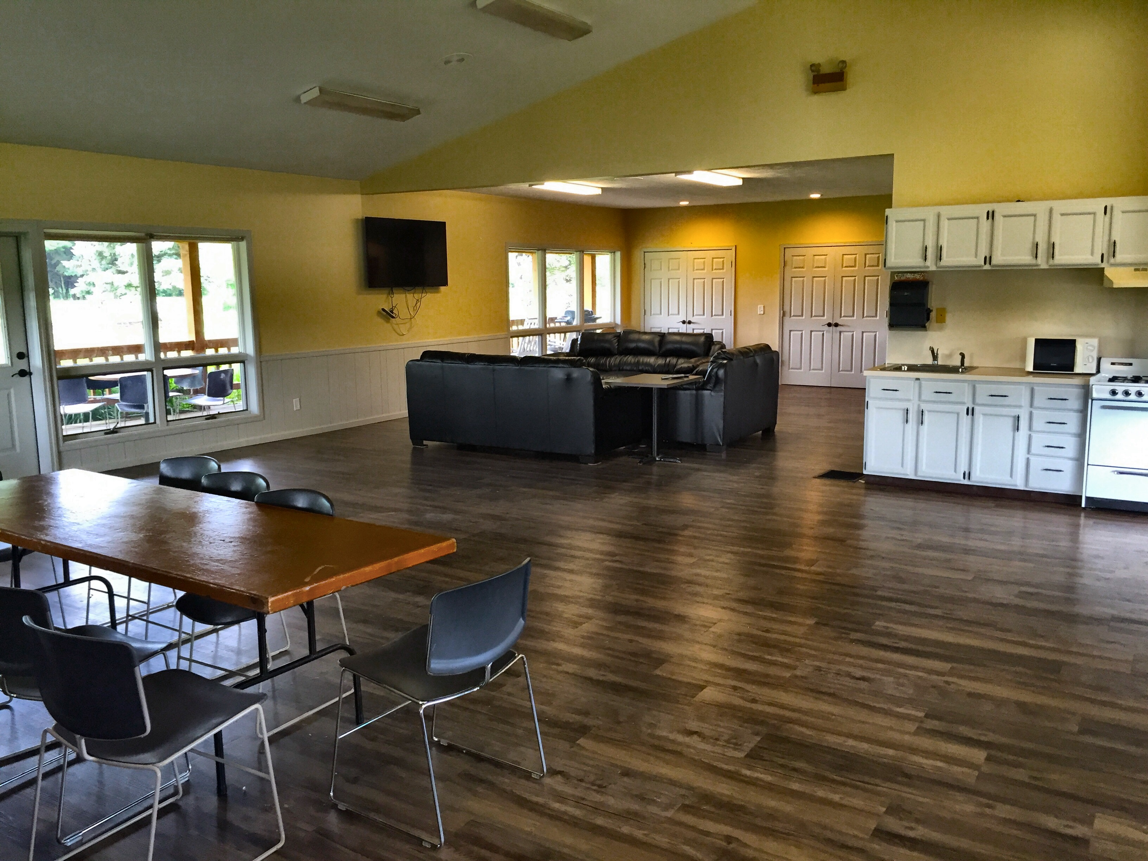 |  |  | RATES  STANDARD RENTAL RATES*  FIRST TWO HOURS - $200*  EACH ADDITIONAL HOUR - $50  CAC SET UP FEE - $50  1 HOUR SET UP/DECORATION - $25  GRADUATION OPEN HOUSE RATES  FIRST TWO HOURS - $200  EACH ADDITIONAL HOUR - $50  *FOR SPECIAL PRICING ON RECURRING USAGE, OR UNIQUE CIRCUMSTANCES CONTACT US AT THE OFFICE FOR MORE INFORMATION. | CONTACT US  CHRISITAN ATHLETIC COMPLEX  3450 36TH ST SE  GRAND RAPIDS, MI 49512  (616) 942-7540  OFFICE@CHRISTIANATHLETICCOMPLEX.ORG  VISIT US ON THE WEB:  WWW.CACGR.ORG |  | ADDITIONAL ITEMS AVAILABLE:  - 30/60 CUP COFFEE POTS*  - PUNCH BOWL  - REFRIGERATOR WITH FREEZER  - MICROWAVE  - SMALL STOVE/OVEN  - A/V EQUIPMENT*  - OUTDOOR CHARCOAL GRILL (CHARCOAL & LIGHTER NOT INCLUDED) *  - PODIUM  - MOVIE SCREEN*  - WHITE PLASTIC TABLE COVERS*  *ADDITIONAL CHARGE  OTHER INFORMATION:  - CLUBHOUSE RENTAL INCLUDES TABLES AND CHAIRS.  - BANQUET STYLE CAPACITY IS 100.

WHO WE ARE

ABOUT US
THE CHRISTIAN ATHLETIC COMPLEX PROVIDES AN ENVIRONMENT IN WHICH FAMILIES CAN SAFELY ENJOY SOFTBALL, AN 18-HOLE GOLF COURSE, A NEW PLAYGROUND, 18-HOLE MINIATURE GOLF COURSE, AND A BANQUET FACILITY AVAILABLE FOR RENT.
OUR FACILITIES CREATE A WARM, FAMILY FRIENDLY ENVIRONMENT SUITABLE FOR MANY DIFFERENT OCCASIONS SUCH AS BUSINESS MEETINGS, GRADUATION OPEN HOUSES, AND EVEN WEDDINGS.

