1001 W President George Bush Hwy
Richardson, Tx 75080
(972) 792-9393

“Satin”
Wedding Package

♥Complimentary Luxury King Suite for Bride and Groom♥
♥Chocolate Dipped Strawberries, Complimentary Bottle of Champagne ♥
♥Breakfast for Two The Next Morning♥
♥White Spandex Chair Covers/Sashes ♥
♥White Floor Length Tablecloths ♥
♥Champagne Rosette Overlays ♥
♥Personalized Mini Chocolate Bar Party Favors♥
♥Dance Floor♥
♥Centerpieces with Tea Lights and Tile Mirrors♥
♥Champagne Toast for Each Guest♥
$4,000.00 F&B Minimum
$700.00 Setup Fee/Deposit Includes All The Above (Non-Refundable)

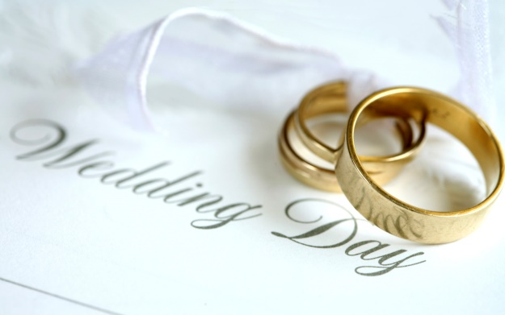

A 22% Service Charge and 8.25% Sales Tax Will Be Added To Minimum

