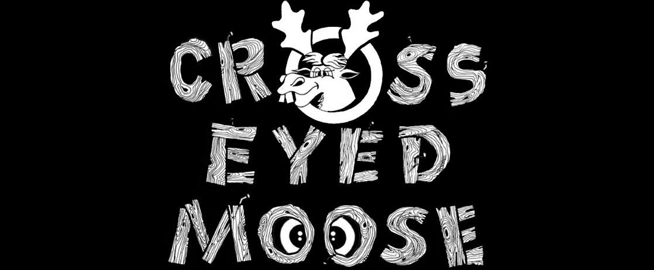

THE CROSS EYED MOOSE EVENT CENTER

**VENUE PRICING**

Our venue is as unique as the name, we are truly one of a kind. we are confident we can make your event a dream come true!

Below is our pricing guide to help you choose your best options. We are proud to offer monthly payment plans and if our pricing guide isn’t fitting your budget don’t worry, just ask!

we can offer several options including special discounts! Be sure to also follow us on social media for upcoming promotions!

|  |  |  |
| --- | --- | --- |
| Hourly rate per level  saturday | $125 per hour | 3 hours minimum |
| Upper level full day  saturday | $1000 | Up to 8 hours |
| Lower level full day  Saturday | $1000 | Up to 8 hours |
| Both levels full day  saturday | $2000 | Up to 8 hours |
| Monday-Thursday special | $75 per hour | Any hours |
| Friday & Sunday special | $100 per hour  $800 upper  $800 lower  $1500 both levels | 2 hour minimum  8 hrs  8 hrs  8 hrs |
| Overnight suites | $125 per night | Check in 3pm  Check out 11am |

*All prices include our venue amenities!*

Pricing includes 1 free hour before for set up & 1 free hour after for clean-up

Call & book today

Only $500 deposit to reserve your date/ deposit is included in pricing above,

if total event is less than $500 then total balance is due at the time of booking

330.525.4026

themooseeventcenter@gmail.com

*prices effective for bookings after 7.1.19*