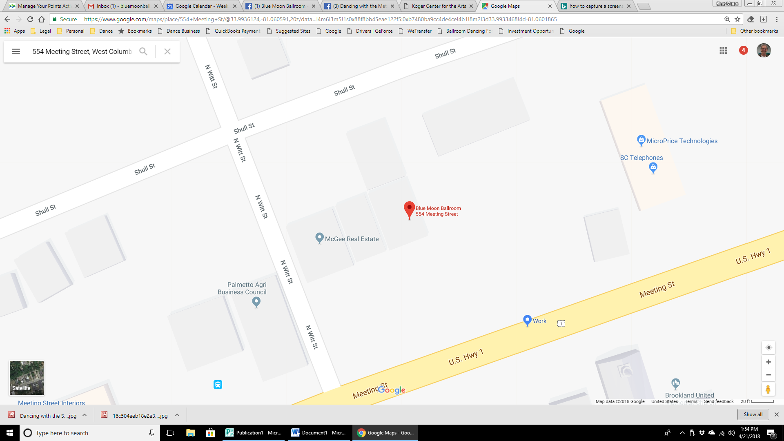

**Enter Here**

**Front Parking lot**

**Parking**

**Enter Here**

**Additional**

**Parking**

**Parking along street**